**22nd SUNDAY IN ORDINARY TIME, YEAR C**

**August 30/31, 2025 - Labor Day Weekend**

**READINGS:**

**Sirach 3:17-18, 28-29** Conduct your affairs more humbly, the greater you are, and God will favor you. A wise person always takes joy in listening to others.

**Hebrews 12:18-19, 22-24a** “You have approached Mount Zion and the city of the living God.” The judge of all comes into our assembly. Jesus our mediator reaches to touch us and invites us to touch him. We join the festival gathering of our living God.

**Luke 14:1, 7-14** The exalted shall be humbled and the humble exalted. When you have a dinner, invite poor people or persons with disabilities. Have a reception for persons who cannot repay you, “For you will be repaid at the resurrection of the righteous.”

**Prelude:** Musician’s Choice

**GATHERING RITE**

**Gathering Song:** Gather Us In NG # 848

Table of Plenty S&S #163

**Glory to God: Heritage Mass**

**LITURGY OF THE WORD**

**CLOW: 10:00am ONLY**

**Psalm 68:** **God, In Your Goodness (NEW!)**  Verses 1, 2 and 3

**Alleluia:** **Mass of Christ the Savior – with chanted verse**

Take my yolk upon you, ***says the Lord***, / and learn from me, for I am meek and humble ***of heart.***

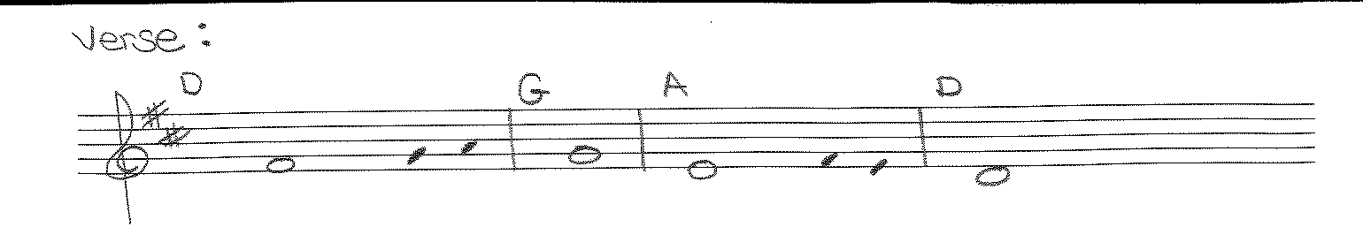

**Liturgy of the Eucharist**

**Preparation of the Gifts:** Hosanna (Music in Work Room)

Ubi Caritas NG # 696

Once Again VAO #325

**Eucharistic Acclamations:** **Heritage Mass**

**Communion Songs: Sanctuary – 2X**

Canticle of the Turning NG # 622

10,000 Reasons (Music in Work Room)

He is Exalted S&S #179 **St. Michael Prayer**

**CONCLUDING RITE**

**Closing Song:**  City of God NG #766

Bring Forth the Kingdom NG # 734