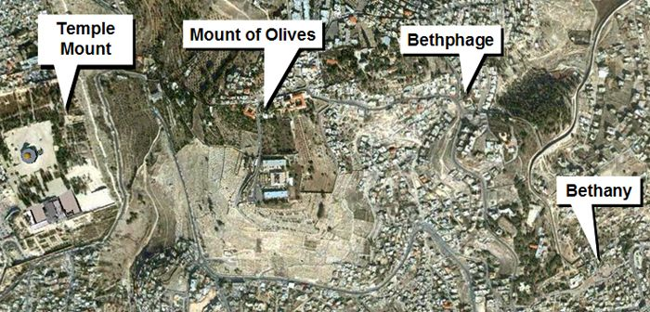 | The beginning  of the beginning  Matthew 21

The time had come, Jesus was nearing the completion of His mission. Up to this point, Jesus drove out demons and would not let them speak because they knew who He was. He warned his disciples not to tell anyone He was the Christ. He told the man cured of leprosy, “See that you tell no one…”, a warning He told others who were healed. He withdraws to a mountain because He perceived “… that they were intending to come and take Him by force to make Him king”. Jesus tells Peter, James and John, “Tell the vision to no one until the Son of Man has risen from the dead” on the mount of transfiguration. He spends his last Sabbath having dinner with Lazarus and his sisters. Mary pours expensive perfume on Jesus feet, wipes it with her hair, anointing His body for what was to come. But things were about to change. Jesus comes to Bethphage, and sends two disciples, “saying to them, “Go into the village opposite you, and immediately you will find a donkey tied there and a colt with her; untie them and bring them to Me.” Little did they know, their mission would fulfill prophesy recorded five hundred years earlier in Zachariah 9:9, “Rejoice greatly, O daughter of Zion! Shout in triumph, O daughter of Jerusalem! Behold, your king is coming to you; He is just and endowed with salvation, Humble, and mounted on a donkey, Even on a colt, the foal of a donkey.” Jesus, the King of Kings and the Lord of Lords rides into town on the foal of a beast of burden, not a regal chariot, or a white charger, just as God’s prophet predicted. Jesus did not come in wealth, grandeur, or glory but in poverty, humility and meekness. His entry also fulfilled the prophecy in Daniel 9:25, “So you are to know and discern that from the issuing of a decree to restore and rebuild Jerusalem until Messiah the Prince there will be seven weeks and sixty-two weeks; it will be built again, with plaza and moat, even in times of distress.” Having completed their task, they had no idea which animal Jesus would ride into the city, so they put their garments on both. Jesus choose the colt. However, the fulfillment of prophecy went unnoticed by the disciples, crowd and leaders of the day. As Jesus rides into the city, people throw their garments on the road, others were cutting branches from trees and spreading them on the ground in front of the colt, all of which symbolized their respect and submission to His authority. The crown cries out, “Hosanna to the son of David, blessed is He who comes in the name of the Lord; Hosanna in the highest”. The message which was hushed for years is now shouted by a few hundred thousand people. All the city of Jerusalem could hear their voices. Save us, son of David, Save us! Jesus had preached to the multitudes, healed the sick, the lame and the blind; He raised the dead, and taught with authority. The crowd sees the coming of Passover as the perfect time for Jesus to miraculously deliver them. As God through Moses had delivered Israel, surely Jesus would use His supernatural power against the oppressive rule of the Roman Empire and free His people from tyranny. Sadly, their words were right, but their hearts were not. Their expectation of a conquering King and deliverance from Rome, was not Christ’s purpose. As John MacArthur states in his commentary, “He did not come to make war with Rome but to make peace with God for men.”
One day Jesus will return, and we shall see, “…. heaven opened, and behold, a white horse, and He who sat on it is called Faithful and True, and in righteousness He judges and wages war. His eyes are a flame of fire, and on His head are many diadems; and He has a name written on Him which no one knows except Himself. He is clothed with a robe dipped in blood, and His name is called The Word of God. From His mouth comes a sharp sword, so that with it He may strike down the nations, and He will rule them with a rod of iron; and He treads the wine press of the fierce wrath of God, the Almighty.” Their enthusiasm would quickly fade. Their expectations would go unfulfilled. Their cries of hosanna would be replaced by a call for crucifixion. The world does not expect to find strength in humility. They did not expect to see someone defeat death and make the crooked straight. They wanted what they wanted, a conquering hero and not what Jesus offered, a payment for sin, victory over death and the grave, and eternal life. They witnessed miracles, healings and people being raised from the dead but missed the fact He was God’s Son. What about you?

1. Read Matthew 21:1-11. What direction does Jesus give to the two disciples he sent into the village and why is it interesting? Why did Jesus ride into Jerusalem on a donkey? (See Isaiah 62:11 and Zechariah 9:9) Why did they bring both the colt and mother to Jesus? What was the response of the crowd?

2. Where is the first place Jesus goes after he enters Jerusalem and what does He do? Why? How did the chief priest and scribes react? How does Jesus respond and where did He go?(12-17)

3. List and explain the events that take place in Matthew 21:18-22. What day is it? Why did Jesus condemn the tree? What was the disciples reaction and how did Jesus answer their question?

4. What questions do the chief priests and elders ask Jesus and why was it so important? What was Jesus response and what problem did it pose to the chief priests and elders? What was their answer and what was Jesus response?

5. Read verses 28-32. How would you explain the parable of the two sons? What is the meaning of this parable?

