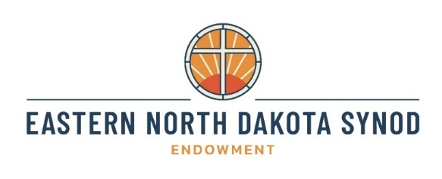
Endowment Sunday: October 19th, 2025
Congregations are encouraged to celebrate Synod Endowment Sunday on Sunday, October 19th. Consider taking a special offering or making a designated gift to one of the synod’s endowment funds to help the synod support thriving ministry for generations to come!


The Eastern North Dakota Synod Endowment consists of six endowment funds: Sustaining Endowment Fund, Vital Leaders Endowment Fund, Native American Ministry Endowment Fund, Resurrection Endowment Fund, Holy Innovations Endowment Fund, and Campus Ministry Endowment Fund. Investment in these endowment funds supports the mission and ministry of congregations, the synod, and ministry partners, as well as providing robust accompaniment for rostered ministers. The Eastern North Dakota Synod Endowment Funds will ensure robust and thriving ministry for generations to come. Any undesignated gifts to the Eastern North Dakota Synod Endowment will be directed to the Sustaining Endowment Fund.

HOW TO GIVE:
Online:
https://www.eandsynod.org/endowment-funds
Scan to Give Now!

By Check: Checks may be remitted to the Eastern North Dakota Synod, with the specific fund listed in the memo line. Mail to:
Eastern North Dakota Synod
PO Box 2019; Fargo, ND 58107


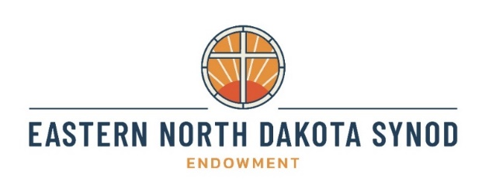
Endowment Sunday: October 19th, 2025
Congregations are encouraged to celebrate Synod Endowment Sunday on Sunday, October 19th. Consider taking a special offering or making a designated gift to one of the synod’s endowment funds to help the synod support thriving ministry for generations to come!

The Eastern North Dakota Synod Endowment consists of six endowment funds: Sustaining Endowment Fund, Vital Leaders Endowment Fund, Native American Ministry Endowment Fund, Resurrection Endowment Fund, Holy Innovations Endowment Fund, and Campus Ministry Endowment Fund. Investment in these endowment funds supports the mission and ministry of congregations, the synod, and ministry partners, as well as providing robust accompaniment for rostered ministers. The Eastern North Dakota Synod Endowment Funds will ensure robust and thriving ministry for generations to come. Any undesignated gifts to the Eastern North Dakota Synod Endowment will be directed to the Sustaining Endowment Fund.

HOW TO GIVE:
Online:
https://www.eandsynod.org/endowment-funds
Scan to Give Now!

By Check: Checks may be remitted to the Eastern North Dakota Synod, with the specific fund listed in the memo line. Mail to:
Eastern North Dakota Synod
PO Box 2019; Fargo, ND 58107

Sustaining Endowment Fund
Gifts to the Eastern North Dakota Synod Sustaining Endowment Fund will support the synod mission plan. All undesignated gifts to the Eastern North Dakota Synod Endowment will be directed to this fund.
Vital Leaders Endowment Fund
The purpose of the Vital Leaders Endowment Fund is to sustain rural ministry and enhance the quality of leadership for our pastors and deacons.
Native American Ministry Endowment Fund
The Native American Ministry Endowment will ensure sustained, robust synod funding for existing Native American Ministries in the synod and will provide support for emerging ministries in the future.
Resurrection Endowment Fund
Disbursements from the Resurrection Endowment will support new and renewing ministry initiatives across the Eastern North Dakota Synod.
Holy Innovations Endowment Fund
The Holy Innovations Endowment will encourage ministry vitality and inspire congregations and ministries to think boldly and innovatively about being the church in the world today. Grants from this endowment will support innovation and experimentation in congregations and ministries.

Campus Ministry Endowment Fund
The Campus Ministry Endowment will ensure sustained, robust synod funding for existing Campus Ministries in the synod and will provide support for emerging ministries in the future.

Sustaining Endowment Fund
Gifts to the Eastern North Dakota Synod Sustaining Endowment Fund will support the synod mission plan. All undesignated gifts to the Eastern North Dakota Synod Endowment will be directed to this fund.
Vital Leaders Endowment Fund
The purpose of the Vital Leaders Endowment Fund is to sustain rural ministry and enhance the quality of leadership for our pastors and deacons.
Native American Ministry Endowment Fund
The Native American Ministry Endowment will ensure sustained, robust synod funding for existing Native American Ministries in the synod and will provide support for emerging ministries in the future.
Resurrection Endowment Fund
Disbursements from the Resurrection Endowment will support new and renewing ministry initiatives across the Eastern North Dakota Synod.
Holy Innovations Endowment Fund
The Holy Innovations Endowment will encourage ministry vitality and inspire congregations and ministries to think boldly and innovatively about being the church in the world today. Grants from this endowment will support innovation and experimentation in congregations and ministries.
Campus Ministry Endowment Fund
The Campus Ministry Endowment will ensure sustained, robust synod funding for existing Campus Ministries in the synod and will provide support for emerging ministries in the future.

