# ELCA Churchwide Assembly



[www.eandsynod.org](http://www.eandsynod.org/)

701-232-3381

[office@eandsynod.org](mailto:office@eandsynod.org)

**MINISTRY CONNECTIONS**

August 2025

#### by: Bishop Tessa Moon Leiseth

The Tri-annual Churchwide Assembly of the ELCA met July 28 - August 2 in Phoenix, Arizona, under the theme, “For the Life of the World.” As your bishop, I was one of 20 voting members from the Eastern North Dakota Synod.

This assembly had many exciting actions including electing a new presiding bishop, Rev. Yehiel Curry (currently serving as bishop of the Metro Chicago Synod) and a new secretary, Rev. Lucille “CeCee” Mills (currently assistant to the bishop in the North Carolina Synod). These are great headlines of the assembly and hopeful actions for our shared life together as a church. I invite you to read more from the ELCA about actions of the assembly.

My own reflection since has centered on images of the church of today and church of the future. Churchwide Assembly is a unique time to see the ELCA gathered together in a larger way. There are voting members from every one of the 65 synods. We sat near our domestic companion synod, the Alaska Synod. Metro Chicago was behind us. Western North Dakota was in another section of the room. I could see Southeastern Iowa in front of us a bit. Snippets of various ELCA synods, all God’s children, united in our shared Lutheran faith, but also diverse as human beings.

One voice that was particularly present was the voice of youth and young adults. There was an amendment to change the constitutional goal of youth/young adult voting members at a churchwide assembly from 10% to 20%. It was one of the items that had the most speakers from the floor. I saw young people at least 5 deep at every microphone, lining up and waiting for their turn to speak as to why this goal was important. This image sticks with me. Our young people making sure the church is listening and including. It got me curious – what does this look like in our congregations in Eastern North Dakota? How do we open those pathways more and more? I’d love to talk about that with you when we are together. Please invite me to be with you – for this conversation, for worship, or whatever you want to talk about!

The church keeps changing how we share the Good News of Jesus. It even changes some things of how we organize to be church together. But one thing is sure – Jesus’ love and faithfulness endure forever. It was great to be church together at the 2025 Churchwide Assembly!

## *United in Christ, we dare to invite, connect, and act.*

**Churchwide Assembly Reflections**

“What really made an impact on me from Churchwide Assembly was how prayerful and deliberate the voting process was. We would sing a hymn and have a time of prayer before every one of the big votes, and it helped center us in God’s presence and promises.”

-Rev. Cassie Borges, EaND Synod CWA Voting Member

EaND Synod Voting Members at the 2025 Churchwide Assembly in Phoenix

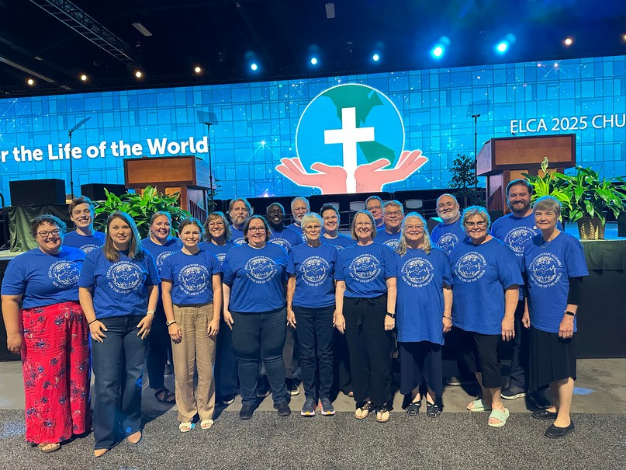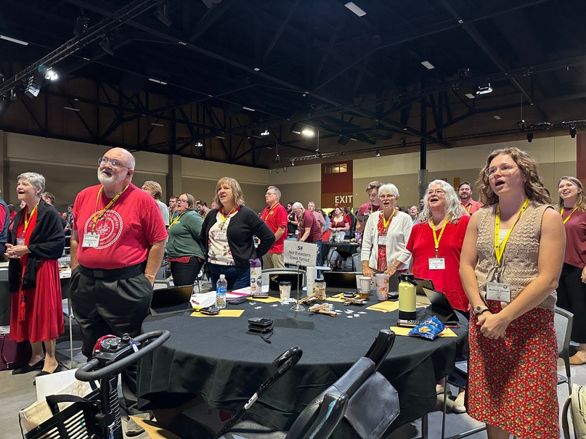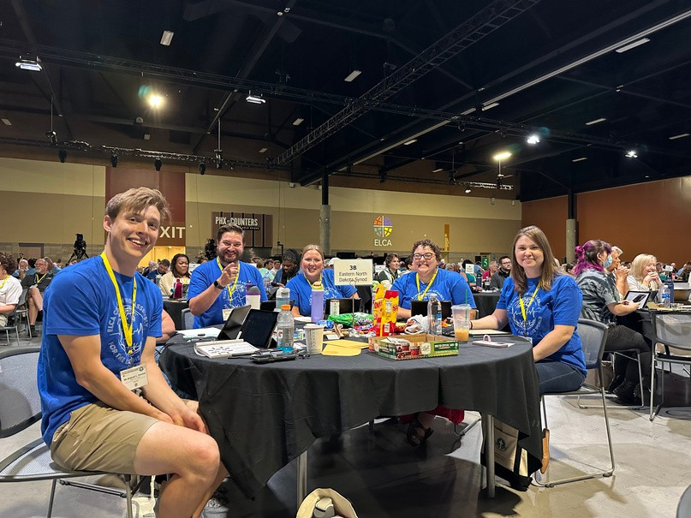

“When I think about my experience at the assembly, the first thing that comes to mind is that when I gazed over the 803 voting members I saw White, Black, Asian, Native American, straight, LGBTQIA+ and others. It reminds me about how far we have come. We are definitely a diverse church. It is our love for God, our love for neighbor, and our love for the world that binds us together. The worship services were as unique and diverse as the congregation, and the music was uplifting and had many in the aisles dancing for Jesus. But even with all that, the one thing I will always remember is receiving the Body of Christ from our new presiding Bishop.”

- Bob Schlotman, EaND Synod CWA Voting Member

**Did you know** that Eastern North Dakota is among the synods with a larger allocation of voting members due to the number of church members we have? Twenty voting members is a large group. We want to continue to have a strong voice at Churchwide Assembly and need your help. Form A is sent to all congregations (using the email address you have on record with the ELCA) early in the year. Please fill yours out in 2026. If it isn’t filled out, your congregation’s numbers will be recorded as “0”. We want everyone counted – for voting members at Churchwide Assembly and to represent who we are numerically. Thank you for your assistance with this!

**Learn More:**

Daily summaries from the ELCA Churchwide Assembly can be found at

https://[www.livinglutheran.org/tag/](http://www.livinglutheran.org/tag/) 2025-elca-churchwide-assembly /

# Synod News

#### Holy Innovations Grant Recipients

We are thrilled to announce the recipients of this round of Holy Innovations Grants! The selected ministries and their proposed projects are:

 **Christus Rex**: Community Building Trip with Crossroads NDSU

 **Grand Forks Conference:** Gods Work. Our Hands. Community Event

 **The Neighborhood Church:** Creating a Confirmation Space

 **Grace Lutheran, Oakes:** Technology Upgrade for Youth and Community Events

 **Northwood/Washington Parish:** Faith Sharing Initiative

#### Vital Church: Why Lutheran? Why Church?

**Saturday, October 18, 2025; 10am-4pm; Red Willow Ministries & on ZOOM**

75 years ago, the answer to “why church?” was simple- it’s just what we did! Faith communities today are challenged to create a more robust answer to the question “why church?” and “why Lutheran?” Together we will explore the unique and specific why of our shared story as ELCA Christians and have the

opportunity to create the unique and specific why of your specific congregation- for the sake of sharing your story with new people! Register online: [www.eandsynod.org/events/vital-conversations](http://www.eandsynod.org/events/vital-conversations)

#### New Resource: Grace Upon Grace Devotional Series

Grace Upon Grace: Cultivating your Congregation's Stewardship Story is a devotional and discussion guide created specifically for councils, teams, and congregations in the Eastern North Dakota Synod. This resource invites you to explore the stories of generosity that have shaped you as an individual and as a community and to wonder together about what new stories might be emerging. Learn more and download this free resource at https://[www.eandsynod.org/resources/grace-upon-grace-devotional-series](http://www.eandsynod.org/resources/grace-upon-grace-devotional-series)

**Mission Support at Work**

**A Prayer for Harvest**

O Lord, maker of all things, you open your hand and satisfy the desire of every living creature. We praise you for crowning the fields with your blessings and enabling us once more to gather in the fruits of the earth. Teach us to use your gifts carefully, that our land may continue to yield its increase, through Jesus Christ, our Savior and Lord.

Amen.

*ELW,* p. 62

The Mission Support your congregation shares with the Eastern North Dakota Synod is also shared with our ELCA Churchwide Organization. A vital ministry of our Churchwide Organization is work around our social teachings, including our ELCA Social Statements. With your support, the Churchwide Assembly adopted our 14th Social Statement: Civic Life and Faith. This task force was co-chaired by a member of the EaND Synod, Phyllis Johnson!



**Upcoming Events**

 **September 1:** Synod Office Closed (Labor Day)

 **September 7-10:** Fall Theological Conference (Fair Hills Resort, Detroit Lakes)

 **September 8-10:** Synod Office Closed (Fall Theological Conference)

 **September 10**: Dean’s Meeting

 **September 18:** Boundaries Training, 9am-12pm (Zoom)

 **September 23:** Retired Rostered Ministers Brunch, 10am (Trinity, Moorhead)

 **September 23:** Fall Youth Retreat Informational Zoom Session, 1pm

 **September 26-28:** Fall Youth Retreat (Castaway Club)

 **September 27:** Synod Lay Minister & Mentor Retreat (Red Willow Ministries)

 **September 27:** Small Church Saturday Book Club, 9am (Zoom)

 **October 2:** New to the Synod Lunch

 **October 7: “**When Healing Hurts” Text Study, 5pm (Zoom)

 **October 10-11**: Synod Council Meeting

### **October 18:** Vital Church: Why Lutheran? Why Church?, 10am-4pm (Red Willow Ministries & Zoom)

 **October 19:** Endowment Sunday

### **October 23:** First Third of Life Ministry Brunch, 10am (Faith Journey, West Fargo)

 **October 26:** Small Church Saturday Book Club, 9am, Zoom

 **October 30:** Dean’s Meeting

 **November 2-3:** Synod Lay Ministry Mentor’s Retreat

 **November 6:** Professional Development Day: Antiracism

### **November 11:** Stewardship Starters Quarterly Webinar: “Thanking Your Volunteers”

 **November 23:** Small Church Saturday Book Club, 9am, Zoom

 **November 27-28:** Synod Office Closed (Thanksgiving)

 **December 4:** Senior Pastor Lunch

 **December 4:** Synod Council Meeting

***More information about these events can be found at*** [***www.eandsynod.org/events***](http://www.eandsynod.org/events)