
2026 Synod Assembly
www.eandsynod.org
701-232-3381
office@eandsynod.org
MINISTRY CONNECTIONS
April 2026
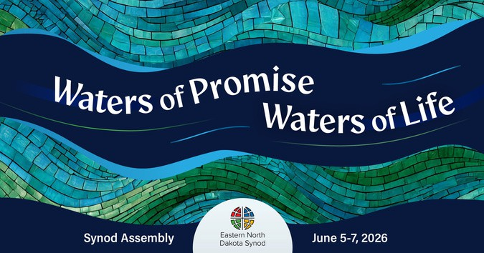
The Eastern North Dakota Synod will gather in Assembly on June 5-7, 2026 at the Holiday Inn in Fargo, ND under the theme of “Water of Promise, Water of Life.” There will be a bishop election and other important business for our life together as the Eastern North Dakota Synod. Our Bible study leader will be Bishop Regina Hassanally from the Southeastern Minnesota Synod. Imran Siddiqui, ELCA Vice President, will oversee the bishop election and serve as our churchwide representative.
Synod Assembly is the annual gathering and business meeting of the 175 congregations of the Eastern North Dakota Synod. Each congregation can send lay voting members based on their membership (voting chart available on our website). All rostered ministers (pastors and deacons) under call are voting members. Others are welcome to attend as visitors.
At this year’s Synod Assembly, our business will include a bishop election, hearing reports from officers, holding elections for Synod Council and committees, adopting a Mission Plan for Fiscal Year End 1-31-2028, and voting on Resolutions. Participants will hear about ministry across the synod and ELCA and highlights from our ministry partners. Worship, Bible study, workshops, meals, and anniversary celebrations will also take place during Synod Assembly.

Registration Details
Synod Assembly registration is online and payment can be made by credit card or check.
Voting Members: $255 (rostered ministers and lay)
Visitors: $155
Registration deadline: May 19
Late registration will be available for an additional fee of $25 until May 26.

No registrations will be accepted after May 26.
A document is available on our website with information on who is eligible to serve as a voting member, including the number of lay voting members for congregations and how rostered ministers who are not under call can serve as voting members. Voting Member Packets will be available on May 22nd and sent by email to all registrants and posted to our website.
Visit www.eandsynod.org/events/synod-assembly for more information!

United in Christ, we dare to invite, connect, and act.

Synod News

Synod Assembly Deadlines
- Hotel Room Block Reservation: May 5
- Resolutions: May 5
- Workshop Proposals: May 5
- Display Table Registration: May 15
- Voting Member & Visitor Registration: May 19
- Late Registration Deadline: May 26
Visit www.eandsynod/org/events/synod-assembly for more information.



Visit the Synod Assembly Webpage

Bishop Election Update
There will be two forums for bishop nominees that are open to anyone in the synod. There will be an online forum on April 23rd at 7pm and an in-person forum on April 30th at 7pm at Faith Lutheran Church in Valley City. For more information on these forums, visit our bishop election webpage or call the synod office.
Visit www.eandsynod.org/bishop-election for more information.

Synod Assembly Offering
This year’s Synod Assembly offering will be for the Holy Innovations Endowment Fund. This fund provides grants to congregations, as they live out their baptism in their local communities.

GIVE NOW!
A Baptismal Blessing
We give you thanks, O God, that through water and the Holy Spirit you give us new birth, cleanse us from sin, and raise us to eternal life. Stir up in your people the gift of your Holy Spirit: the spirit of wisdom and understanding, the spirit of counsel and
might, the spirit of knowledge and the fear of the Lord, the spirit of joy in your presence, both now and forever.
Amen.

“Affirmation of Baptism,” ELW, p. 237

Scan to go to the EaND Synod Giving page.

Mission Support at Work

Your generosity supports the work of the Synod Council. The Synod Council meets six times a year to tend to the business of the synod between annual synod assemblies. There are 24 members with representatives from each conference who provide vision and care for our work together.
United in Christ, we dare to invite, connect, and act.

