SNS: The Book of Revelation

Participant’s Guide

Week 6

Archangels-

10 I was in the Spirit on the Lord’s day, and I heard behind me a loud voice like the sound of a trumpet,

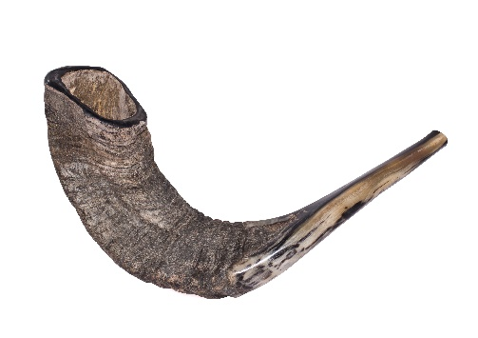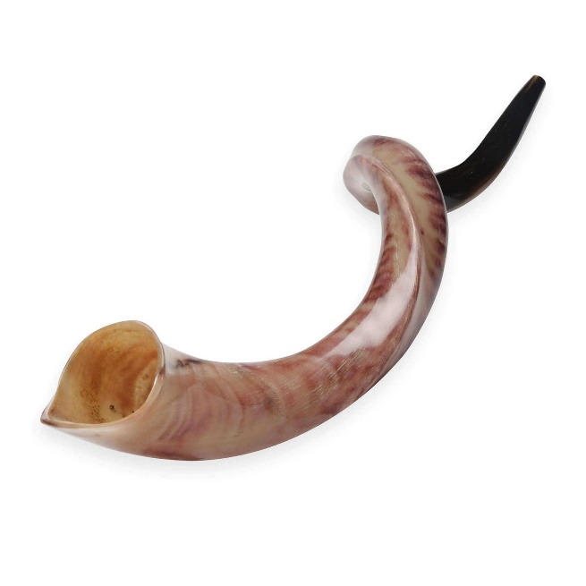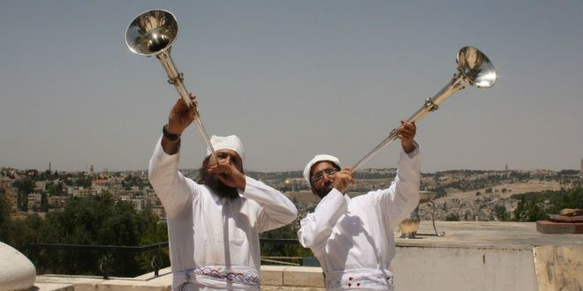

Trumpet-

When are trumpets used? 3 reasons…

- NT-

11 saying, “Write in a book what you see, and send it to the seven churches: to Ephesus and to Smyrna and to Pergamum and to Thyatira and to Sardis and to Philadelphia and to Laodicea.”

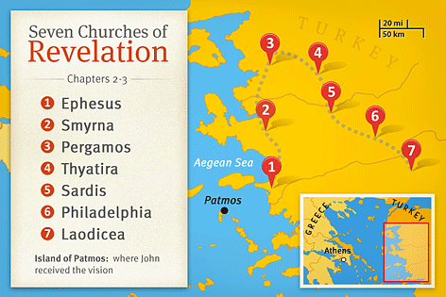

Book-

Churches-

12 Then I turned to see the voice that was speaking with me. And having turned I saw seven golden lampstands;

lampstand= menorah Exodus 25:31-40

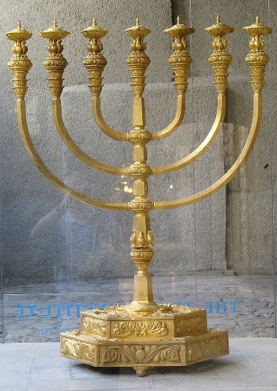

13 and in the middle of the lampstands I saw one like a son of man, clothed in a robe reaching to the feet, and girded across His chest with a golden sash.

Son of Man-

14 His head and His hair were white like white wool, like snow; and His eyes were like a flame of fire.
15 His feet were like burnished bronze, when it has been made to glow in a furnace, and His voice was like the sound of many waters.

16 In His right hand He held seven stars, and out of His mouth came a sharp two-edged sword; and His face was like the sun shining in its strength.

17 When I saw Him, I fell at His feet like a dead man. And He placed His right hand on me, saying, “Do not be afraid; I am the first and the last,
18 and the living One; and I was dead, and behold, I am alive forevermore, and I have the keys of death and of Hades. 19 Therefore write the things which you have seen, and the things which are, and the things which will take place after these things. 20 As for the mystery of the seven stars which you saw in My right hand, and the seven golden lampstands: the seven stars are the angels of the seven churches, and the seven lampstands are the seven churches.

