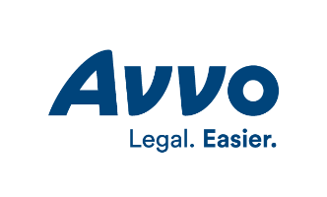

Dear Avvo,

We would like to claim the Avvo profiles for multiple attorneys in our firm.

We have authorized the below firm administrator to serve and act on the attorneys' behalf in accepting Avvo's terms and conditions of use and in entering information to their individual Avvo profiles.

Once the firm administrator has received the links and unique sign-in credentials for each profile, he or she can provide that information to the individual attorneys. For security purposes, we will also update each password.

Firm Name Click here to enter text.
Firm Administrator Name Click here to enter text.
Firm Administrator Title Click here to enter text.
Email Click here to enter text.
Phone Click here to enter text.

Authorized Signature Click here to enter text.

Date Click here to enter a date.

