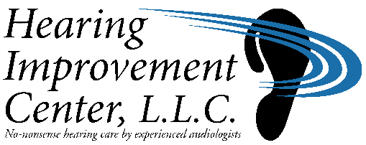**[x] WEST HARTFORD**

28 North Main Street **Caren A. Barone, AuD, CCC-A**

West Hartford, CT 06107

(860) 561-2345 FAX: (860) 561-2666

**[ ]** **WETHERSFIELD** **Hannah F. Vollinger, AuD, CCC-A**

919 Silas Deane Highway

Wethersfield, CT 06109

(860) 529-3443 FAX: (860)513-1277 **Shannon O’Rourke, AuD, CCC-A**

Thank you for scheduling an appointment at the Hearing Improvement Center*.*

Enclosed are some forms that need to be completed prior to your appointment. We ask that you please arrive 10 minutes early to your appointment and that you bring your insurance card(s), photo identification, and a medication list with you. It is helpful to bring a family member or friend with you to the appointment, as we will be discussing a lot of information that is often unfamiliar. If you have a prior hearing evaluation or any documentation related to your hearing health, please bring these too.

Again, thank you for choosing the Hearing Improvement Center to help you with your hearing healthcare needs. We are a locally owned business that has been providing quality service for over forty years and appreciate your patronage. Please feel free to contact our office if you have any questions or need to reschedule your appointment. Please provide our office with 24-hour notice to change or cancel the appointment. We look forward to meeting you.

Sincerely,

The Staff at the Hearing Improvement Center