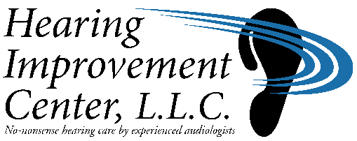**[x] WEST HARTFORD**

28 North Main Street **Caren A. Barone, AuD, CCC-A**

West Hartford, CT 06107

(860) 561-2345 FAX: (860) 561-2666

**[ ]** **WETHERSFIELD** **Hannah F. Vollinger, AuD, CCC-A**

919 Silas Deane Highway

Wethersfield, CT 06109

(860) 529-3443 FAX: (860)513-1277 **Shannon O’Rourke, AuD, CCC-A**

**Informed Consent for Text Messaging**

**Patient Name: ______________________________________ Date: ______________________**

With your consent, the Hearing Improvement Center, LLC, would like to send text (SMS) messages to the mobile number you have provided in our records.

By providing your informed consent where indicated, you acknowledge that you have understood the information below and agree to participate in our text (SMS) messaging service.

Purpose and Description: The Hearing Improvement Center’s text (SMS) messaging service is designed to provide you with helpful information, reminders, and notifications via text messages sent to your mobile phone. We may use text (SMS) messages to communicate with you for a variety of purposes, including:

* Appointment reminders
* Surveys and inventories

Voluntary Participation: Participation in our text (SMS) messaging service is entirely voluntary. You have the right to refuse or withdraw your consent at any time.

Benefits and Risks: Benefits: The text (SMS) messaging service aims to keep you informed about the Hearing Improvement Center by providing an additional method of convenient and timely communication.

Risks: While every effort will be made to protect the security and confidentiality of information transmitted through text (SMS) messages, there are inherent risks associated with all electronic communication. These risks include unauthorized access, loss of privacy, and potential breach of sensitive information. It is important to be aware that text (SMS) messages may not be entirely secure and could be intercepted or accessed by unintended reciptients.

Potential Costs: Participation in the text (SMS) messaging service may involve standard text messaging charges applied by your mobile service provider. Please consult your mobile service provider regarding any applicable fees or charges.

By signing below, I acknowledge my rights and responsibilities.

Patient or Guardian Signature