Magic Mirror/Smart Mirror
“Mirror Mirror on the Wall”

EEC 693 CYBER PHYSICAL SYSTEMS
INSTRUCTOR: Prof. Jongman Kim
Professor of Electrical and Computer Science
Engineering

Christopher Isabella
Srikar Pinnapreddy
Yaseen Shaik

Table of Contents
Page no

INTRODUCTION/PURPOSE STATEMENT 3

EXISTING/RELATED WORK 3-5

SWOT OF THE MAGIC MIRROR 5-6

COST ANALYSIS 6

MILESTONES 7

INFORMATION ARCHITECTURE AND DISPLAY LAYOUT 7-9

PICTURES AND CODE SAMPLES 9-13

FUTURE WORK /CONCLUSION 14

REFERENCES 15

INTRODUCTION/PURPOSE STATEMENT

Ever since Snow White and the Seven Dwarfs was released in 1937, everyone was astonished by the thought of the Magic Mirror. How helpful would it be to have a common household item that you look at every day also serve as a useful assistant every morning? The answer is extremely helpful!
The Magic Mirror project is designed to provide simple real time information to the user about their day. By default, the mirror will display the time, weather, and upcoming calendar appointments. It will also feature a news feed and a notification alert section. The center of the screen will be used as a general display that will allow any information the user likes to be displayed, but its default behavior is to show nothing so it can still function as a mirror. The center area is also where added widgets can be displayed using publically available APIs or even specific user created APIs. We use a combination of widgets and APIs from the smart mirror open source hobbyist project [5], Open Weather Map [6], and our own created applications. We also make use of the open source Electron framework to control the layout and display of these widgets [2]. Finally, we are developing a way to integrate our mirror with Alexa, so that we can utilize its affective voice controls in order to control the mirror, just like in the classic Disney movie. This last feature is still being developed, but it is a part of our future work.
The main construction of the mirror will consist of a monitor, a Raspberry Pi, and a double sided acrylic mirror that is of similar size to the monitor, and an assembled enclosure. Overall, the mirror should be easy to assemble and the most expensive component is the computer monitor. Parts in total should be less than $150. We list the required parts in the subsequent cost analysis section.

EXISTING/RELATED WORK

The Internet of Things (IoT) is a common buzzword that you hear often in today’s modern developing tech community. There are products that are coming up that help to facilitate this role in many ways, such as the smart restaurant, automated carwashes, and smart watches. “It (IoT) has no certain limitation on application, rather than that it creates a new service while having convergence with existing systems and services” [3]. The smart or “Magic” mirror is just another extension of our world that can be implemented as another IoT device.

Currently there are many monitors that are used as displays. Some examples are movie theater poster displays, fast food restaurant menus, airport terminals, etc. We are used to seeing these in our everyday lives, but they are mostly used for advertising purposes. A smart mirror would fill a segment of the market by allowing a common household item to double as a personalized assistant to your day. There are no fully assembled smart mirrors that are commercially available on the market today. Others have built smart mirrors, but as hobbyist/DIY projects. Being able to assemble and cost affectively produce a user friendly and fully working Magic Mirror would allow an early jump on the smart mirror market that will grow quickly over the next coming years.

We are not the only group that sees the value of a smart mirror. There are several papers and sources that look into this topic as well. First, there are the hobbyist sources. Source [5] is an open source project that provides widgets to use and frameworks for users to create other widgets for a Raspberry Pi display. We are using some of these widgets in our version for class. This source also provides some simple troubleshooting tips for Raspberry Pi projects. Source [8] is another hobbyist source. They are a provider of preassembled mirror monitors that can be used with a Raspberry Pi or other device. They do not provide preassembled smart mirrors, and that is where we can capitalize on the market with the release of a fully assembled and ready to use product.

There are also quite a few papers that research the use of a smart mirror in various scenarios. The paper from Henriquez, et al. uses a smart mirror to monitor a person’s facial expressions and physical signs in order to determine their well-being status and offer guidance to them on how they can change their lives [4]. Their work resulted in over 20 different ways in which their mirror could measure someone. They concluded that there is still much more work that needs to be done in order to fully understand the complexities of the human condition and process all 20 measurements affectively, but their work is a step in the right direction to allow the Magic Mirror to assist in a health environment. Yu, et al. [9] take a similar approach to [4], but they play uplifting music and give helpful comments when a user is feeling down on their luck. Their initial results have shown to be significant in increasing and improving users’ attitudes

Another paper is the FitMirror [1]. The authors of this paper use a smart mirror in conjunction with a Microsoft Kinect and Wii Balance Board to wake up and motivate users in the morning to be active. Their trials and results proved to be affective in helping non-morning people wake up easier, and it also helped generally increase users’ fitness levels throughout the day.

A final related work is from Saakes, et al [7]. All this paper does is propose using a smart mirror to “virtualize” various pieces of clothing onto a user so that they can try outfits on in quicker succession. This idea can easily be applied to retail stores, and even allow people to try on clothing items without having to leave their home.

SWOT OF THE MAGIC MIRROR
Strengths
Our version of the mirror is a cost-effective model. The parts are simple, off the shelf, and easy to obtain. Also, its design is simple since basic woodworking is needed for the frame enclosure, and the enclosure can also be pre-made/automated for manufacture, thereby reducing cost. Maintenance is easy as well since it uses the coding languages C (for the Raspberry Pi control) and JavaScript (for the Electron widget control) which are both widely supported languages. There is also extensive open source support for the Pi which can help during development and deployment. Once development is complete, the Pi image can be cloned and applied to others for ease of mass production. The Magic Mirror has no limits on what can be displayed, it is very easily expanded and integrated with other systems. This ease of expansion allows different versions to be made as well, such as a basic and premium model.
Weaknesses
Possible locations for a mirror will most likely include places that have a high moisture content. This can damage the electronic components of the mirror. A strong enclosure is necessary to seal its internals from the outside world. Also, the Magic Mirror will be reliant on your internet connection. If your connection drops, then your product won’t work. Only basic functionality (such as time of day comments) will be available. Finally, this product might be foreign to some people who are not tech oriented. As such, they might not purchase the product, or they could have trouble setting it up. We need an easy user setup process.
Opportunities
There are many opportunities for the Magic Mirror. Mirrors are used everywhere in our lives. This technology can be applied to automotive, consumer & household, medical & healthcare, and advertising & retail markets. Currently, there are no mass market smart mirrors available, so it would be beneficial to jump and capitalize on the market early. Premium places of business (law firms, tech companies, and hospitals) would be extremely interested in the Magic Mirror as it would allow them to increase their brand image and extend their influence to even more forefronts.
Threats
There are a number of threats to the Magic Mirror. For example, a customer might choose another smart appliance based on their preferences. They might prefer to have a smart refrigerator, or Google home device. Another threat is privacy. The Magic Mirror is an internet enabled device, so there is always a risk of data theft and loss. Also, if there is a camera attached to a particular model, then it could be hacked which could then lead to sensitive leaked pictures.
COST ANALYSIS
Class Prototype
- Raspberry Pi 2 with power supply and Wi-Fi adapter - obtained for free
- Monitor - 15-inch + cable - obtained for free
- Mirrored Acrylic Two-Way (Customize Sizing) – Clear 3/16 inch thick, 12.5 inches wide, 15 inches long - $45
- 1/8 x 3 inch board and a few 2 $×$ 4 in wooden blocks - $10

Premium Model – Future Work
The Magic Mirror has great potential to be a premium item in the restroom of nice restaurants, companies, law offices, and premium universities. The main component is the Raspberry Pi, and that part runs around $50 for the most expensive model. The size of the mirror is only limited by the size of the display screen, the most expensive component. Screens can range from a few hundred dollars to upwards of tens of thousands of dollars for large displays. Customers of the magic mirror can be charged a 50% increase over the cost to assemble the mirror along with yearly fees to update and service the mirror.

MILESTONES
Below is the breakdown of the work that we have completed over the last semester to create the prototype mirror for the class. We have followed this schedule and it has resulted in the work being completed in a timely fashion.
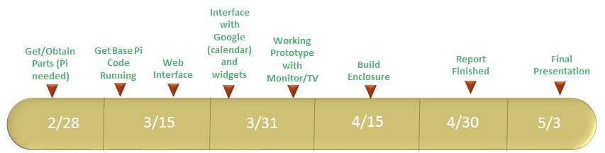

INFORMATION ARCHITECTURE AND DISPLAY LAYOUT
The magic mirror project is designed to provide simple real time information to the user about their day. By default the mirror will display the time, weather, and upcoming calendar appointments. It will also feature a news feed and a notification alert section. The center of the screen will be used as a general display that will allow any information the user likes to be displayed, but its default behavior is to show nothing so it can still function as a mirror. The center area is also where added widgets can be displayed using publically available APIs or even specific user created programs. Below is a diagram that will model the general layout of the mirror.
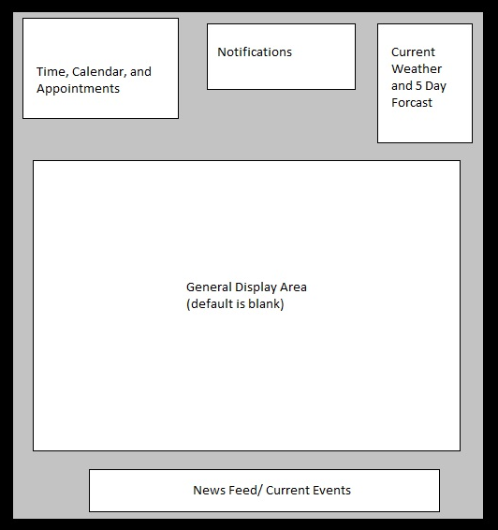
The project for this class is a non-touch version. This means that the mirror displays a predetermined set of items and widgets. The user can change what is displayed, but they will have to go through the network interface and edit the configuration JavaScript file. A more premium model can come with a touch screen interface on the mirror that will allow more interaction and real time interface customization. The next few diagrams will show an example of what each section of the mirror is going to be displaying.
Time, Calendar, and Appointments

Notifications
Due in 5 Minutes!
Class
New/Current Events
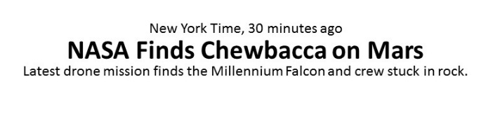
Weather
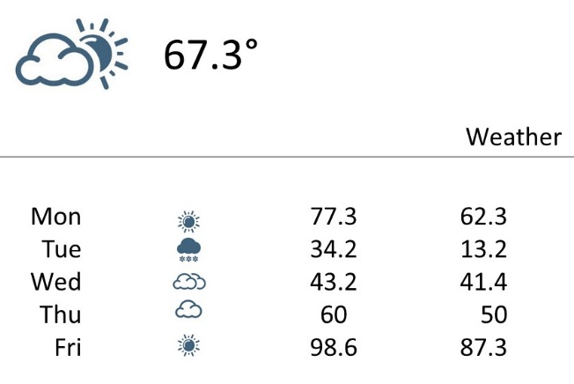
PICTURES AND CODE SAMPLES
The following section will contain pictures and a simple example of a configuration script that a user would create to Tayler the Magic Mirror to their liking. This script can also be set up to promote a certain business, such as a restaurant or office.
Here is the first picture. It shows the prototype mirror running on a TV screen. This is what we used to develop and configure the mirror before the configuration was completed. Notice the Raspberry Pi on the bottom left.
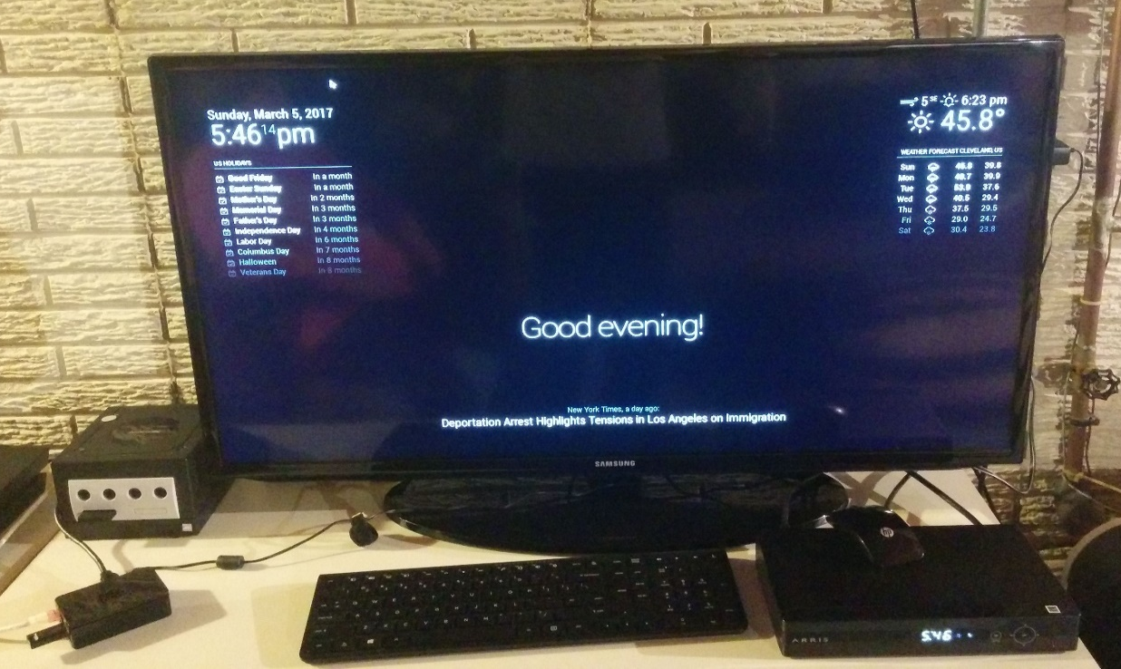

The next set of pictures show the completed mirror enclosure before it is powered on. The enclosure was built by cutting some scrap stud board and attaching it together with wood screws. The mirror is held to the frame with strong bathroom sealant. Inside of the frame, the monitor is held in place by L joints attached to the inner wall of the frame. All other components are attached to the back of the monitor with double sided mounting tape. Finally, the back of the mirror is a cutout of cardboard with holes drilled for airflow and power cords.
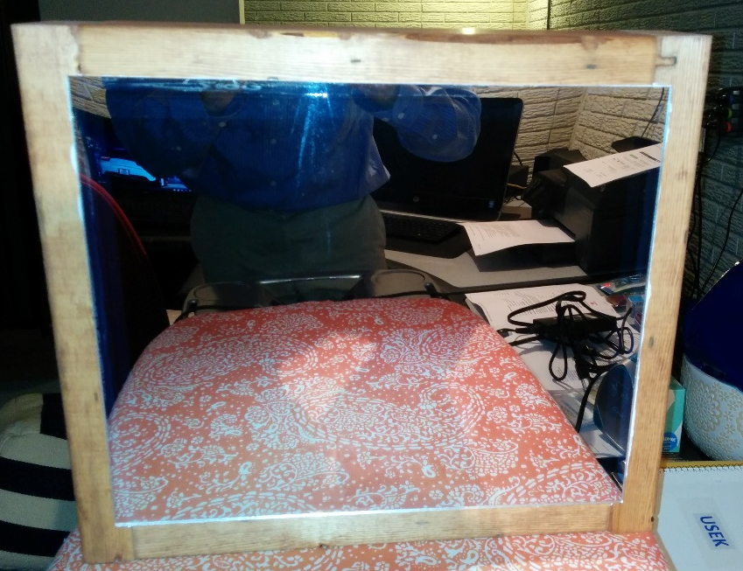
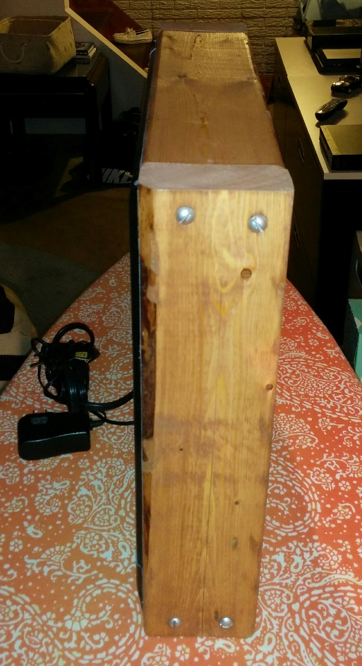
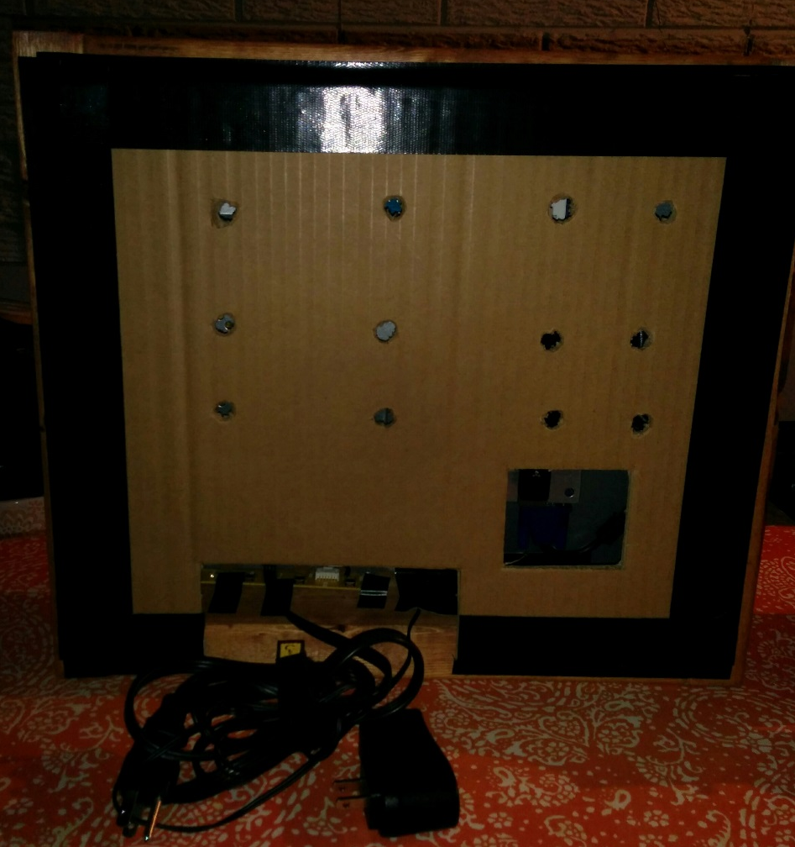
This final picture shows the working mirror with its default modules displaying.
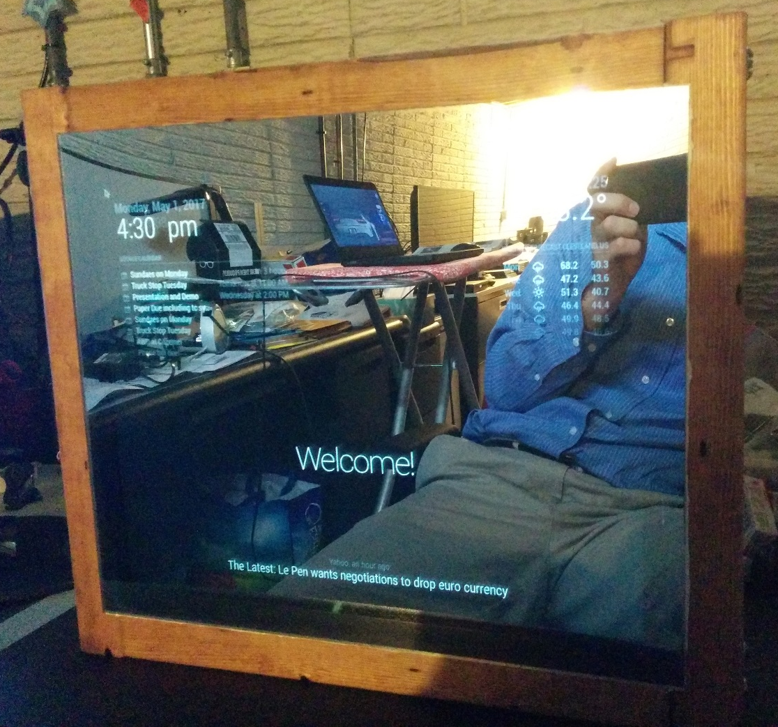
Finally here is an example configuration script. All config scripts are written in JavaScript. The Electron framework uses this to decide where to place the modules on the display screen.
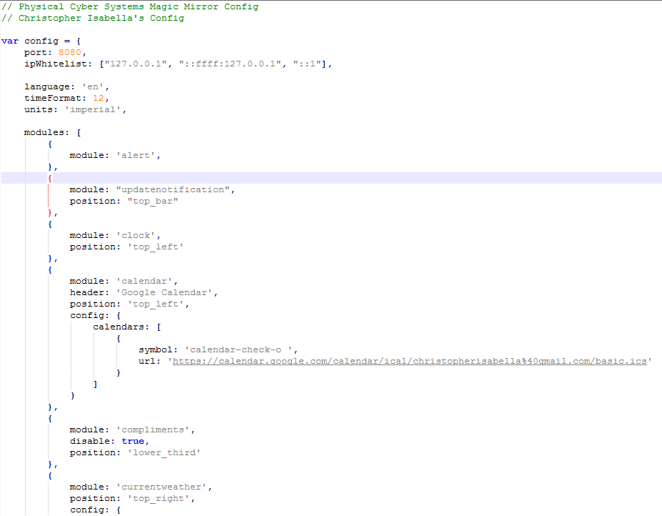
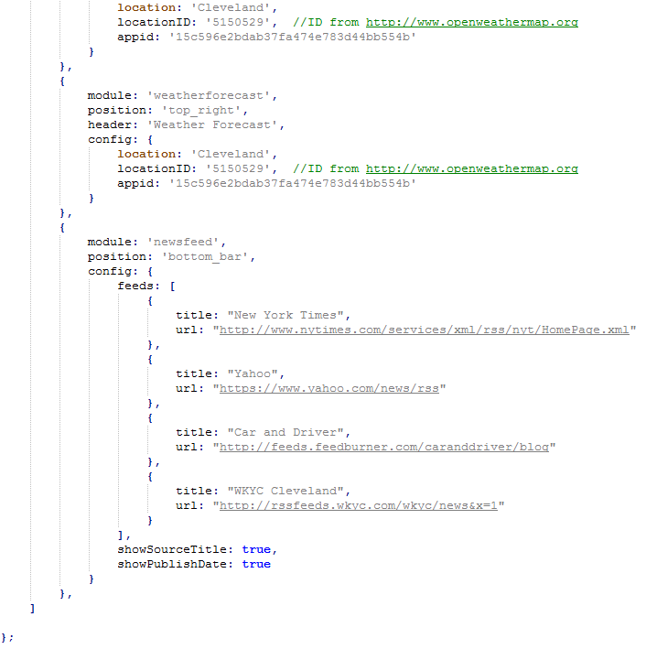
FUTURE WORK/CONCLUSION
The limits of the Magic Mirror are as endless as your imagination. Going forward we plan on finishing up the integration of the Alexa voice controls so that we can search topics and control the mirror with voice commands. The commands we are working on are a Google command that when ran, the mirror will display images from a Google search of whatever is dictated. Other voice commands that we are working on are control commands. For example, if a user says turn off calendar module, then the calendar module will be hidden which in turn allows more use of the mirror surface area to be used unobstructed.
We also plan on putting effort into other models for premium use in businesses. High end restaurants and businesses would be willing to pay for a Magic Mirror and the service agreement that goes along with it. This has the potential to be a highly profitable segment due to the fact that there are not companies that offer fully assembled smart mirrors and the support for them in the market today.
In terms of this semester project, we believe that we have successfully demonstrated a prototype Magic Mirror that encapsulates the ideas and topics that were discussed in Physical Cyber Systems.

REFERENCES
- Besserer, Daniel, et al. "FitMirror: A Smart Mirror For Positive Affect in Everyday User Morning Routines." Proceedings of the Workshop on Multimodal Analyses enabling Artificial Agents in Human-Machine Interaction, 12 Nov. 2016, pp. 48-55.
- Electron. electron.atom.io/. Accessed 29 Apr. 2017.
- Ha, Jun, et al. "A Perspective on the IoT services through a multidimensional analysis." Proceedings of the 2015 Conference on research in adaptive and convergent systems, 9 Oct. 2015, pp. 479-81.
- Henriquez, Pedro, et al. "Mirror mirror on the wall... an unobtrusive intelligent multisensory mirror for well-being status self-assessment and visualization." IEEE Transactions on Multimedia, pp. 1-14.
- MagicMirror². 2016, magicmirror.builders/. Accessed 29 Apr. 2017.
- Open Weather Map. 2016, www.openweathermap.org. Accessed 29 Apr. 2017.
- Saakes, Daniel, et al. "Mirror Mirror: An On-Body Clothing Design System." SIGGRAPH 2015: Studio, 9 Aug. 2015.
- Two Way Mirror. www.twowaymirrors.com/. Accessed 29 Apr. 2017.
- Yu, Yuan-Chih, et al. "Magic Mirror Table for Social-Emotion Alleviation in the Smart Home." IEEE Transactions on Consumer Electronics, vol. 58, no. 1, 1 Feb. 2012, pp. 126-31.

