
Phone: 1.866.289.9909 Fax 1.866.545.5672
www.MarcoPromos.com
Directions for setting up Marco insert item #A-3LI – 2.25”H x 3.5” W

Microsoft Word 2007 & Newer Directions
Step 1. Open Word
Step 2. Click on the Mailings Tab
Step 3. Click Labels
Step 4. Click on Options
Step 5. Click New Label
Step 6. Complete the field as follows:

Label Name | MARCO A-3LI
Top Margin: | 0”
Side Margin | 0”
Label Height | 2.25”
Label Width | 3.5”
Number Across | 2
Number Down | 4
Vertical Pitch | 2.25”
Horizontal Pitch | 3.5”
Page Size | Letter (8.5 x 11in.)

Step 7. Click OK
Step 8. Click OK
Step 9. Click New Document and begin entering your information

Microsoft Access 2007 & Newer
If you have created a database of names that you would like to use for your inserts it is easier to set the format in Access than exporting it into Word.
Step 1. Open your database file in Access 2007
Step 2. Open the Navigation Pane on the left of the screen
Step 3. Select the table that contains the data you would like on the labels
Step 4. Click Create from the toolbar
Step 5. Click Labels from the menu bar
Step 6. Make sure English is selected as a unit of measure and the Label Type is selected as Sheet Field
Step 7. Now click Customize
Step 8. Then click New
Step 9. Enter the label name Marco A-3LI
Step 10. Select Portrait as the Orientation
Step 11. Enter the number across as 2
Step 12. Fill in the measurements per the diagram below
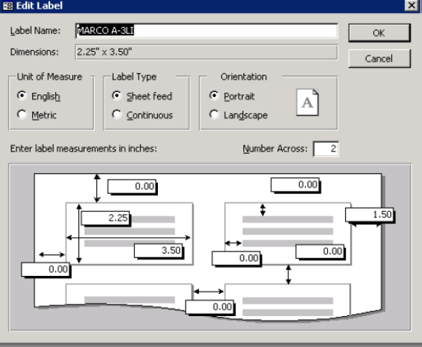
Step 13. Click OK
Step 14. If it says that one or more margins are set outside the printable area of the page. Select NO to not increase the margins
Step 15. Click Close
Step 16. Make sure the Label MARCO A-3LI is selected and click next
Step 17. Make sure your font size, style, and color selections. NOTE: You may need to make changes to this depending on what you want. 24pt is a good size to see a person’s name, but if all the fields are 24pt and you have several lines, it will probably not fit.
Step 18. Click Next
Step 19. Now add fields to the label as needed by clicking them and then clicking the right facing arrow. NOTE: When selecting the fields, you need to add commas and spaces in between the fields exactly like you want it to print on the insert and you need to enter at the end of each line.
Step 20. Click Next
Step 21. Now you can sort your labels if needed by clicking the field/fields you want to sort by and clicking the single right facing arrow.
Step 22. Click Next
Step 23. Name the report file as needed.
Step 24. Click Finish
Step 25. If changes need to be made to the font they can be completed using the design view accessed by right clicking on the page. If no changes are needed you are set to print.

