Texas v. Johnson / Should the U.S. Enact a Flag Desecration Amendment?
Directions:
- Read the Background section below.
- Complete the Flag Desecration Amendment section (page 3).

Background
Did you know that the proper method of destroying or “retiring” a flag that is worn out or soiled is to burn it? Boy Scouts and American Legion groups regularly perform such ceremonies. However, ordinary U.S. citizens who have burned flags for other reasons, such as political protest, have often been subject to arrest. Congress passed the Flag Protection Act in 1968 while some people were protesting against the Vietnam War. It was a national law that made it illegal to burn or treat the flag disrespectfully, which is called desecration. Many states also had laws that made flag burning illegal.
In 1984, Gregory Lee Johnson was arrested for burning a flag during a protest outside the Republican National Convention in Texas. His case, Texas v. Johnson, eventually went to the Supreme Court of the United States. In the 5-4 ruling the Court explained that what Johnson did is a form of speech that is protected by the First Amendment making all flag desecration laws unconstitutional.
Because of the Supreme Court’s decision in Texas v. Johnson, those who wanted to ban flag burning would have to amend the Constitution to make it happen. The most common path to enact a proposed constitutional amendment is proposal by two-thirds majority in both houses of Congress and ratification by three-fourths of the state legislatures (see graphic on page 2).
Flag supporters have tried to pass a constitutional amendment to protect the flag or prohibit flag burning many times. Since the Supreme Court ruling in Texas v. Johnson in 1989, the House has approved flag amendments in 1995, 1997, 1999 and 2001, and 2005, all with the necessary two-thirds majority. The Senate, in votes in 1995 and 2000, came up with only 63 votes, four short of the two-thirds majority needed. In 2006, the Senate was only one vote short of the 67 needed.
People who wanted this amendment argued that flag burning is an offensive action that shows disrespect to the nation. They pointed out that there are many forms of speech that are not protected by the First Amendment. People who did not want this amendment argued that freedom of political speech is protected by the First Amendment. They also pointed out that one of the proper ways to dispose of a flag is by burning it.
The debate continues. In November 2016, then-President-Elect Donald Trump tweeted, “Nobody should be allowed to burn the American flag—if they do, there must be consequences —perhaps loss of citizenship or year in jail!” In commemoration of Flag Day 2019, Republican Senator Steve Daniels from Montana proposed an amendment, S.J. Res. 49, with the support of the Trump Administration.
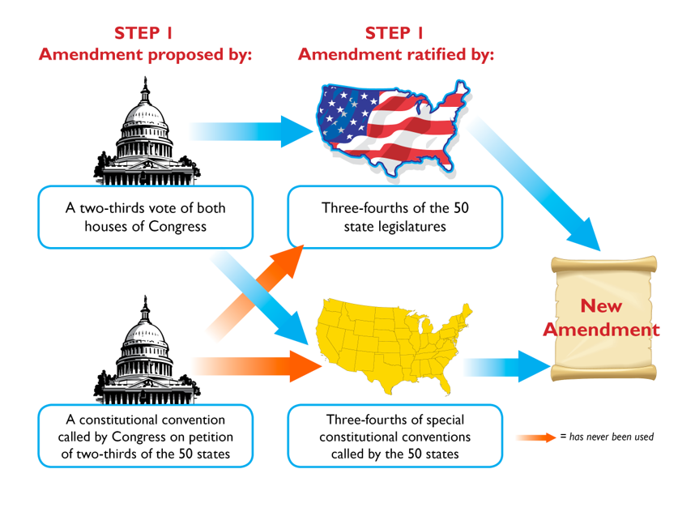

Flag Desecration Amendment
Imagine that you are a recently elected U.S. senator, and this amendment has been submitted to the Senate again. You will be asked to vote on this issue, which is very important to many of your constituents. You will vote on this issue: Should the United States enact a constitutional amendment to prohibit flag burning?
The Congress shall have power to prohibit the physical desecration of the flag of the United States.
– Text of Senate Joint Resolution 49, proposed Flag Desecration Amendment (June 13, 2019)
Questions to Consider
- What is the main idea of the Flag Desecration amendment?
- What is one reason that this amendment should be ratified?
- What is one reason that this amendment should not be ratified?
- As a senator, will you vote for or against proposing this amendment? Explain your reasoning.

