Texas v. Johnson / Data Analysis: How Do Americans Feel about a Flag Desecration Amendment?
Directions: Review the data in the tables below. Then answer the Questions to Consider (page 2).
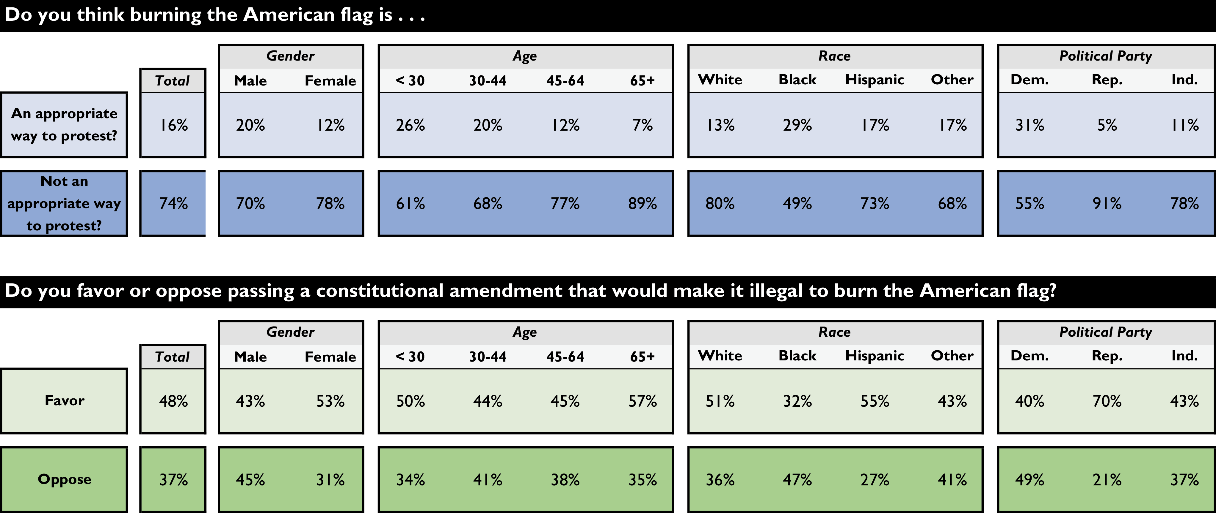
Source: YouGov Poll, http://big.assets.huffingtonpost.com/tabsHPFlagBurning20161201.pdf. Interviewing Dates: November 30–December 1, 2016. Target population: U.S. citizens, aged 18 and over. Sampling method: Respondents were selected from YouGov’s opt-in Internet panel using sample matching. A random sample (stratiﬁed by gender, age, race, education, geographic region, and voter registration) was selected from the 2014 American Community Study. Number of respondents: 1000. Margin of error: ±4% (adjusted for weighting). Survey mode: Web-based interviews.
Questions to Consider
- How do most Americans feel about whether it is an appropriate form of protest to burn the flag?
- Which demographic group is most in favor of a constitutional amendment making it illegal to burn the flag?
- Which demographic group is most opposed to a constitutional amendment making it illegal to burn the flag?
- Which of the following conclusions can be drawn from the data regarding the constitutional amendment to protect the flag?
  - It will pass by a large margin.
  - It enjoys widespread political support.
  - It has only partisan support.
  - Many people who disapprove of flag burning do not support an amendment to ban it.
- From studying the tables, what conclusions can be drawn regarding American political opinion on the issue of the Constitutional amendment to protect the flag?
- What would account for the differences in results in Question 2 and Question 3?
- Why do some people believe that even speech that is unpopular needs to be protected?

