New Jersey v. T.L.O. / You Decide: Is this a Legal School Search?
Directions:
- Read the Background section below.
- Complete the “Is this a Legal School Search?” activity (page 3).
- If your teacher assigns it, complete the Extension Activity (page 5).

Background
The Supreme Court determined that school administrators who search students are not required to meet the standard of probable cause or obtain a search warrant. Instead, school searches are examined using the reasonableness standard. In other words, did the school administrator have “reasonable suspicion,” based on fact, that a student broke a school rule or law? In New Jersey v. T.L.O. (1985), the item searched was T.L.O.’s purse. However, searches at schools may also include backpacks, lockers, vehicles, cellphones, and any other item that a student would bring to school. What areas, and under what circumstances, are school officials allowed to search on a student?
In cases involving the constitutionality of searches, the Supreme Court attempts to balance the liberty of the individual with the order of the government entity. School searches are reasonable when the privacy of the student is carefully balanced with the duty of the school to maintain discipline and order. It is important to think about this achieving this balance as a seesaw because it is dynamic and can change in each circumstance.
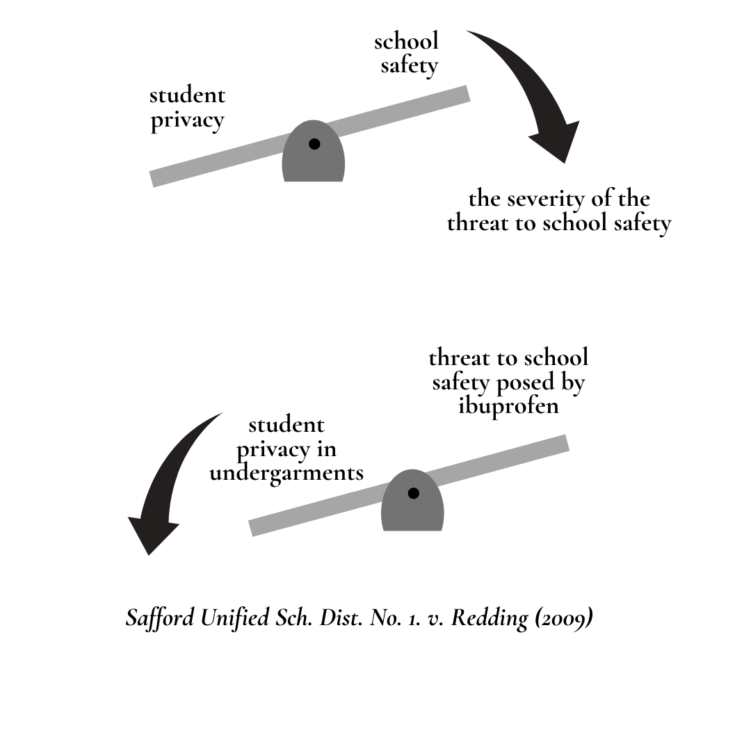
When making decisions, the Court considers the following:
- Consideration 1: Is this a search? Places at a school where students do not have a reasonable expectation of privacy do not enjoy Fourth Amendment protections against unreasonable searches and seizures. Therefore, the Supreme Court would typically not classify gathering of evidence from one of these areas as a search due to the fact it is considered public. The fact that many students do consider their personal possessions such as backpacks, items stored in lockers, and vehicles to be private creates uncertainty in analyzing whether protections against unreasonable searches and seizures apply. Therefore, many school districts have specified where students should not expect to have a reasonable amount of privacy while at school in their policies and procedures. Should there be something a student considers private stored in one of these areas, the Fourth Amendment will not apply.
Example: If a school district outlines that lockers are considered to be school property in their policies, students would not have a reasonable expectation of privacy in their lockers. Therefore, there would be no search and the Fourth Amendment would not apply.
- Consideration 2: Prior to searching, does the school administrator have a reason to believe that the search will produce evidence that the student was breaking a rule or law?
- Consideration 3: Is the school administrator conducting the search in a manner that is reasonably related to the evidence they are looking for? If a student was accused of having a gun in school, a search that would be reasonably related to the evidence or the crime would be in an area where a gun could fit or be carried.
- Consideration 4: Does the student consider this to be excessively intrusive considering their age, gender, and nature of the rule or law they are accused of breaking?
This requires a balancing test. The more privacy that a student would have in an area, the more severe the threat to school safety should be to violate it. In other words, the student’s privacy should not be violated extensively in light circumstances.

Is this a Legal School Search?
Read each scenario in the table below. Indicate if the search is legal or illegal by putting an X in the appropriate space. Provide a brief explanation for your answer. Use the information from the summary of the decision and majority opinion (page 6) to help you complete the chart.
Scenario | Is this a legal search?
Scenario | (Y) | (N)
- School administrators receive an email from a student reporting that a member of the cheerleading squad is selling drugs. They confront her and tell her they are going to check her locker. Then they do so.
Explanation:
- Concerned over recent school shootings, the school board installs metal detectors in all local high schools and requires that all students walk through them to enter the building.
Explanation:
- After one second grader complains of having lost $5 she got from the tooth fairy, teachers ask all of the students in her class to go into the locker room and remove their clothing so they may be strip-searched.
Explanation:

Scenario | Is this a legal search?
Scenario | (Y) | (N)
- Administrators receive a tip that members of two rival gangs plan to fight after school and that many of the members have brought knives and other weapons to school. The principal calls the police, who conduct a search of the students suspected of being members of the rival gangs.
Explanation:
- Concerned about alcohol use at prom, school officials search the vehicles of all students who plan to attend the prom earlier that day in the school parking lot.
Explanation:
- After receiving an anonymous note that a specific student has brought a gun to school, the principal and security guard bring the student to the office, frisk him, and search his locker.
Explanation:

Extension Activity
At Boulder High School in Boulder, Colorado, $60,000 worth of surveillance equipment is able to keep track of students on school grounds, in the halls, and in class. The principal is able to remotely manipulate the cameras to zoom in on individuals or groups of students.
Is this constitutional? Explain your answer.

New Jersey v. T.L.O. (1985)
Argued: March 28, 1984
Re-argued: October 2, 1984
Decided: January 15, 1985
Decision
In a 6-3 decision, the Supreme Court decided that the school’s search of T.L.O. was not unreasonable and was, therefore, constitutional under the Fourth Amendment.
Majority
Writing for the majority of the Court, Justice White explained that the Fourth Amendment’s prohibition on unreasonable searches and seizures does apply to searches of students conducted by school officials. Students in schools do have a right to privacy, but this right is lower than the rights of individuals outside of schools. At the same time, school officials have a significant interest in addressing disciplinary problems quickly. This helps ensure the school environment is conducive to learning and students are safe during the school day.
Although the Fourth Amendment still applies to school officials, the Court decided not to require search warrants or probable cause. Instead, the Court required searches in schools to be “reasonable under the circumstances.” A school official can start a search if there is a reasonable suspicion that the search will uncover evidence that a student broke school rules or committed a crime. At the same time, any search should invade students’ privacy interests no more than is necessary to preserve order.
In this case, Choplick’s search of T.L.O. was constitutional. After she was caught smoking in the bathroom, it was reasonable for him to think there might be cigarettes in her purse. During his initial search, Choplick found rolling papers, which are commonly associated with marijuana use. This provided reasonable suspicion that there might be other evidence linked to drug use in her purse. Because the search was constitutional, the evidence seized during the search and her confession should not be suppressed.

