New Jersey v. T.L.O. / School Searches and Cellphones: Compare and Contrast
According to a poll conducted by Pew Research Center in 2019, 99% of young adults between the ages of 18 and 29 reported that they owned a cellphone. Only 4% of the young adults surveyed own a phone that was not a smart phone. As almost every student possesses a cellphone, determining the reasonableness of searching a cellphone at school becomes difficult.
Using the Venn Diagram below, compare and contrast the search of a backpack or purse, similar to the search in New Jersey v. T.L.O., to the school search of a cellphone by school officials. In each circle, list characteristics regarding the type of search. You may list items that can be found in each, level of privacy, or anything else you can think of. The outer circles will contain characteristics that differ between cellphones and backpacks, while the area where the circles overlap will contain similarities between the two types of searches.

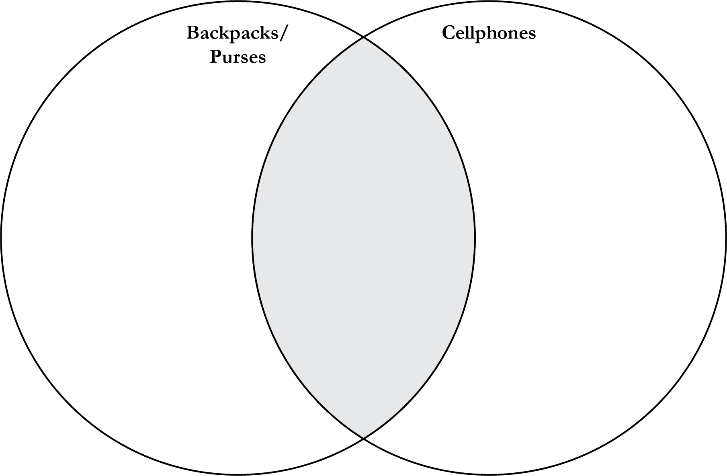
Questions to Consider
- What has changed about students’ possessions since New Jersey v. T.L.O (1985)? What possessions might you and your classmates have that did not exist in schools in 1985?
- What problems might result in applying the precedent from New Jersey v. T.L.O. to students today because of those changes?

