Roe v. Wade / Impact Data Analysis Activity
Years after the Supreme Court’s ruling in Roe v. Wade, the right to an abortion is still controversial in the United States. Many states have continued to pass stricter restrictions on abortion. Consider the following data (current as of May 2019):
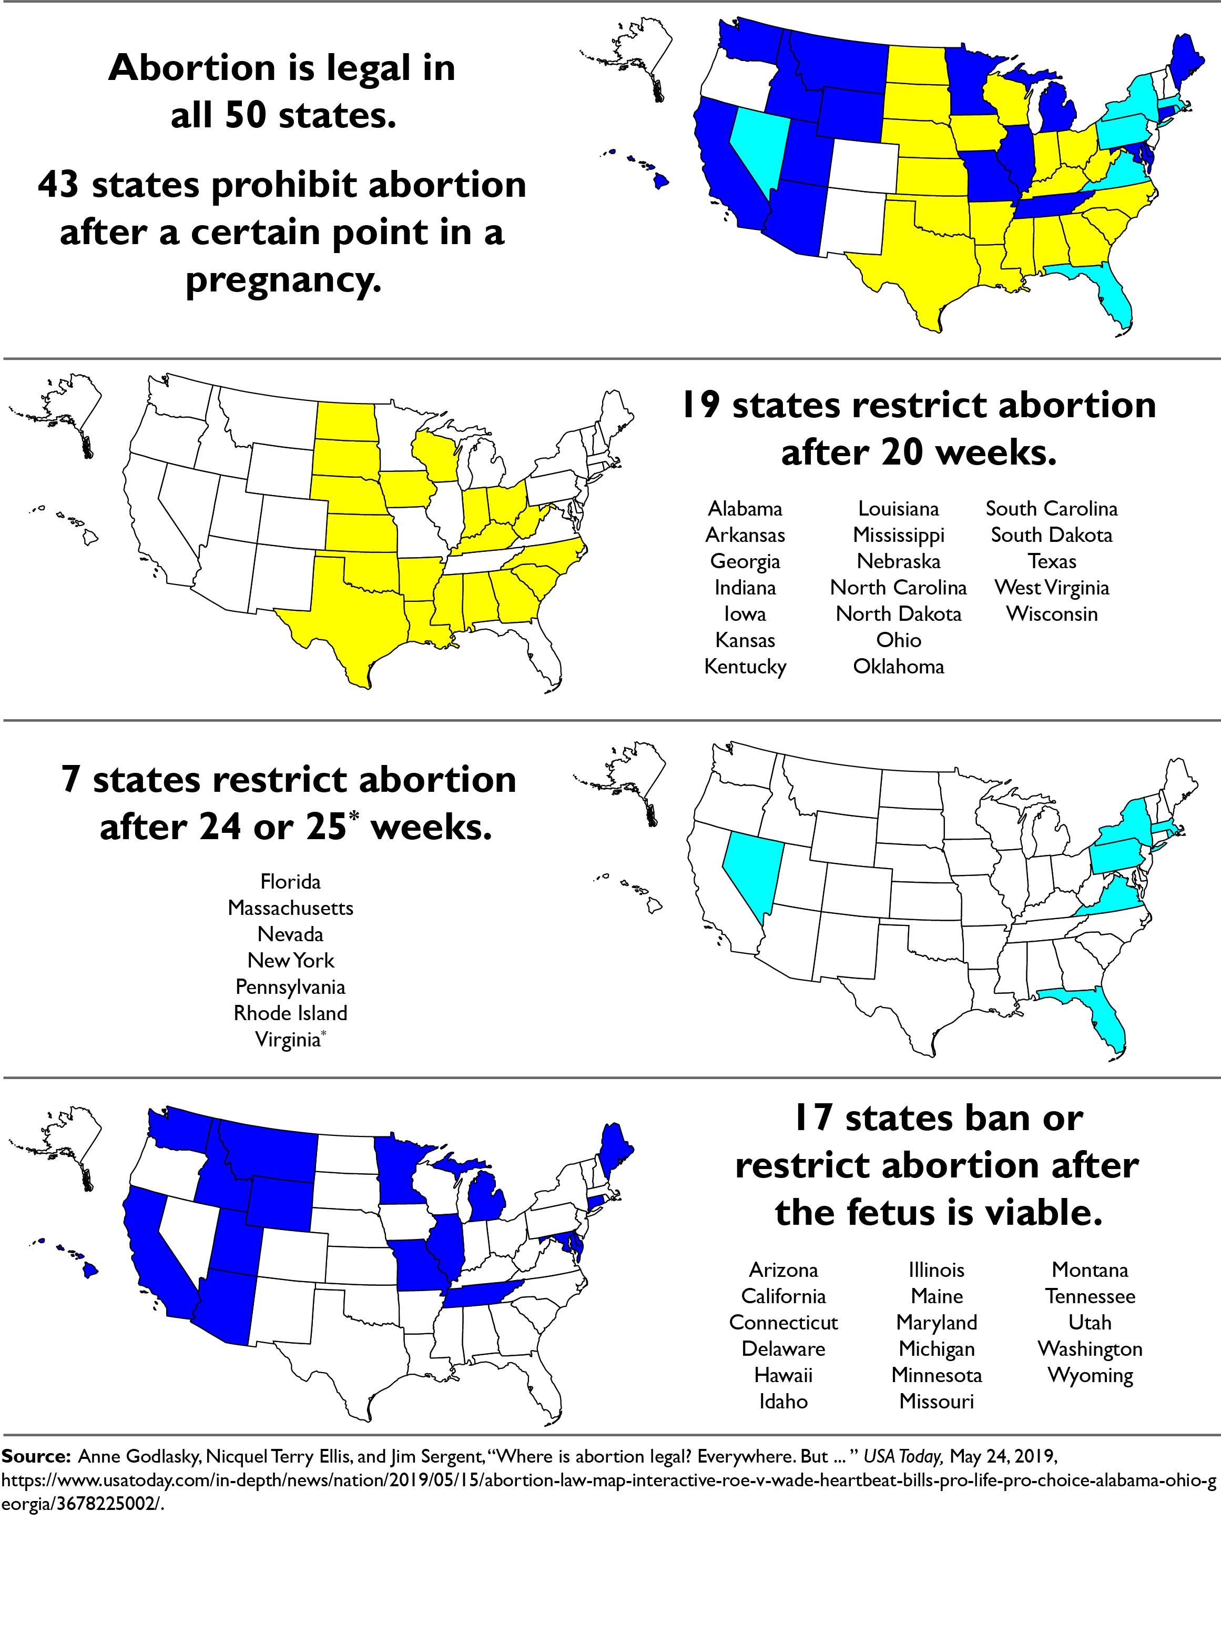
In addition to these restrictions on when an abortion may be performed, some states have passed legislation on the following topics:
- Requiring parental approval if the patient is a minor
- Requiring counseling prior to an abortion
- Requiring a wait period (after counseling)
- Restricting public funding
- Requiring a sonogram (medical procedure)
- Requiring more than one doctor
- Requiring doctors have admitting privileges at a nearby hospital
- Requiring abortions to be performed at a hospital
- Allowing doctors to refuse to perform an abortion
Questions to Consider
- Using the information in the maps on page 1, list your state and two other states that place limits on abortion rights, and briefly explain what those limits are.
State | Limits on the right to an abortion
- What conclusions can you draw from the data in the maps on page 1?
- What does this data tell you about federalism?
- Why do you think states have been able to place the limits on abortion you identified in #1 and still comply with the requirements of Roe v. Wade?
- How might changes in the political landscape lead to challenges to Roe v. Wade?

