Plessy v. Ferguson / Photograph Analysis
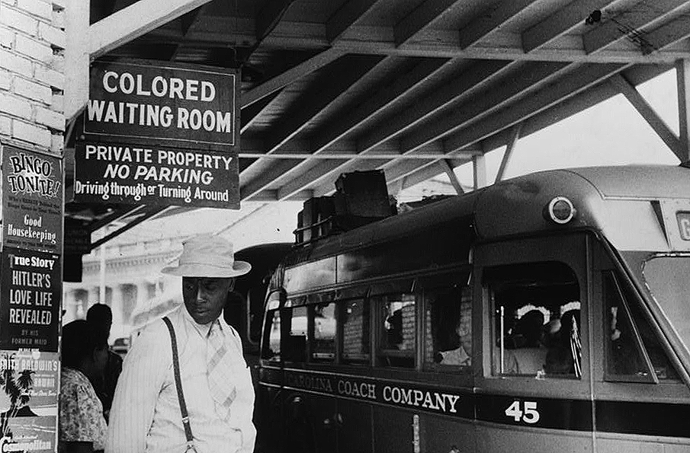
Jack Delano, photographer, “At the bus station in Durham, North Carolina,” Durham, North Carolina, May 1940, Photograph, https://www.loc.gov/item/2017747598/.
Observe
What do you notice first?
What people and objects are shown?
What is the setting?
Reflect
What is happening in this image?
What is significant about when this photo was taken?
How does this image relate to the decision in Plessy v. Ferguson?
Question
What do you still wonder about?
Caption
Write a caption for this image.

