Plessy v. Ferguson / Newspaper Analysis
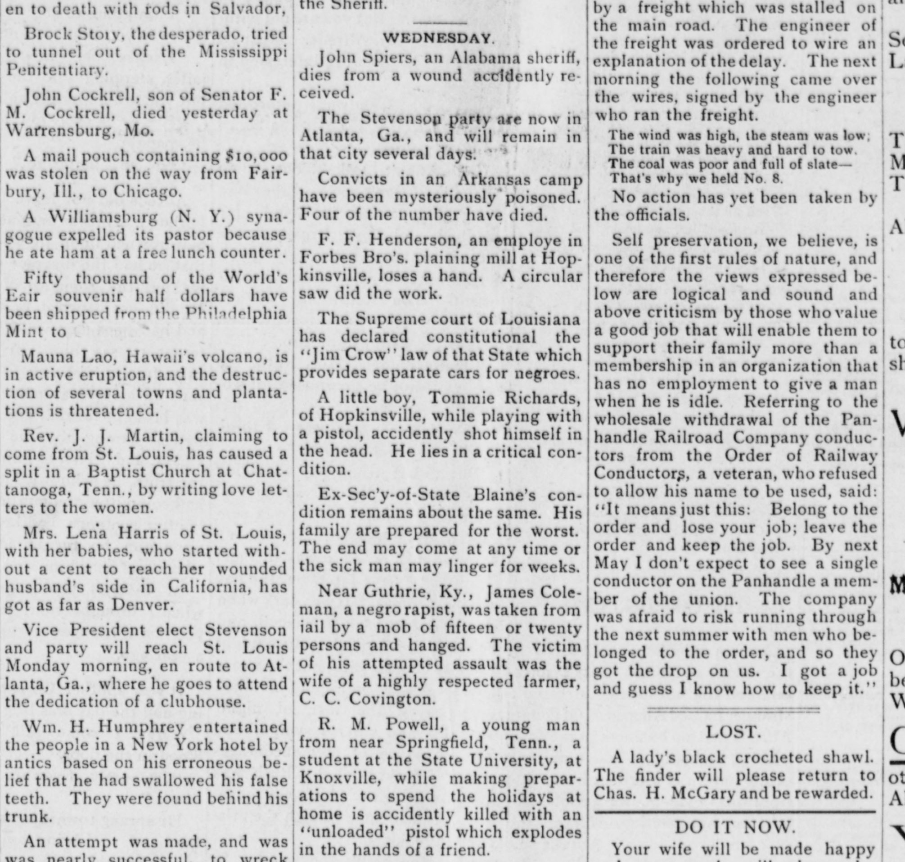
The bee, Earlington, Ky., December 22, 1892, Chronicling America: Historic American Newspapers, Library of Congress, https://chroniclingamerica.loc.gov/lccn/sn87060004/1892-12-22/ed-1/seq-2/.
Observe
- What text do you notice first?
- Where and when was this article published? What is the significance?
- What development in Plessy’s case does this article report?
Reflect
- What can you tell about what was important at the time and place of publication?
- What can you tell about the point of view of the people who wrote and published this article?
Question
- What do you still wonder about this source?

