United States v. Nixon / Principles of Democracy

Directions:
- Read the Background section below.
- Answer the Questions to Consider on page 2.

Background
The United States was set up and operates under democratic principles. These principles include citizen participation, government accountability, equality, free and fair elections, independent judiciary, and several others.
Sometimes, principles of democracy are in conflict with each other. For example, if most people want to pass a law that discriminates against a smaller group of people, should the government reflect the will of the majority of people or protect the basic rights of the minority?
Rule of Law
In countries that are not democratic, leaders make the rules and use those rules to control the people and the country. Rules and decisions can be arbitrary and unpredictable and leaders often do not follow the rules themselves.
In democratic countries, the power of government is limited and rests in the institutions or laws —not in leaders themselves. Laws are applied fairly and equally to everyone. No one is above the law or can ignore the law – not even the highest leaders. This idea is known as the rule of law.
Executive Privilege
Sometimes, presidents want to be able to keep their conversations with their advisers private. They call this executive privilege. They might worry that if information from those conversations were public, it could threaten the security of the country. Presidents might also want to keep their conversations private because they want their advisers to give honest advice, without worrying about being criticized by other people, especially people in the other branches of government. Presidents might say that making good decisions and being a good president requires them to keep certain information private.
Many presidents including (but not limited to) Washington, Jefferson, Jackson, Cleveland, Teddy Roosevelt, Eisenhower, Kennedy, Clinton, George W. Bush, Barack Obama, Donald Trump and, most famously, Nixon all claimed executive privilege when they attempted to withhold information requested by the judiciary or Congress.
The Constitution does not specifically mention executive privilege as a right of presidents, but at times, the courts have recognized and allowed this privilege because it falls under the constitutional principle of the separation of powers. Other times, presidents have lost their claims of executive privilege and had to turn over information requested by the courts or Congress because the constitutional principle of checks and balances says that each branch of government has the ability to restrain the power of the others in certain ways.
Questions to Consider
- What is the link between the rule of law and democracy? Explain your answer.
- How is it the notion of executive privilege supported by the principle of separation of powers?
- How does executive privilege conflict with the principle of checks and balances?
- Read about the other principles of democracy (see page 4). Which other principles might come into conflict with the use of executive privilege? Which might support it?
- Overall, do you believe the use of executive privilege is in line with the principles of democracy? Support your answer.

Principles of Democracy

Accepting the Results of Elections
In elections, there are winners and losers. Sometimes, losers refuse to accept that they lost an election. In a democracy, there must be a peaceful transfer of power from one set of leaders to the next. So if the election really was “free and fair,” then everyone should accept the results.
 | Accountability  In a democracy, people who run the government must be responsible. That means that they should make decisions that are good for all the people whom they represent. They should act in ways that benefit everyone, not just their friends or themselves. They should be held accountable for their decisions and actions.
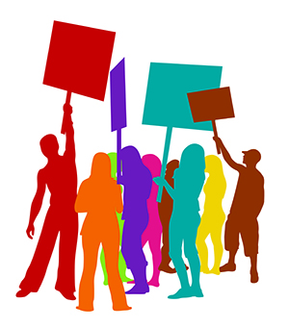  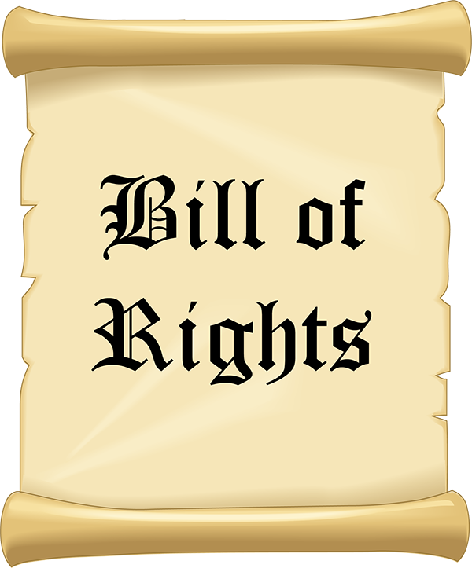 | Bill of Rights  Most democratic countries have a written list of rights to protect the people who live there. Often, these lists are called a “Bill of Rights” and they are part of the country’s constitution. Usually, a “Bill of Rights” limits government from restricting people’s freedom of speech, freedom of press, right to a fair trial, or other freedoms and rights. The courts in democratic countries have the power to enforce these rights.
Civic Participation
Democracies require community member participation in government. Participation is more than just a right—it is a duty. There are lots of different kinds of participation including: voting, debating issues, protesting against the government, paying taxes, and serving on juries. Community members should be able to become informed and attend government meetings. They should be able to join community groups. Community members should be free to run for elected positions themselves. Citizen participation builds a stronger democracy.

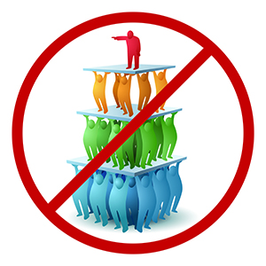 | Control of the Abuse of Power  When government officials use their power to help themselves or their friends, they are abusing their power. This is called corruption. Officials are also corrupt if they use government money illegally. Democratic governments must control the abuse of power. Usually, democratic governments divide power and responsibility into different branches or agencies to avoid the abuse of power by one official. Independent agencies and neutral courts should punish government officials who abuse power or who are corrupt.
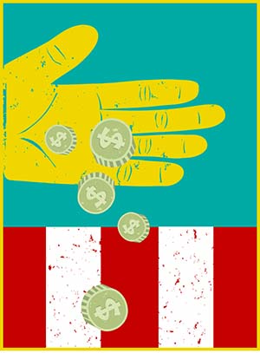 | Economic Freedom  People in a democracy must have some kind of economic freedom. This means that the government should allow people to own property and businesses. People should be able to choose their own work and have the ability to join labor unions. Free markets should exist in a democracy and the government should not totally control the economy.
 | Equality  In a democracy, all people should be treated fairly no matter their race, religion, ethnicity, gender, or sexual orientation and they should have the same social, political, and economic opportunities. Individuals and groups can have different cultures, personalities, languages, and beliefs, but everyone should be treated equally before the law and have equal protection under the law.

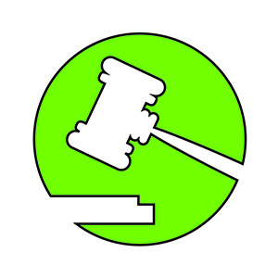  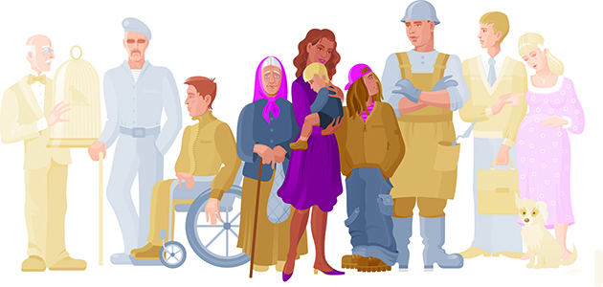 | Human Rights  All democracies try to value human life and dignity as well as respect and protect the human rights of its citizens. Examples of human rights include:  Religion: Everyone has the right to freedom of thought, belief, and religion. This right includes freedom to change his or her religion and to worship alone or in community with others. It also includes the right to not hold religious beliefs.  Speech: Everyone has the right to freedom of opinion and expression. This right includes freedom to hold opinions without interference and to seek and to share information with others.  Assembly: Everyone has the right to organize peaceful meetings or to take part in meetings in a peaceful way. It is undemocratic to force someone to belong to a political group or to attend political meetings or rallies.
Independent Judiciary
In democracies, courts and the legal system should be fair. Judges and the judicial branch should act without influence or control from the other branches of government. They should also not be corrupt. An independent judiciary is important to a just and fair legal system.
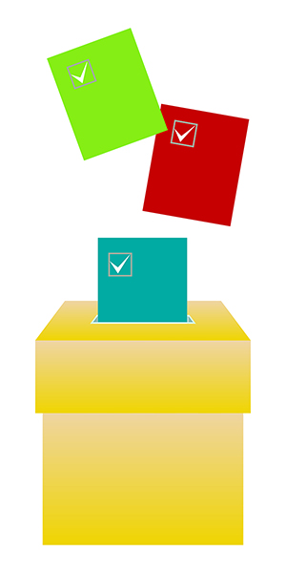 | Multi-Party Systems  To have a democracy, more than one political party must participate in elections and play a role in government. With a multi-party system, there is organized opposition to the party that wins the election. When a government has multiple parties, there are different points of views on issues. Voters also have a choice of different candidates, parties, and policies. When a country only has one party, it is usually a dictatorship.

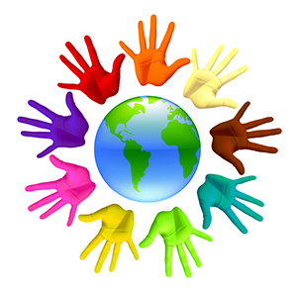 | Political Tolerance  Democratic societies should be politically tolerant. This means that while one political group rules the government, the rights of other groups are still protected. A democratic society usually has people from many cultures, races, religions, and ethnic groups who have different viewpoints. People who are not in power have the right to organize and speak out. Political minorities are sometimes called “the opposition” because they may have ideas that are different from the majority in power. If the majority tries to take away the rights of people in minority groups or with minority viewpoints, then they also take away democracy.
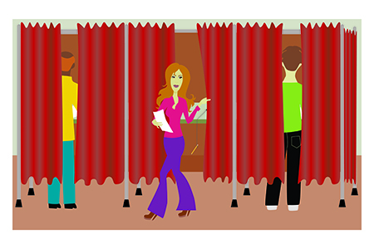 | Regular Free and Fair Elections  One way citizens express their wishes is by electing officials to represent them in government. In a democracy, there should be elections every few years. The people should choose elected officials in a free and fair manner. Most adult citizens should have the right to vote and to run for office—regardless of their race, gender, ethnicity, and level of wealth. There should not be any obstacles that make it hard for people to vote.
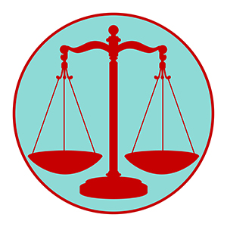 | The Rule of Law  In a democracy, people know about the rules and laws. No one is above the law. Kings, presidents, police officers, and military officers must obey laws, just like anyone else. Anyone who breaks a law should be punished. In democracies, people can trust that laws are enforced in ways that are fair, equal, and consistent.
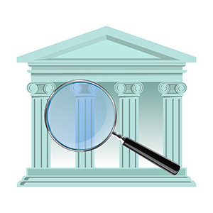 | Transparency  In democracies, people should be able to keep an eye on their government. They should be able to ensure their government is making decisions and taking actions they want. People must be able to access information about what decisions are being made, who is making them, and why. Transparent governments hold public meetings and make information about its actions available to the media and the people. Transparency leads to better accountability and better democracies.

