United States v. Nixon / Cartoon Analysis
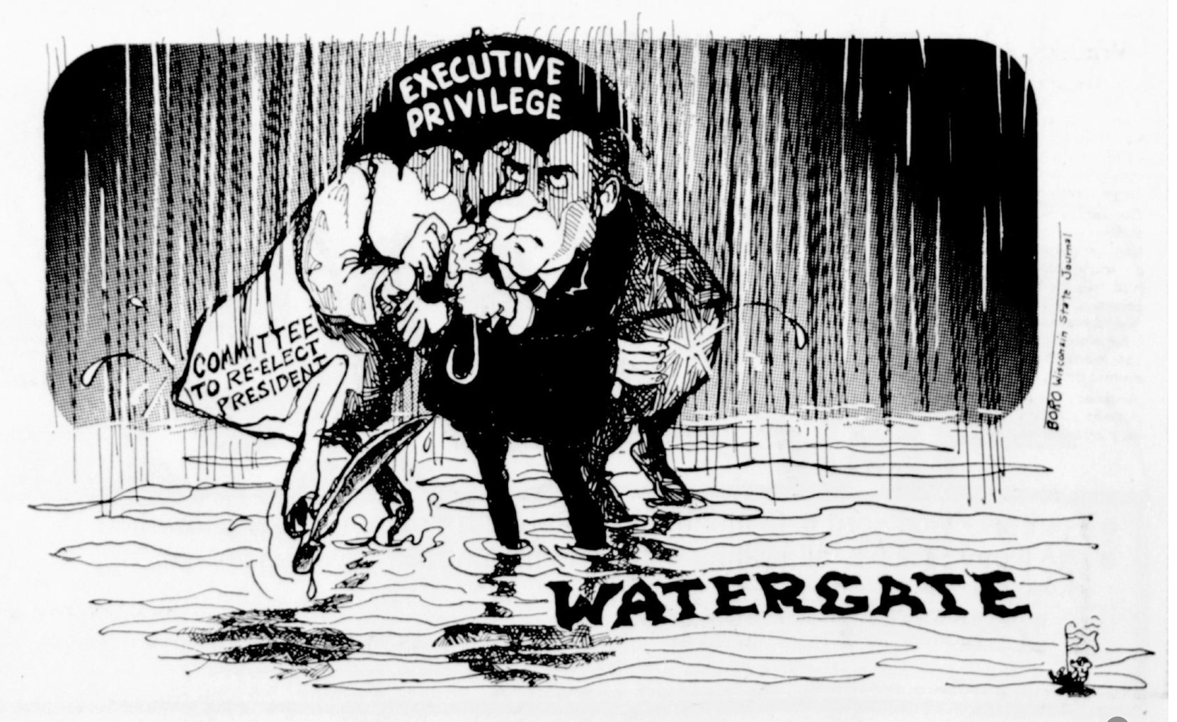
Source: Leonard Borozinki, State Journal (Reprinted with permission)
Background
“Executive privilege” is the concept that the president can withhold certain information from Congress or the courts. Throughout history, Presidents have claimed executive privilege if they see a need to protect military, diplomatic, or national security secrets. President may invoke executive privilege when the sharing of certain conversations or information may harm national interests.
Observe
- What people and objects are shown? Make a list of what you see in the cartoon including captions.

- What is the setting?
Reflect
- What is happening in this image?
- What significance do the labels and symbols have?
Evaluate the Message
- In your opinion, what is the cartoonist’s message? What elements of the cartoon give you that impression?
- Do you agree with the point of view and message of the cartoonist? Why or why not?
Question
- What do you still wonder about?

