McCulloch v. Maryland / Federalism Activity
Directions:
- Read the Background section below.
- Complete the What Type of Power is It? activity (page 2).

Background
Federalism is a major principle of American government. In a federal system of government, there are three levels of government: national, state, and local. Government power is divided between and sometimes shared by the different levels.
The national government generally has power over issues of national concern. The states generally have power over issues of state concern. For example, the national government has power over the defense of the nation because defense must be coordinated for the entire nation. The states have the power to issue drivers’ licenses because driving rules and conditions differ from state to state. The enumerated or delegated powers are specifically listed as powers of national government in the Constitution. You can find these powers written in Article I, Section 8 of the U.S. Constitution (page 3).
The state powers are often called reserved powers. These powers are not listed in the U.S. Constitution. The 10th Amendment states that if a power is not specifically given to the national government in the U.S. Constitution, it is reserved to the states or the people.
Some powers are shared by the national and the state levels of government. These are called concurrent powers. For example, the national, state, and local governments are all permitted to tax. This allows all levels of government to have the money they need to provide services.

What Type of Power is It?
Based on these ideas, examine the list of government powers below and say whether you think each one is an enumerated (national) power, reserved (state) power, or concurrent (shared) power. Place each power in the appropriate section of the Venn Diagram. Be prepared to explain your answer.
- Defend the country | - Protect rights
- Issue drivers’ licenses | - Make laws for the environment
- Levy taxes | - Coin money
- Create marriage laws | - Conduct elections
- Impose tariffs | - Punish law breakers
- Declare war | - Create standards for schools
- Make agreements with other countries

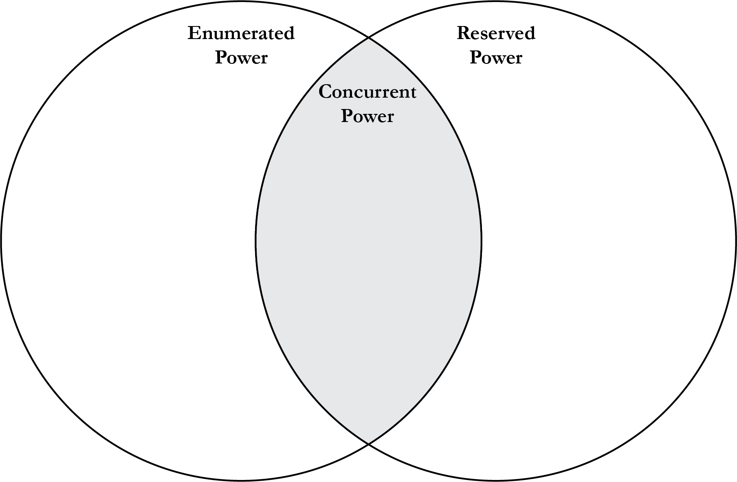
Article I, Section 8 of the U.S. Constitution
Enumerated Powers of Congress
The Congress shall have Power To lay and collect Taxes, Duties, Imposts and Excises, to pay the Debts and provide for the common Defence and general Welfare of the United States; but all Duties, Imposts and Excises shall be uniform throughout the United States;
To borrow Money on the credit of the United States;
To regulate Commerce with foreign Nations, and among the several States, and with the Indian Tribes;
To establish an uniform Rule of Naturalization, and uniform Laws on the subject of Bankruptcies throughout the United States;
To coin Money, regulate the Value thereof, and of foreign Coin, and fix the Standard of Weights and Measures;
To provide for the Punishment of counterfeiting the Securities and current Coin of the United States;
To establish Post Offices and post Roads;
To promote the Progress of Science and useful Arts, by securing for limited Times to Authors and Inventors the exclusive Right to their respective Writings and Discoveries;
To constitute Tribunals inferior to the supreme Court;
To define and punish Piracies and Felonies committed on the high Seas, and Offences against the Law of Nations;
To declare War, grant Letters of Marque and Reprisal, and make Rules concerning Captures on Land and Water;
To raise and support Armies, but no Appropriation of Money to that Use shall be for a longer Term than two Years;
To provide and maintain a Navy;
To make Rules for the Government and Regulation of the land and naval Forces;
To provide for calling forth the Militia to execute the Laws of the Union, suppress Insurrections and repel Invasions;
To provide for organizing, arming, and disciplining, the Militia, and for governing such Part of them as may be employed in the Service of the United States, reserving to the States respectively, the Appointment of the Officers, and the Authority of training the Militia according to the discipline prescribed by Congress;
To exercise exclusive Legislation in all Cases whatsoever, over such District (not exceeding ten Miles square) as may, by Cession of Particular States, and the Acceptance of Congress, become the Seat of the Government of the United States, and to exercise like Authority over all Places purchased by the Consent of the Legislature of the State in which the Same shall be, for the Erection of Forts, Magazines, Arsenals, dock-Yards and other needful Buildings;--And
To make all Laws which shall be necessary and proper for carrying into Execution the foregoing Powers and all other Powers vested by this Constitution in the Government of the United States, or in any Department or Officer thereof.

