Marbury v. Madison /So, What’s the Big Idea???
Assume you are on a social media site, and you are in a group called “The Supreme Court Rules!” Read the following post asking for homework help and the replies from other students trying to be helpful.
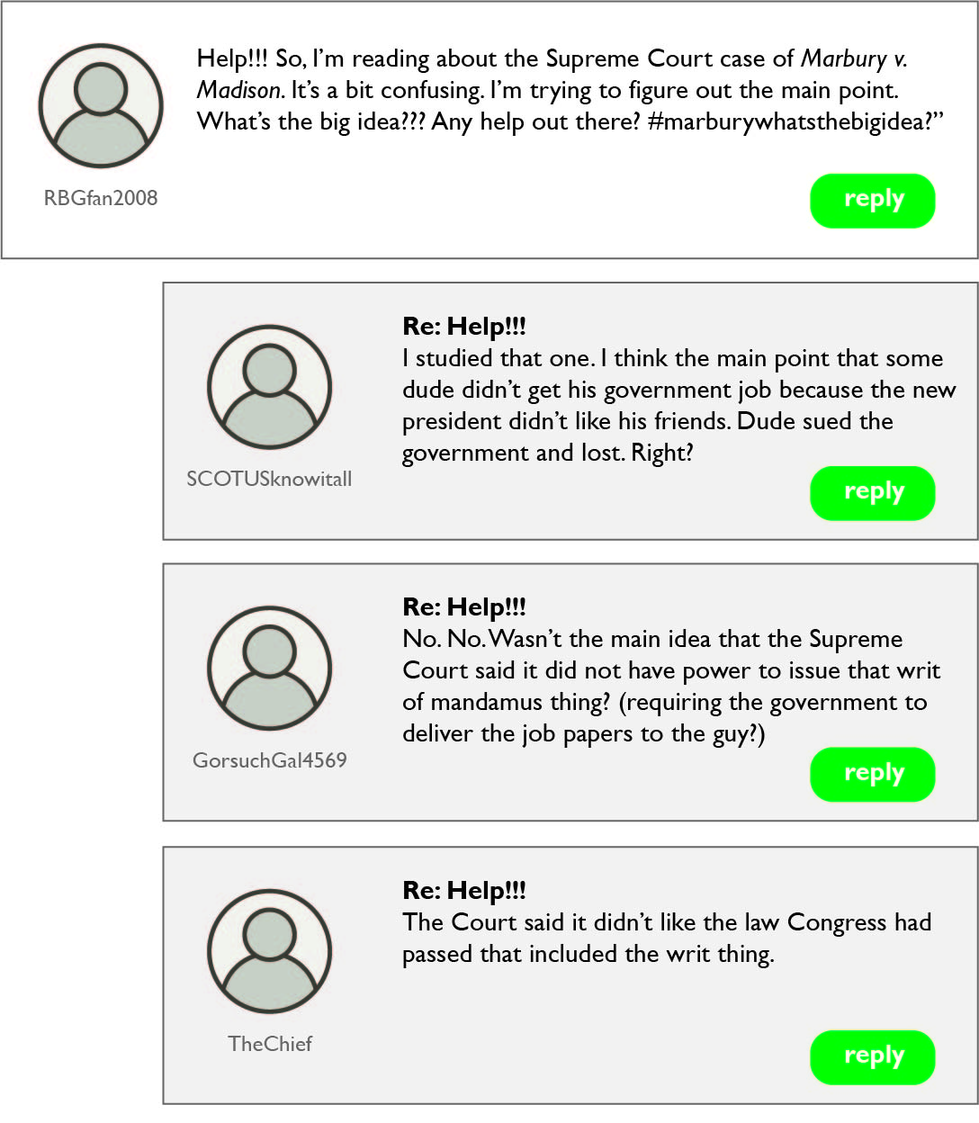

Now it is your turn to demonstrate what you learned about the case of Marbury v. Madison. The people who posted above were not totally wrong, but they did not get the main point of the decision. Set the record straight and write your reply.


