Marbury v. Madison / Cartoon Analysis
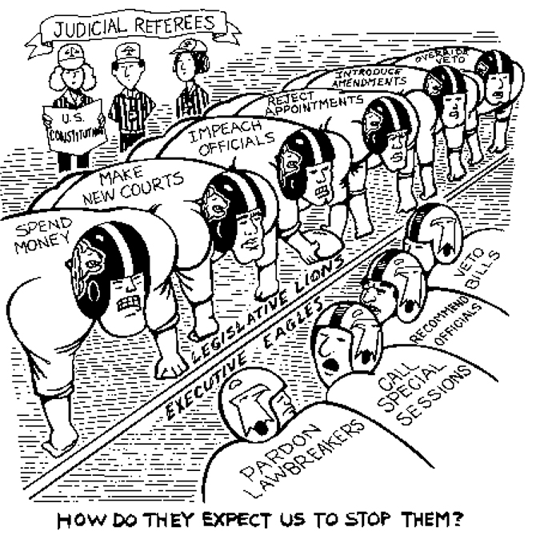
Observe
What people and objects are shown? Make a list of what you see in the cartoon including captions.
- Which of the items on the list from Question 1 are symbols? What does each symbol stand for?
What is the setting?
Are there any objects or people that seem to be exaggerated? If so, why do you think the artist exaggerated?
Reflect
What is happening in this image?
Evaluate the Message
In your opinion, what is the cartoonist’s message? What elements of the cartoon give you that impression?
Do you agree with the point of view and message of the cartoonist? Why or why not?
Question
What do you still wonder about?

