Korematsu v. United States / A Question of Loyalty
Directions:
- Read the Background information.
- Read the Loyalty Questionnaire (page 2).
- Answer the Questions to Consider (page 7).
- Complete the Extension Activity if your teacher assigns it (page 8).

Background
Justice Black’s majority opinion in Korematsu v. United States never questioned the judgment of military authorities that there were disloyal members of the Japanese and Japanese American population. The opinion also never questioned the military’s claim that they could not quickly determine the number of disloyal people.
We cannot reject as unfounded the judgment of the military authorities and of Congress that there were disloyal members of that population, whose number and strength could not be precisely and quickly ascertained.
Nonetheless, while in the internment camps, a loyalty questionnaire was distributed. The loyalty questionnaire had two purposes: the first was to determine who could have been eligible to serve in the military and the second goal was to determine who might require further confinement in the camps. Justice Black made reference to this questionnaire in his decision:
That there were members of the group who retained loyalties to Japan has been confirmed by investigations made subsequent to the exclusion. Approximately five thousand American citizens of Japanese ancestry refused to swear unqualified allegiance to the United States and to renounce allegiance to the Japanese Emperor.
While accepting the military’s claim that the entire group had to be confined because they could not quickly ascertain who was loyal and disloyal, Justice Black used the numbers from this simple questionnaire to support the military’s opinion that some people of Japanese origin were disloyal.
Putting aside this contradiction in logic, an examination of the loyalty questionnaire reveals the difficulties it must have presented for the internees and their families.

Loyalty Questionnaire
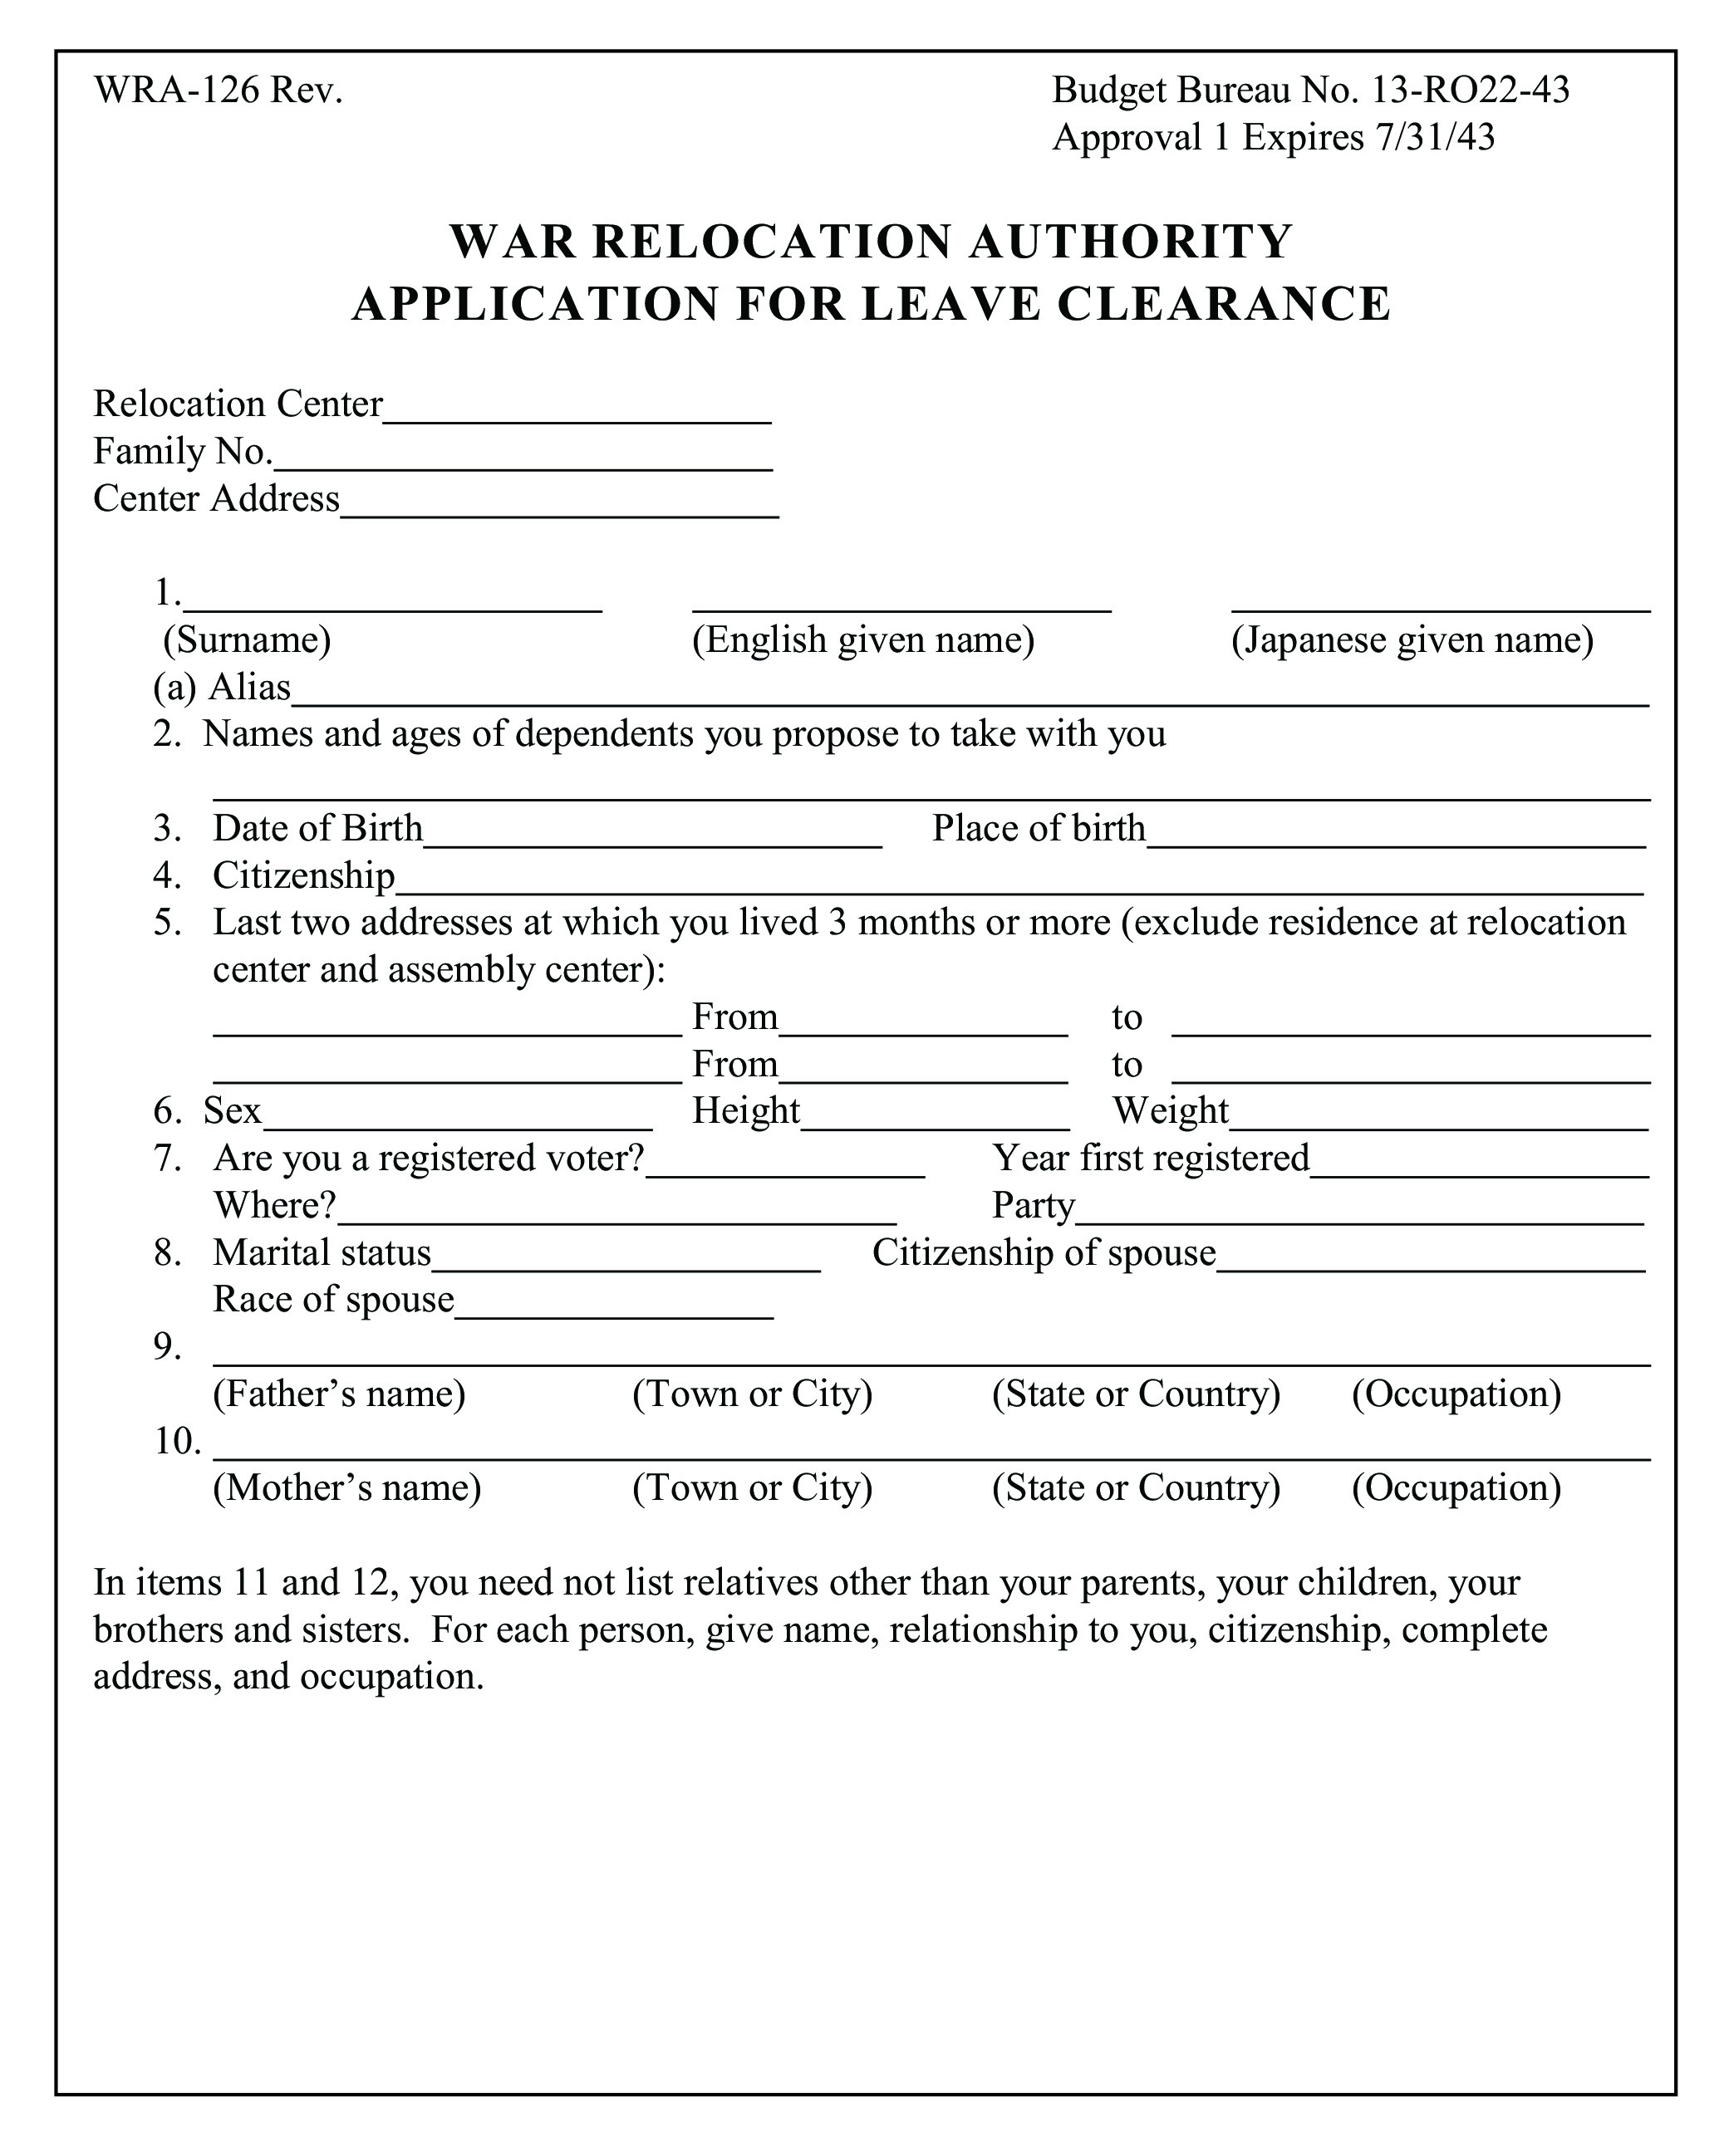

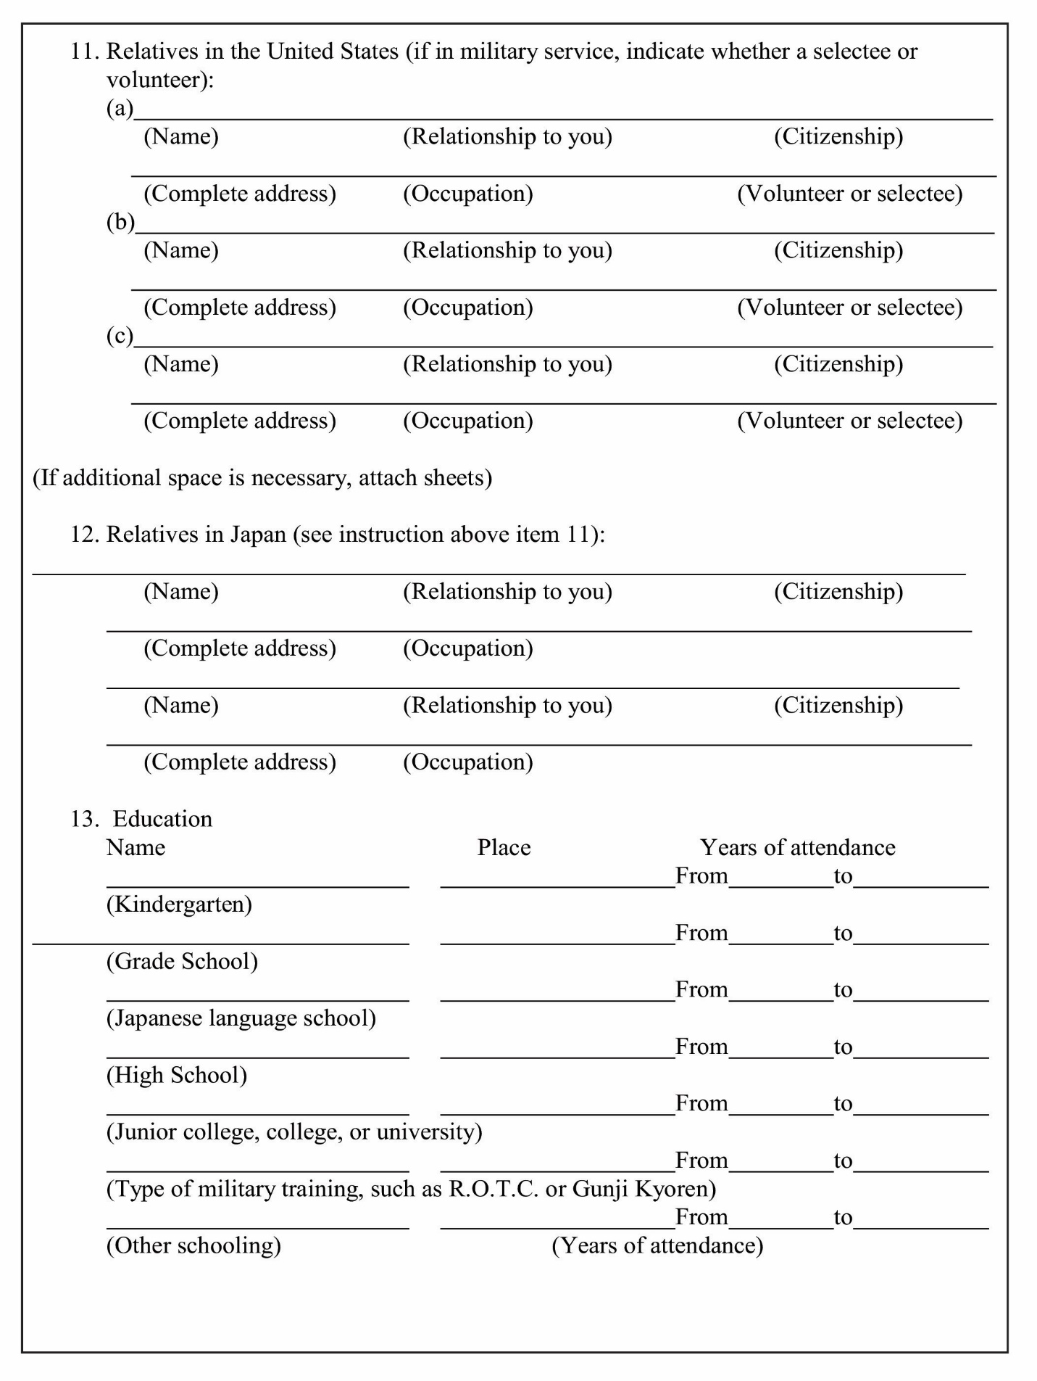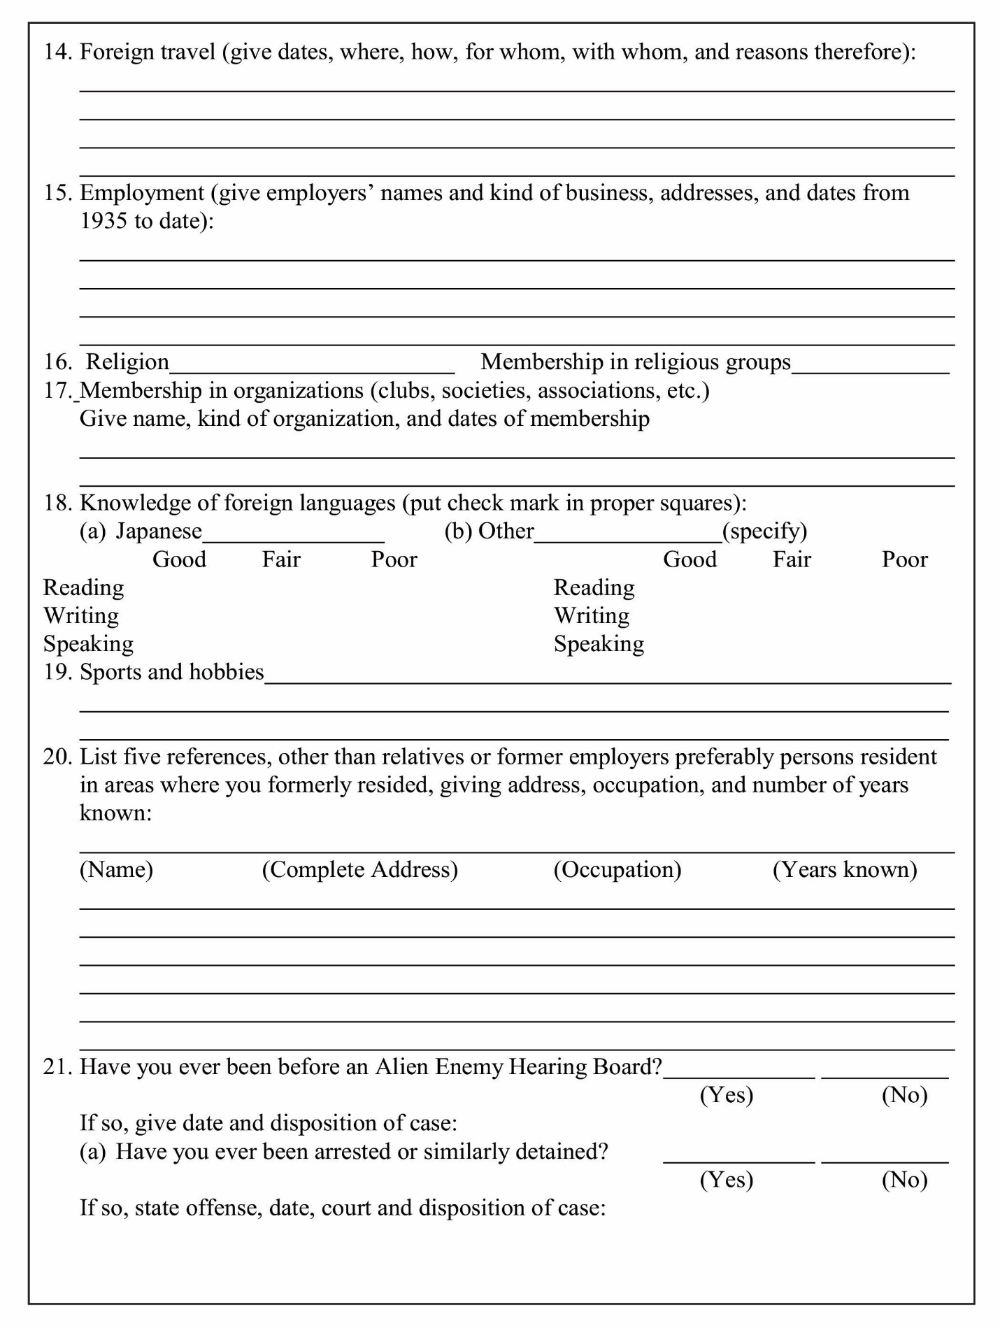

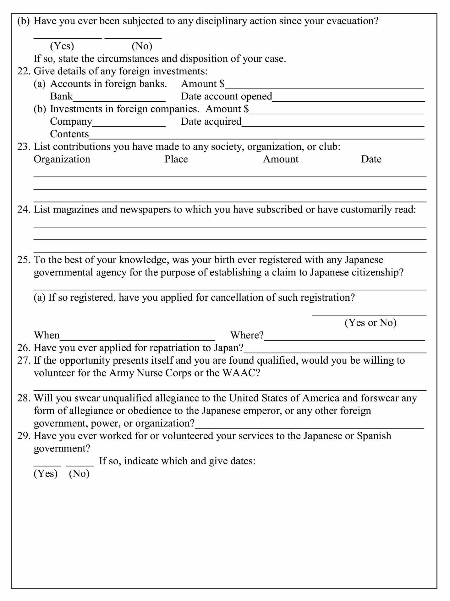

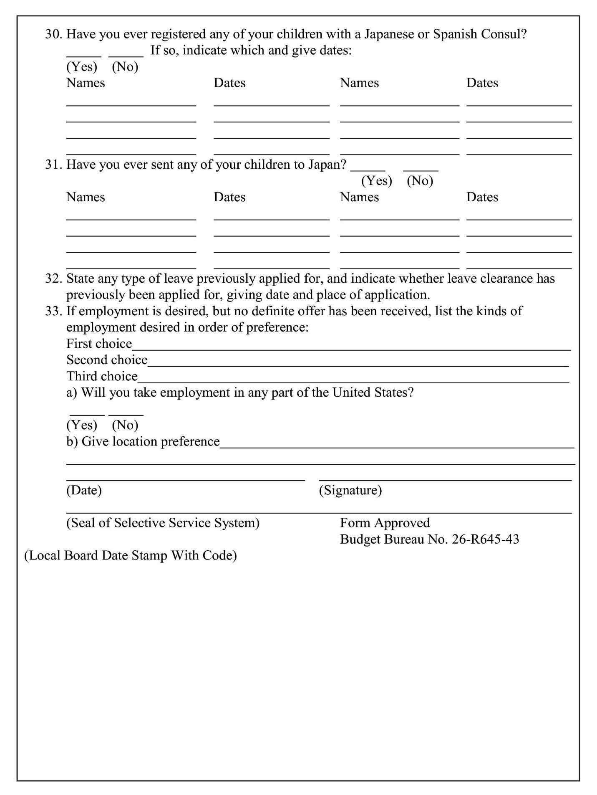
Questions to Consider
- Which questions on the form do you think are relevant and important to determine a person’s loyalty to the United States? Explain.
- Which questions on the form do you think are irrelevant or not important to determine a person’s loyalty to the United States? Explain.
- Look carefully at questions 27 and 28. These were given special attention by the military authorities and are referred to in Justice Black’s opinion. People who answered “no” to these questions were considered to be disloyal.
  - Can you think of reasons why a person would answer “no” to question 27 other than disloyalty?
  - First generation Japanese immigrants (Issei) were unable to obtain American citizenship. How might this have complicated their ability to answer question 28?
  - Are there other challenges or issues you see with these questions?
- What surprised you about the questionnaire?

Extension Activity
Visit the Smithsonian’s A More Perfect Union website to read what the internees thought about the questionnaire and to see an original copy of it. (https://amhistory.si.edu/perfectunion/non-flash/loyalty_questionnaire.html)

