Korematsu v. United States / Primary Source Analysis
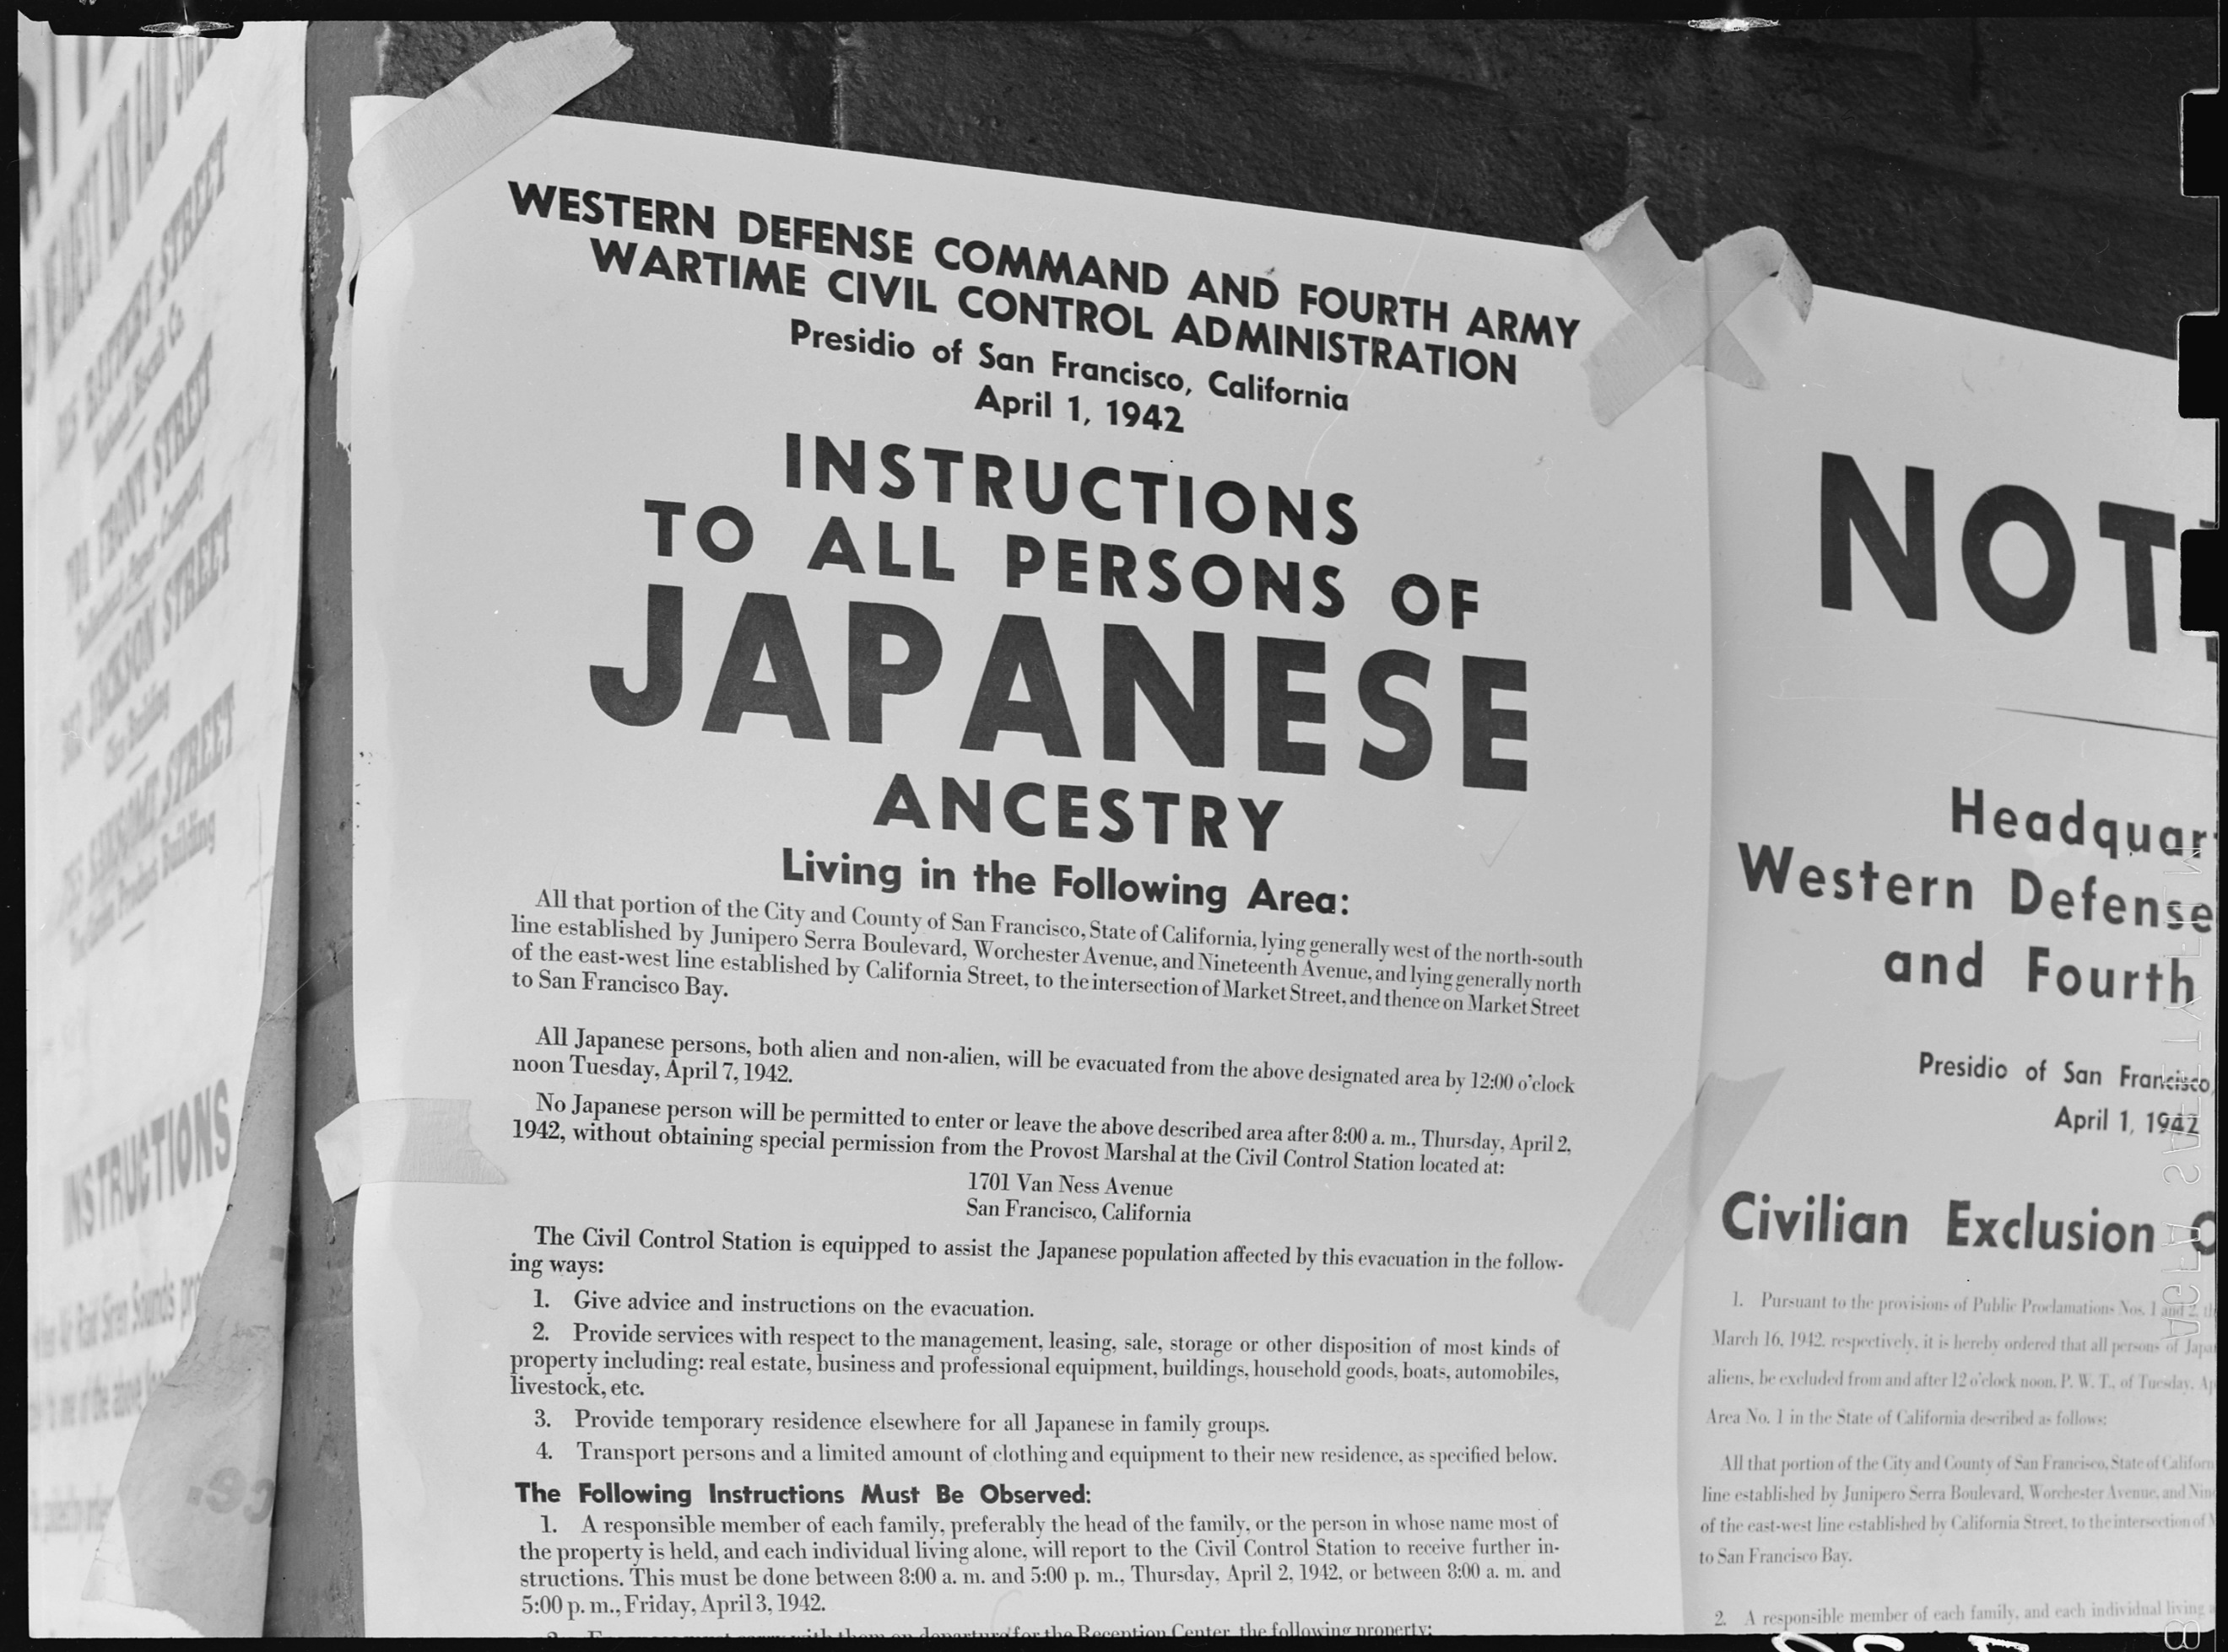
Exclusion Order posted at First and Front Streets directing removal of persons of Japanese ancestry from the first San Francisco section to be affected by the evacuation. Created by the Department of the Interior’s War Relocation Authority.
Source: National Archives, https://catalog.archives.gov/id/536017 .
Observe
What do you notice first?
How is the text and other information arranged on the page?
What is the significance of the date this order was posted?
What do you notice about the date of the order and the date of the evacuation? Why might this be important?
Reflect
Who do you think was the audience for this poster?
What can you tell about what was important at the time this order was posted?
Question
What do you still wonder about?

