Korematsu v. United States / Photograph Analysis
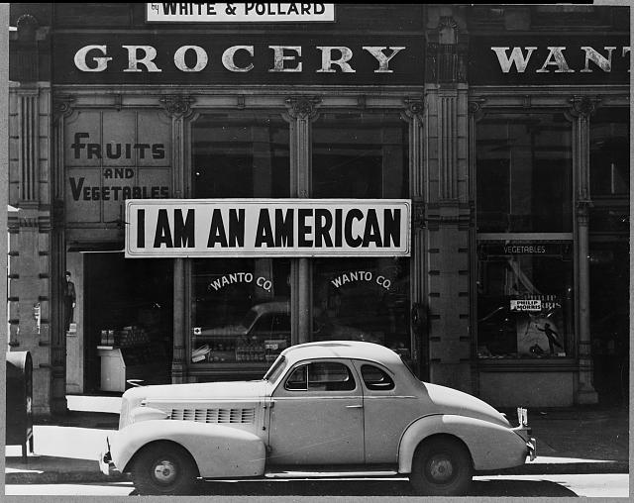
Oakland, California. A large sign reading “I am an American” placed in the window of a store, at Eighth and Franklin streets, on December 8, 1941.
Source: Dorothea Lange, photographer, “I am an American,” Oakland, California, March 1942, Photograph, https://www.loc.gov/item/2004665381/.
Observe
What do you notice first?
What people and objects are shown?
What is the setting?
Reflect
What is happening in this image?
What is significant about when this photo was taken?
Question
What do you still wonder about?
Caption
Write a caption for this image.

