Korematsu v. United States / Cartoon Analysis
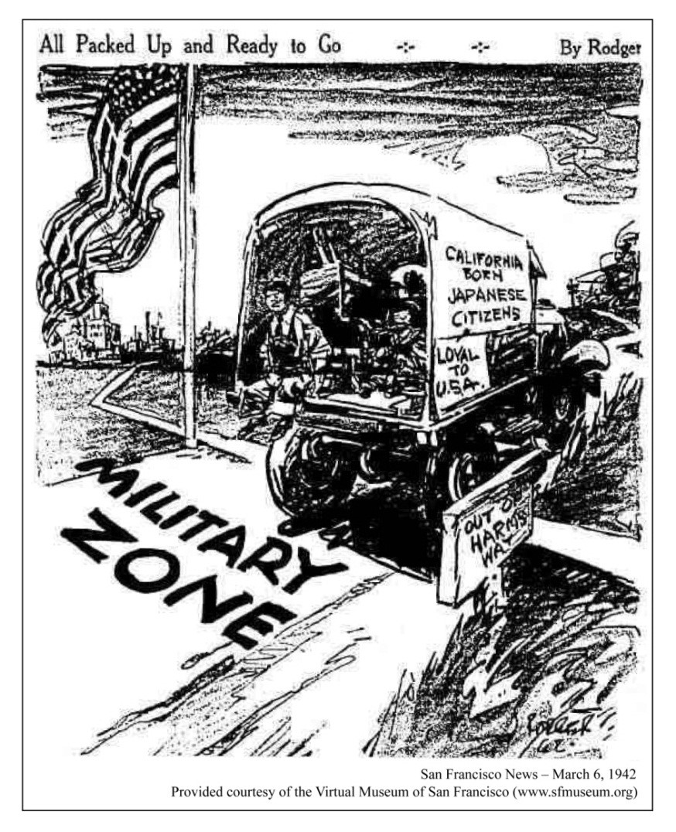
Observe
What people and objects are shown? Make a list of what you see in the cartoon including captions and labels.
What is the setting?
Are there any objects or people that seem to be exaggerated? If so, why do you think the artist exaggerated?
Reflect
What is happening in this image?
What is significant about the date this cartoon was published (March 6, 1942)?
What does this image remind you of? Can you think of events or news stories that are similar? Do these images or issues relate to your community in any way?
Evaluate the Message
In your opinion, what is the cartoonist’s message? What elements of the cartoon give you that impression?
Do you agree with the point of view and message of the cartoonist? Why or why not?
What, if anything, should be done about the problem portrayed in the cartoon? Who should do it?
Question
What do you still wonder about?

