Hazelwood v. Kuhlmeier / Cartoon Analysis
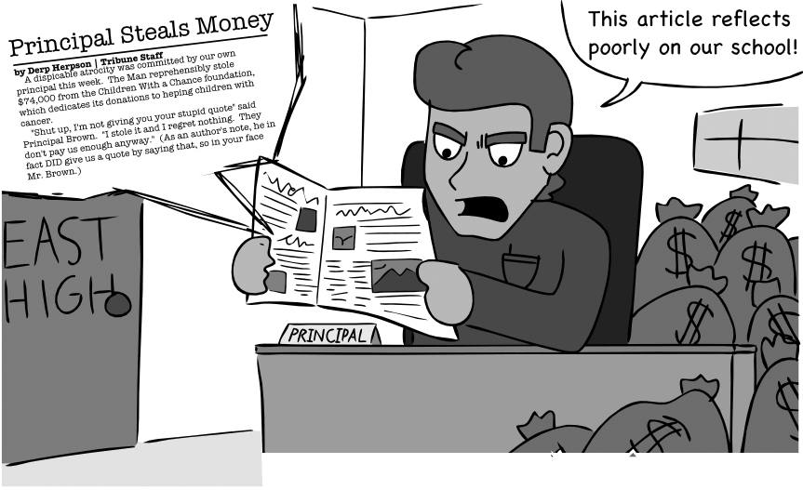
Source: Cartoon from Rio Mirada, the student newspaper of Rio Americano High School in Sacramento, CA (https://www.riomirada.com/uncategorized/2013/03/09/student-press-rights-need-defending/). Reprinted with permission.
In 2004, a financial scandal changed the lives of students attending a Roslyn High School in Roslyn Heights, New York. Students writing for the student newspaper, The Hilltop Beacon, investigated and produced an article that led to the exposure of the embezzlement of over 11 million dollars in funds by school officials. Those two school officials were indicted and later served lengthy prison sentences. The New York Times published an article about the student editors. In 2020, HBO released Bad Education, a movie based on the events at Roslyn High School.
The cartoon above was created by students at a California high school and ran in the student newspaper. The article that accompanies it, Student Press Rights Need Defending, cites several attempts by administrators across the country to stop high school newspapers from exposing malfeasance (wrongdoing) by their own school districts.
Observe
What people and objects are shown? Make a list of what you see in the cartoon including captions.
What is the setting?
Are there any objects or people that seem to be exaggerated? If so, why do you think the artist exaggerated?
Evaluate the Message
In your opinion, what is the cartoonist’s message? What elements of the cartoon give you that impression?
Do you agree with the point of view and message of the cartoonist? Why or why not?
Questions to Consider
Has the time come for state legislatures to effectively overturn the decision made in Hazelwood v. Kuhlmeier?
What potential problems do you foresee occurring if students were given the same First Amendment protections that professional journalists enjoy?
The students producing The Hilltop Beacon were able to get their article published in The New York Times, a national publication. To what extent do you believe student speech is already protected?

Rebekah Rombom, “On Top of the News at Roslyn High,” New York Times, June 27, 2004, https://www.nytimes.com/2004/06/27/nyregion/on-top-of-the-news-at-roslyn-high.html.

