Gideon v. Wainwright / Right to Counsel: Quantitative Analysis
Under the U.S. system of government, each state has the power to write their own laws and create their own justice system. State legislatures provide funding and pass their own legislation affecting the justice system. The Supreme Court decision in Gideon v. Wainwright (1963) requires states to provide counsel for the defense in all criminal felony proceedings upon request by the defendant (at no cost), but it does not dictate how states should do so. Some states have a public defender system with defense attorneys in a public defender’s office. Other states rely upon individual courts contracting with private attorneys in the community to provide this service. The amount of money provided to pay for these services varies tremendously among the states and this impacts the decisions made to defend the accused in many ways.
Consider the impact of average state spending on the rights of defendants to receive effective assistance of counsel. For each graph, answer the questions that follow:
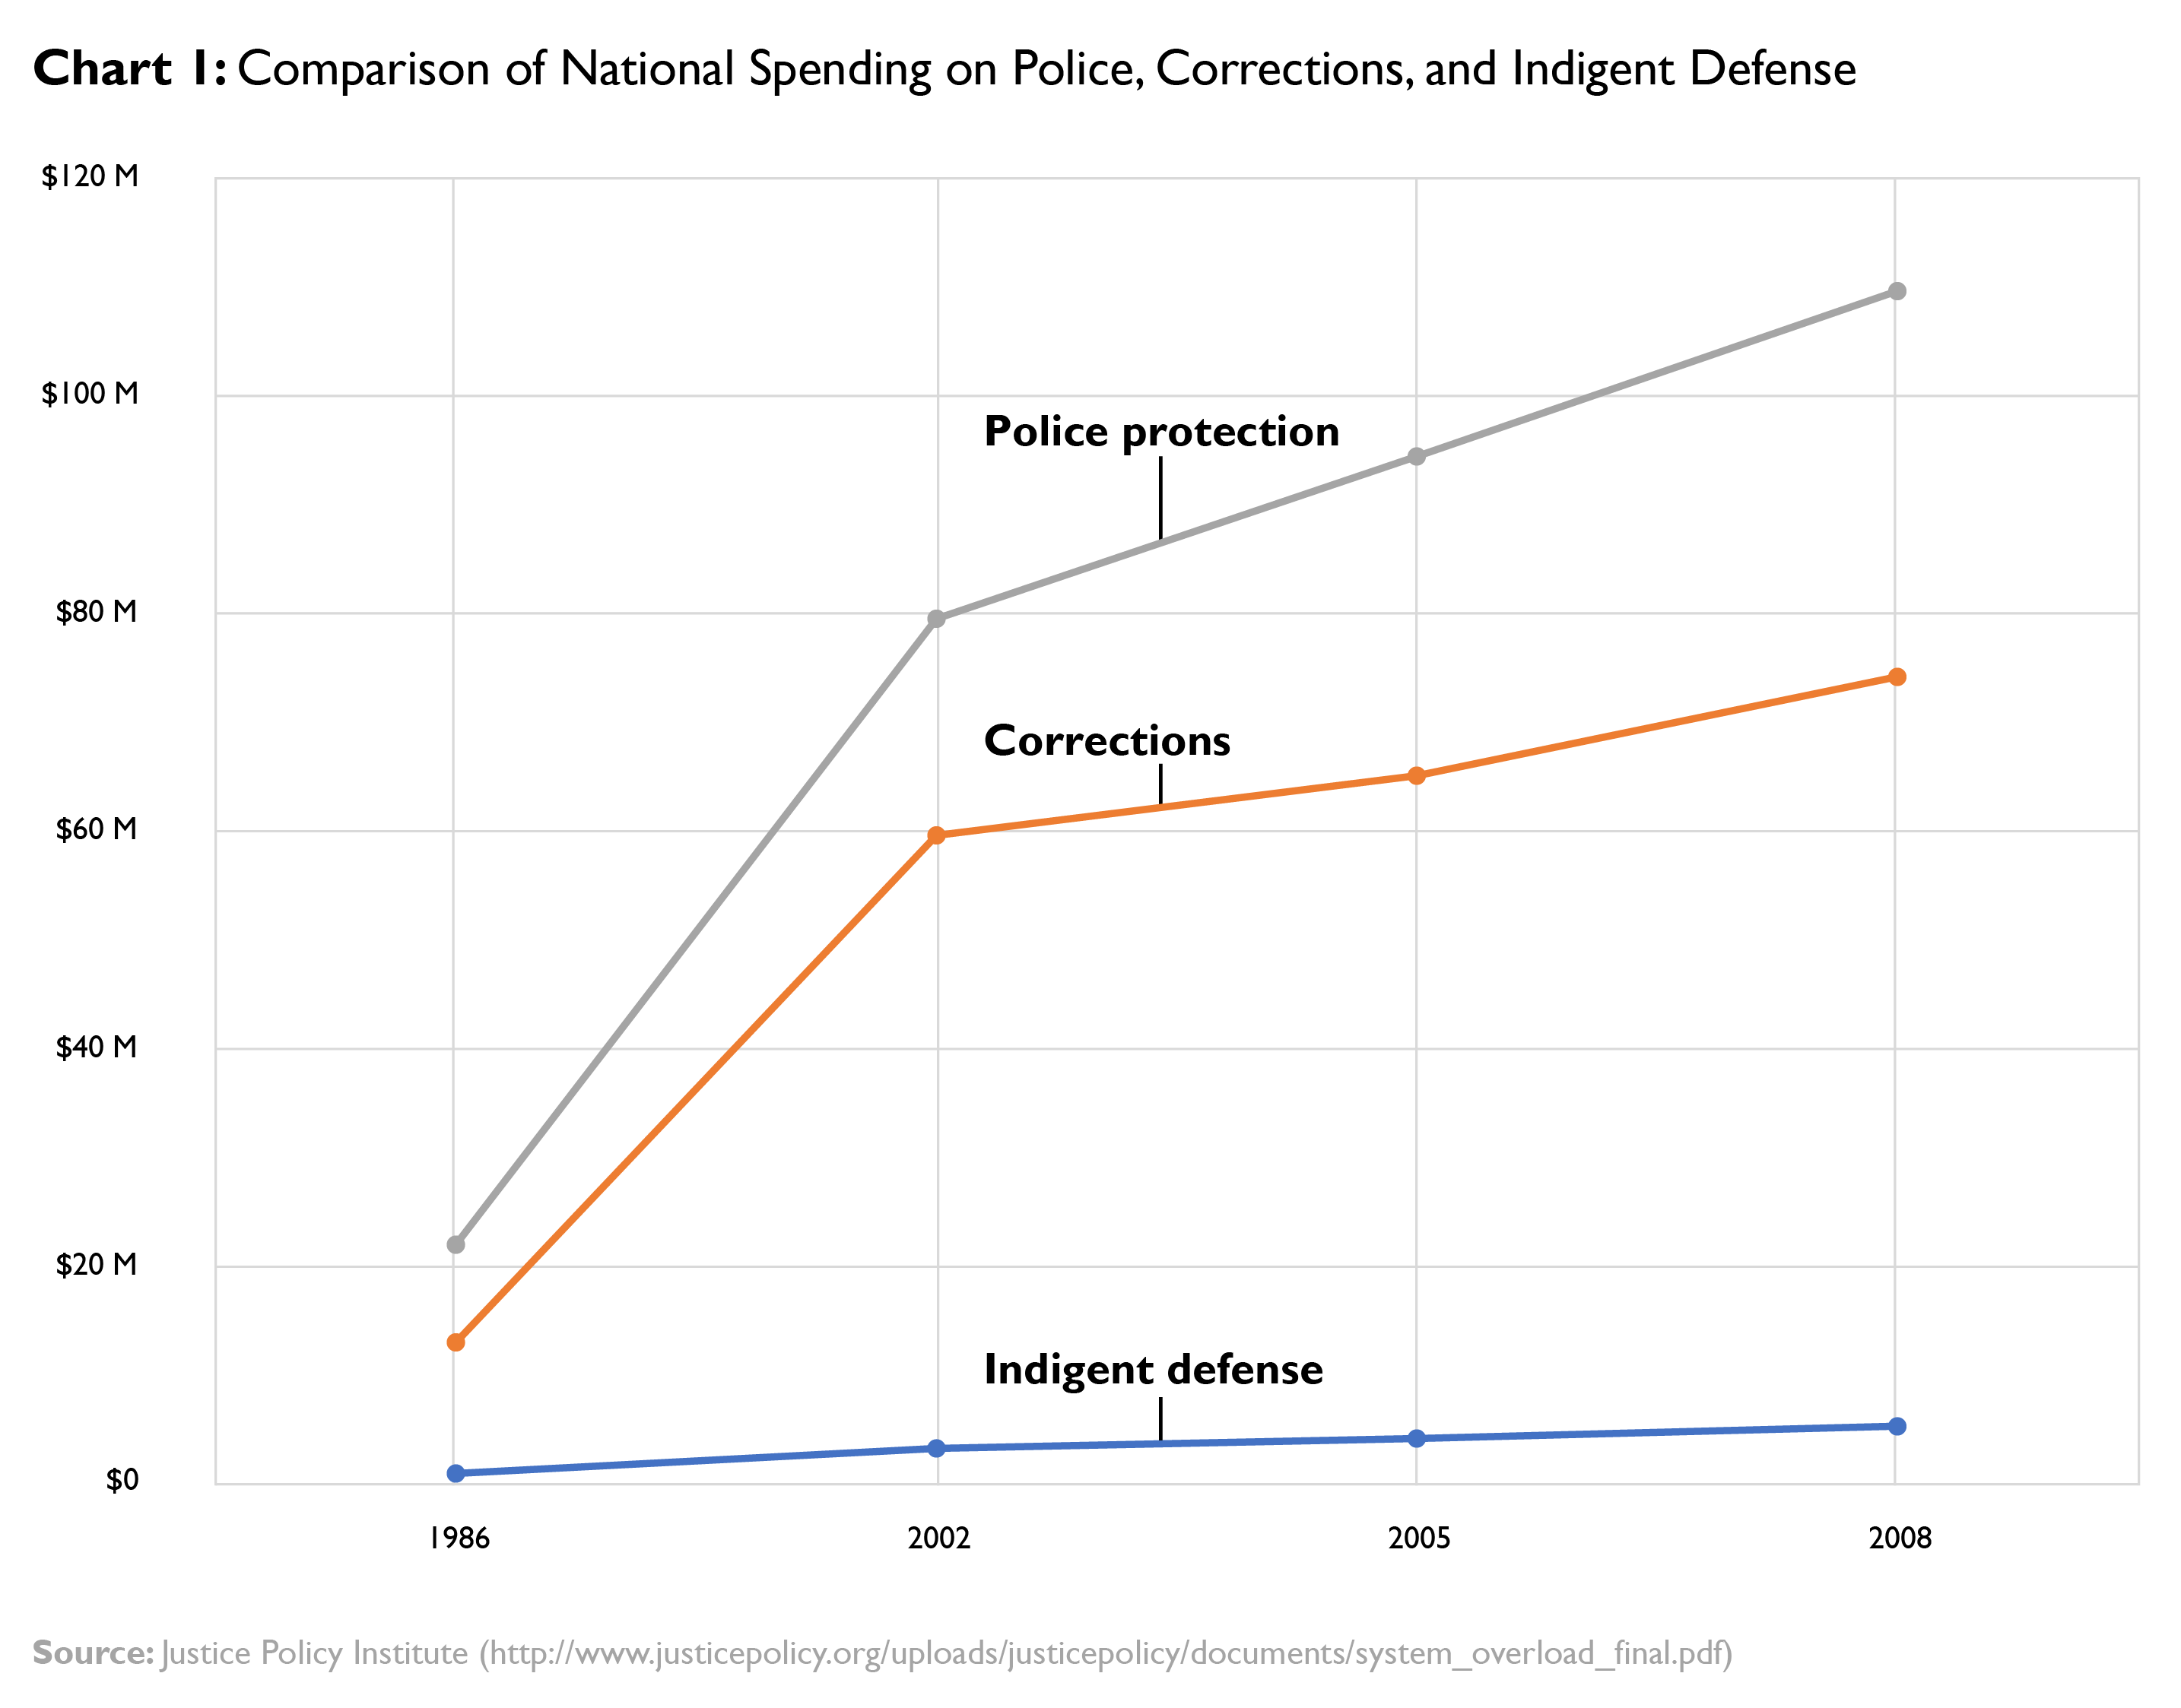
Chart 1 Questions
- Identify a trend in spending for criminal justice.
- Describe a similarity or difference between spending for corrections (prisons and jails) and spending for indigent defense.
- Explain what the impact of the spending preferences represented in this graph might be.
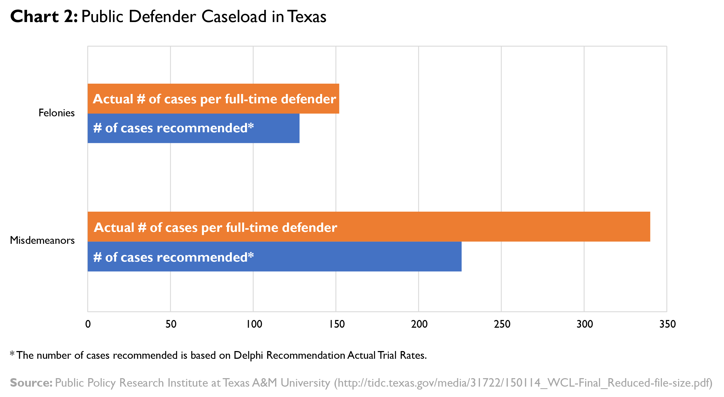
Chart 2 Questions
- Based on the information provided in the graph, identify the category of cases that is the largest for public defenders in Texas.
- According to the graph, which category has the smallest discrepancy (difference) between recommended and actual case load?
- Explain how the discrepancy of actual case load exceeding recommended case load for public defenders might impact the effectiveness of legal counsel.
- Identify one way that states might address this discrepancy.
- What might prevent states from enacting the solution you proposed in #4?

Chart 3 Questions
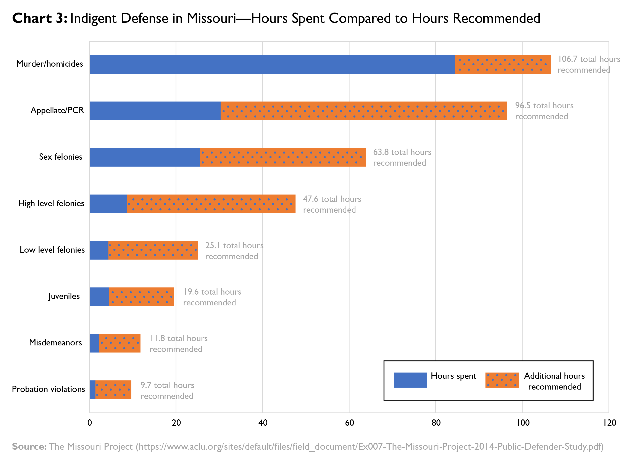
- Identify the 3 categories of cases which have the greatest difference between average hours recommended and average hours spent.
- Which 3 type of case has the highest possible penalties imposed on defendants?
- Explain how the discrepancy of average hours recommended and average hours spent might impact the effectiveness of legal counsel.
- Identify one way that states could address this discrepancy.
- What might prevent states from enacting the solution you proposed in #4.

