Gideon v. Wainwright / Document Analysis
Answer the following questions using the photos of Gideon’s petition (pages 2-6):
- Type of document (check one):
____ Newspaper | ____ Letter | ____ Patent | ____ Memorandum
____ Map | ____ Telegram | ____ Press release | ____ Report
____ Advertisement | ____ Congressional  record | ____ Census report | ____ Other:
- Unique physical qualities of the document (check one or more and note details):
____ Interesting  letterhead | ____ Handwritten | ____ Typed | ____ Seals
____ “Received”  stamp | ____ Other: | Details:
- Author (or creator) of the document:
- Why do you think this document was written?
- What evidence in the document helps you know why it was written? Quote from the document.
- Discuss responses with your classmates.
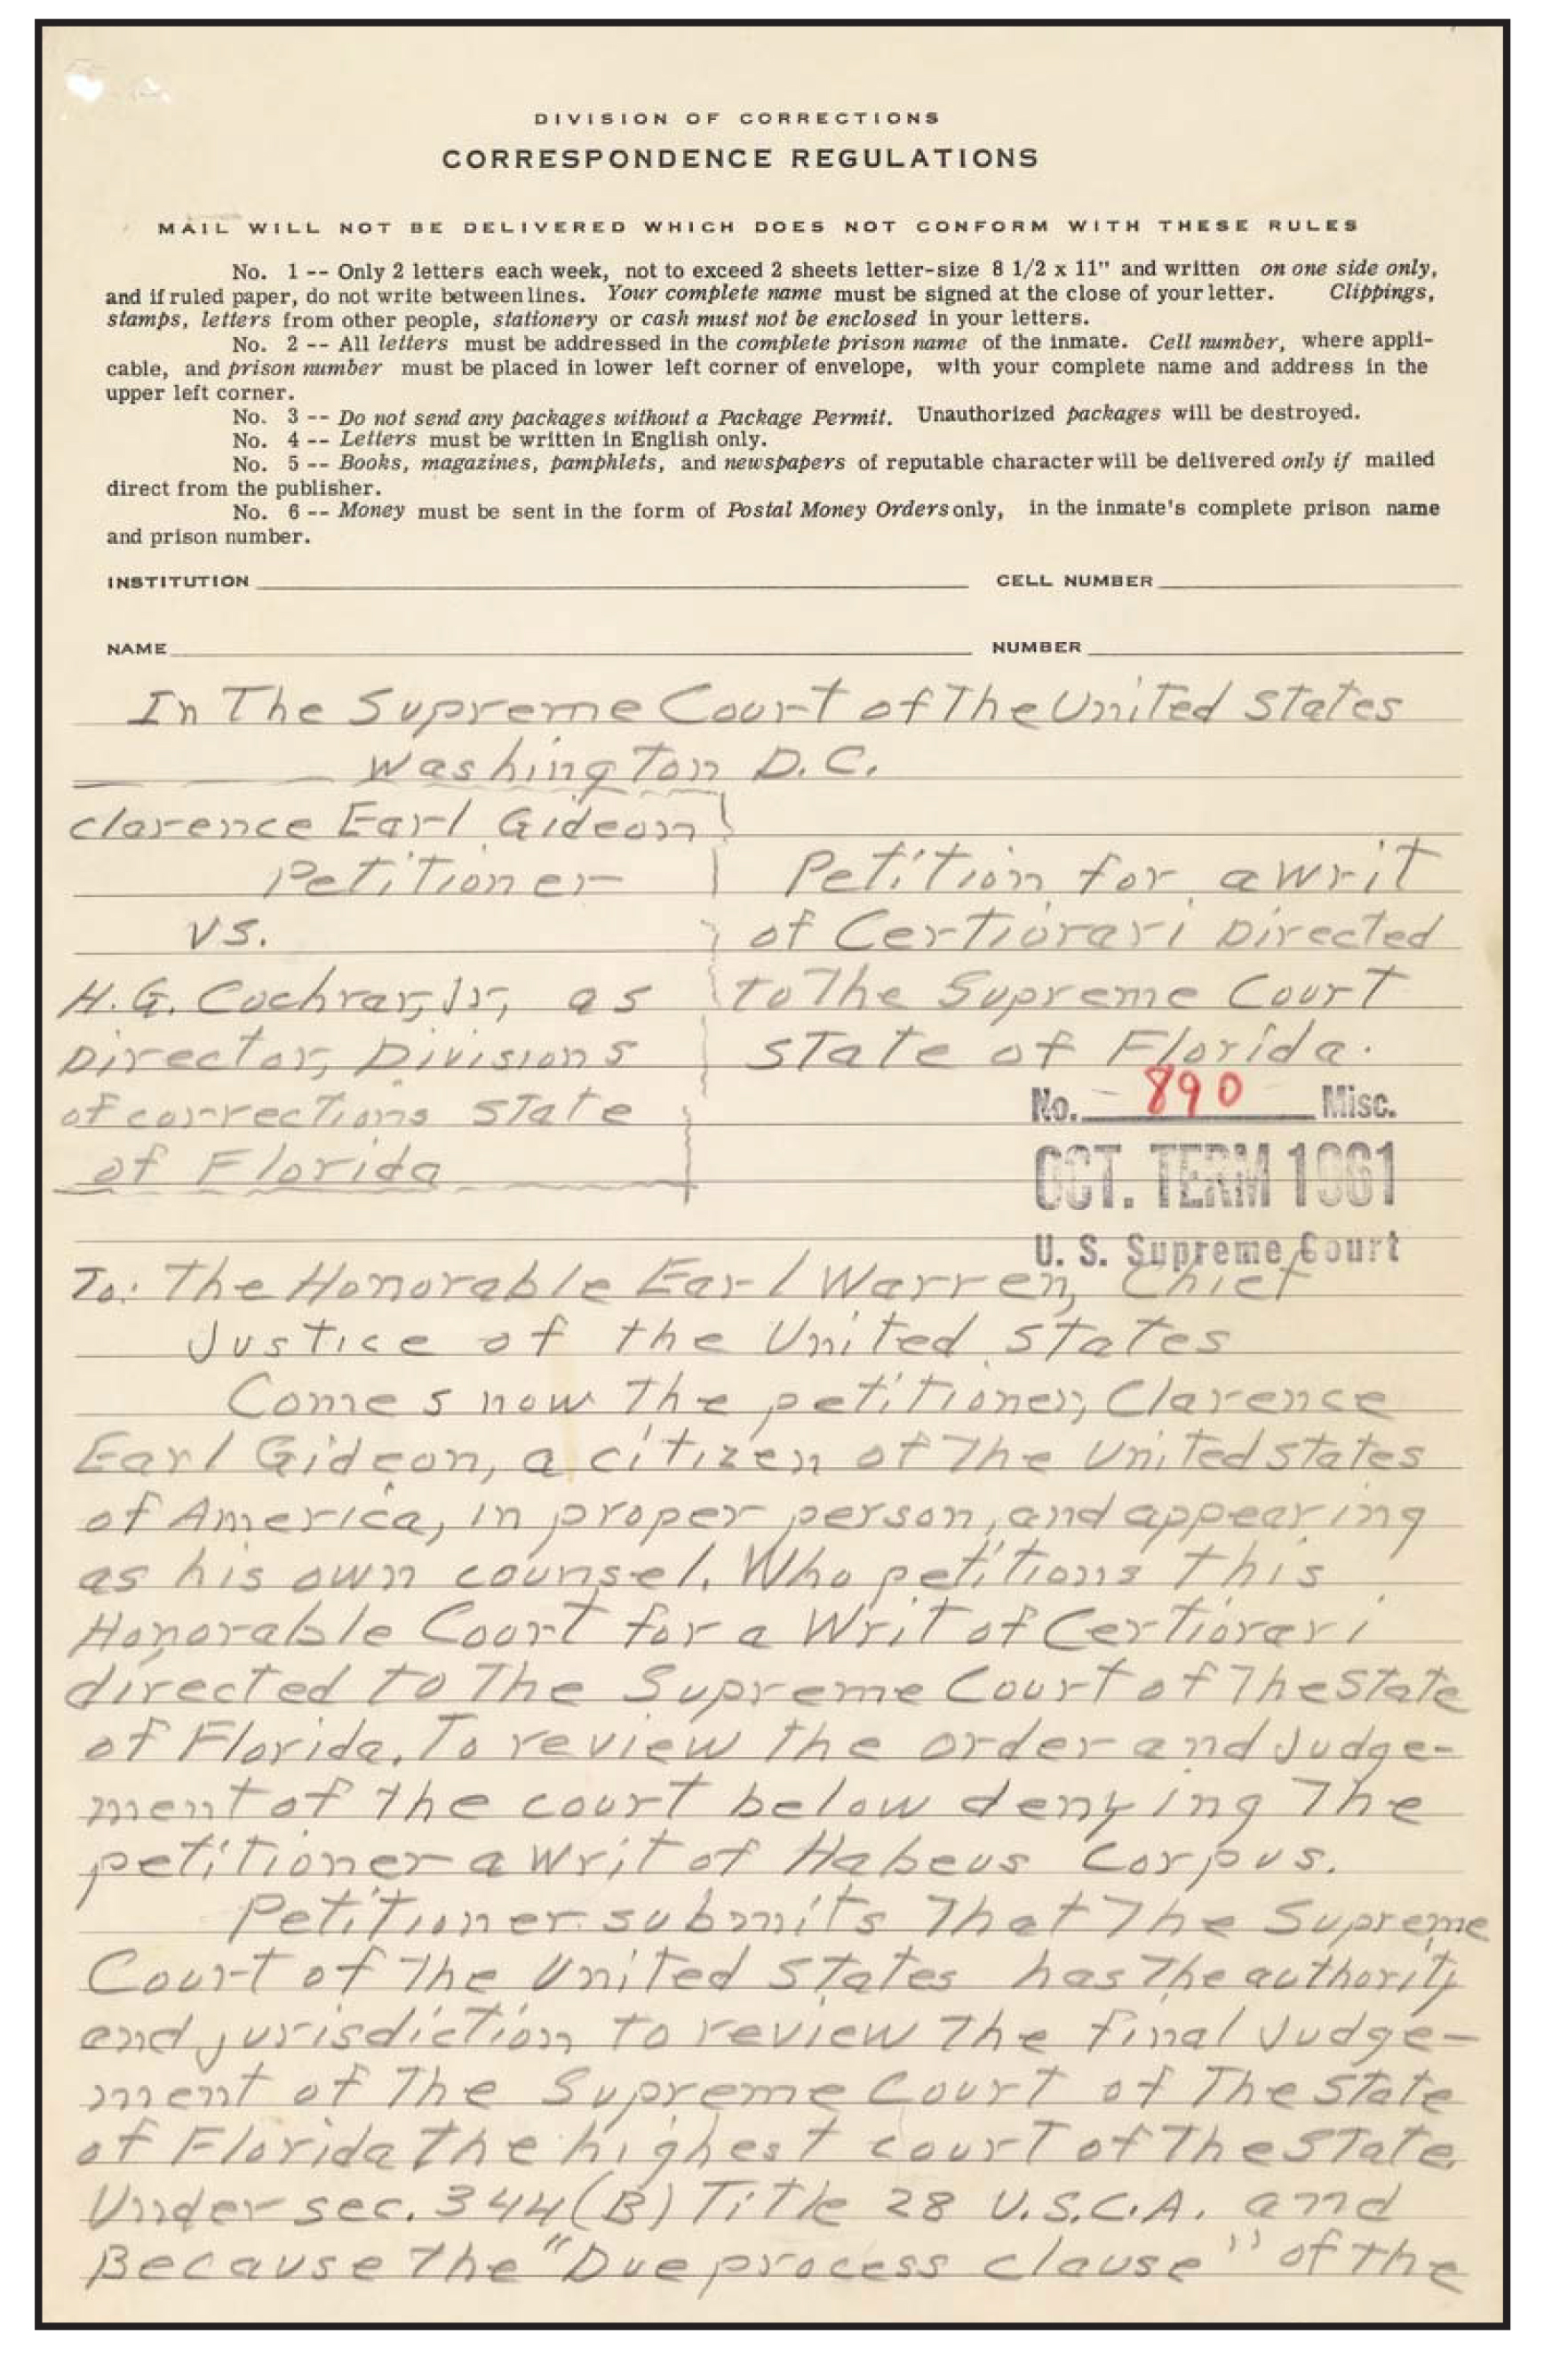

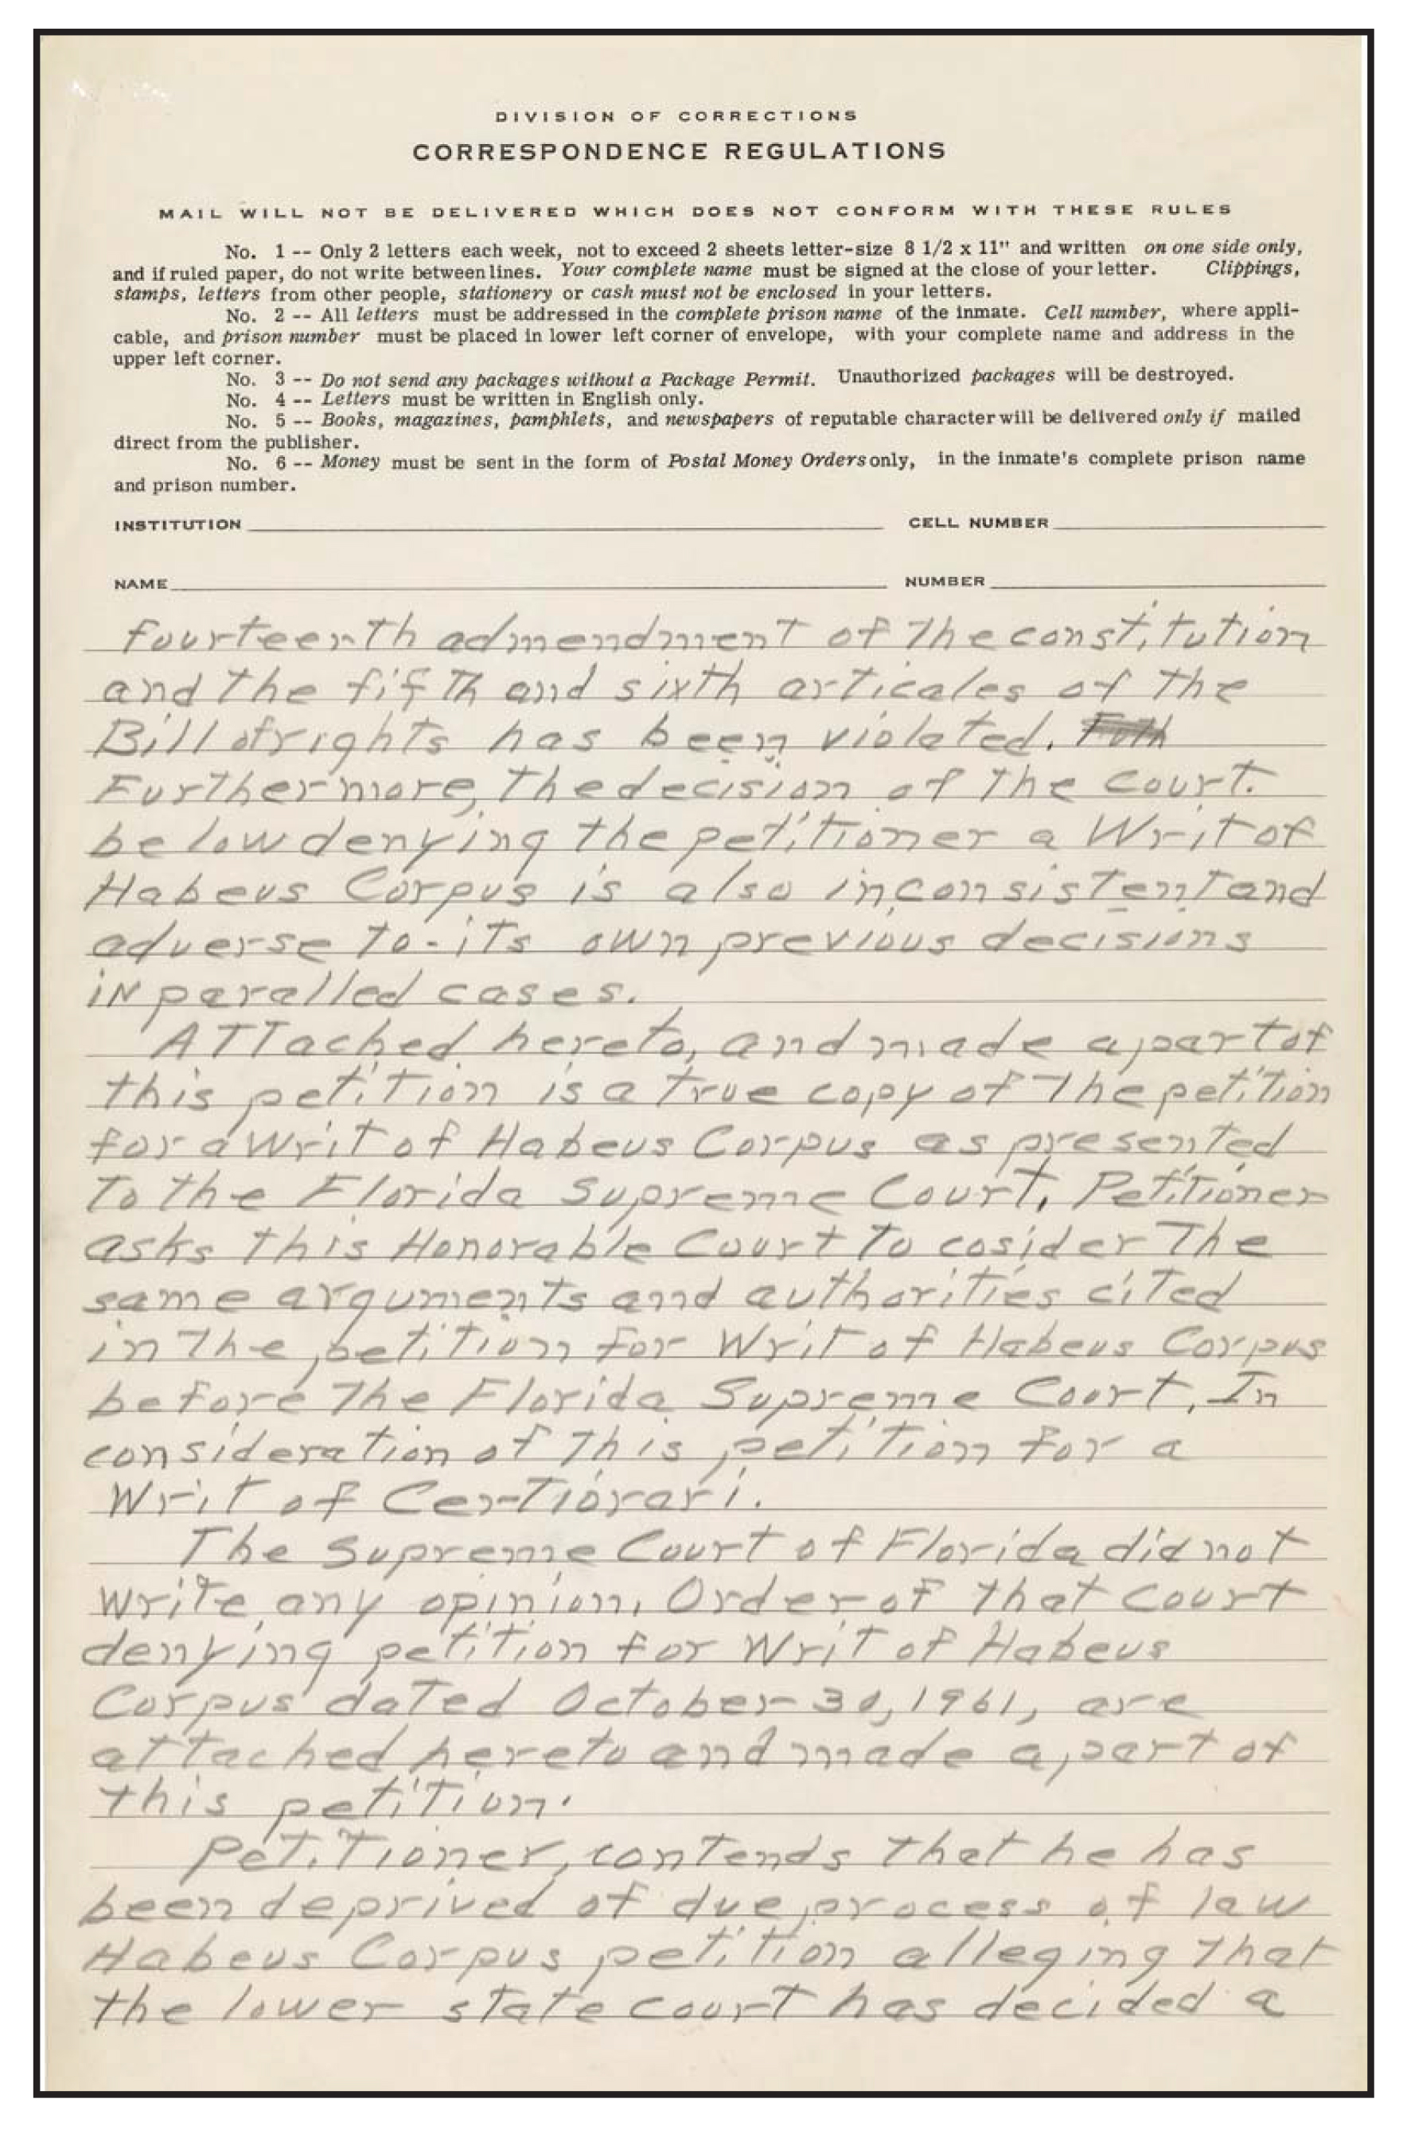
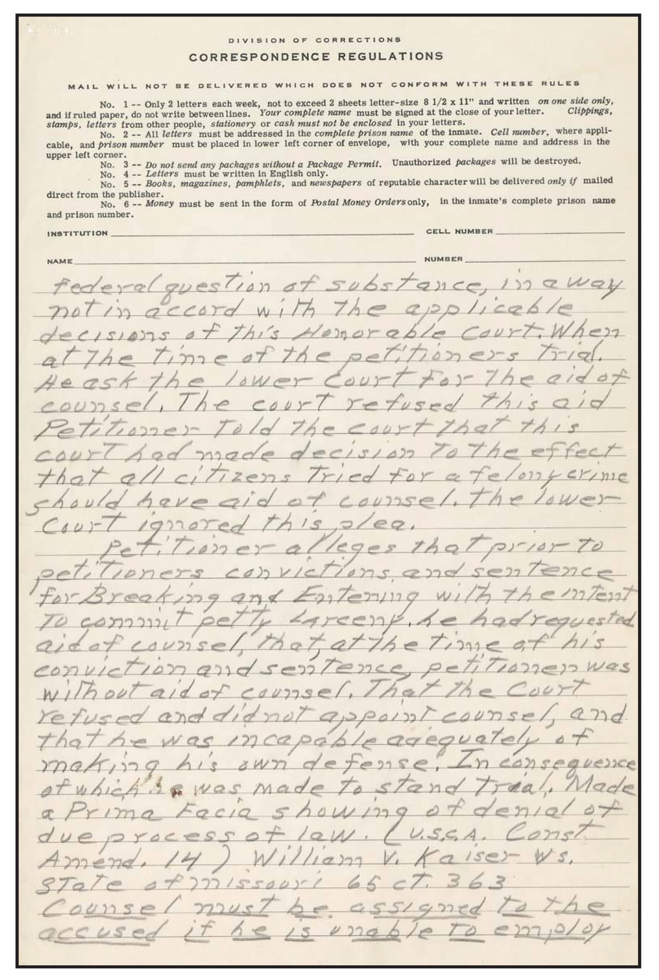
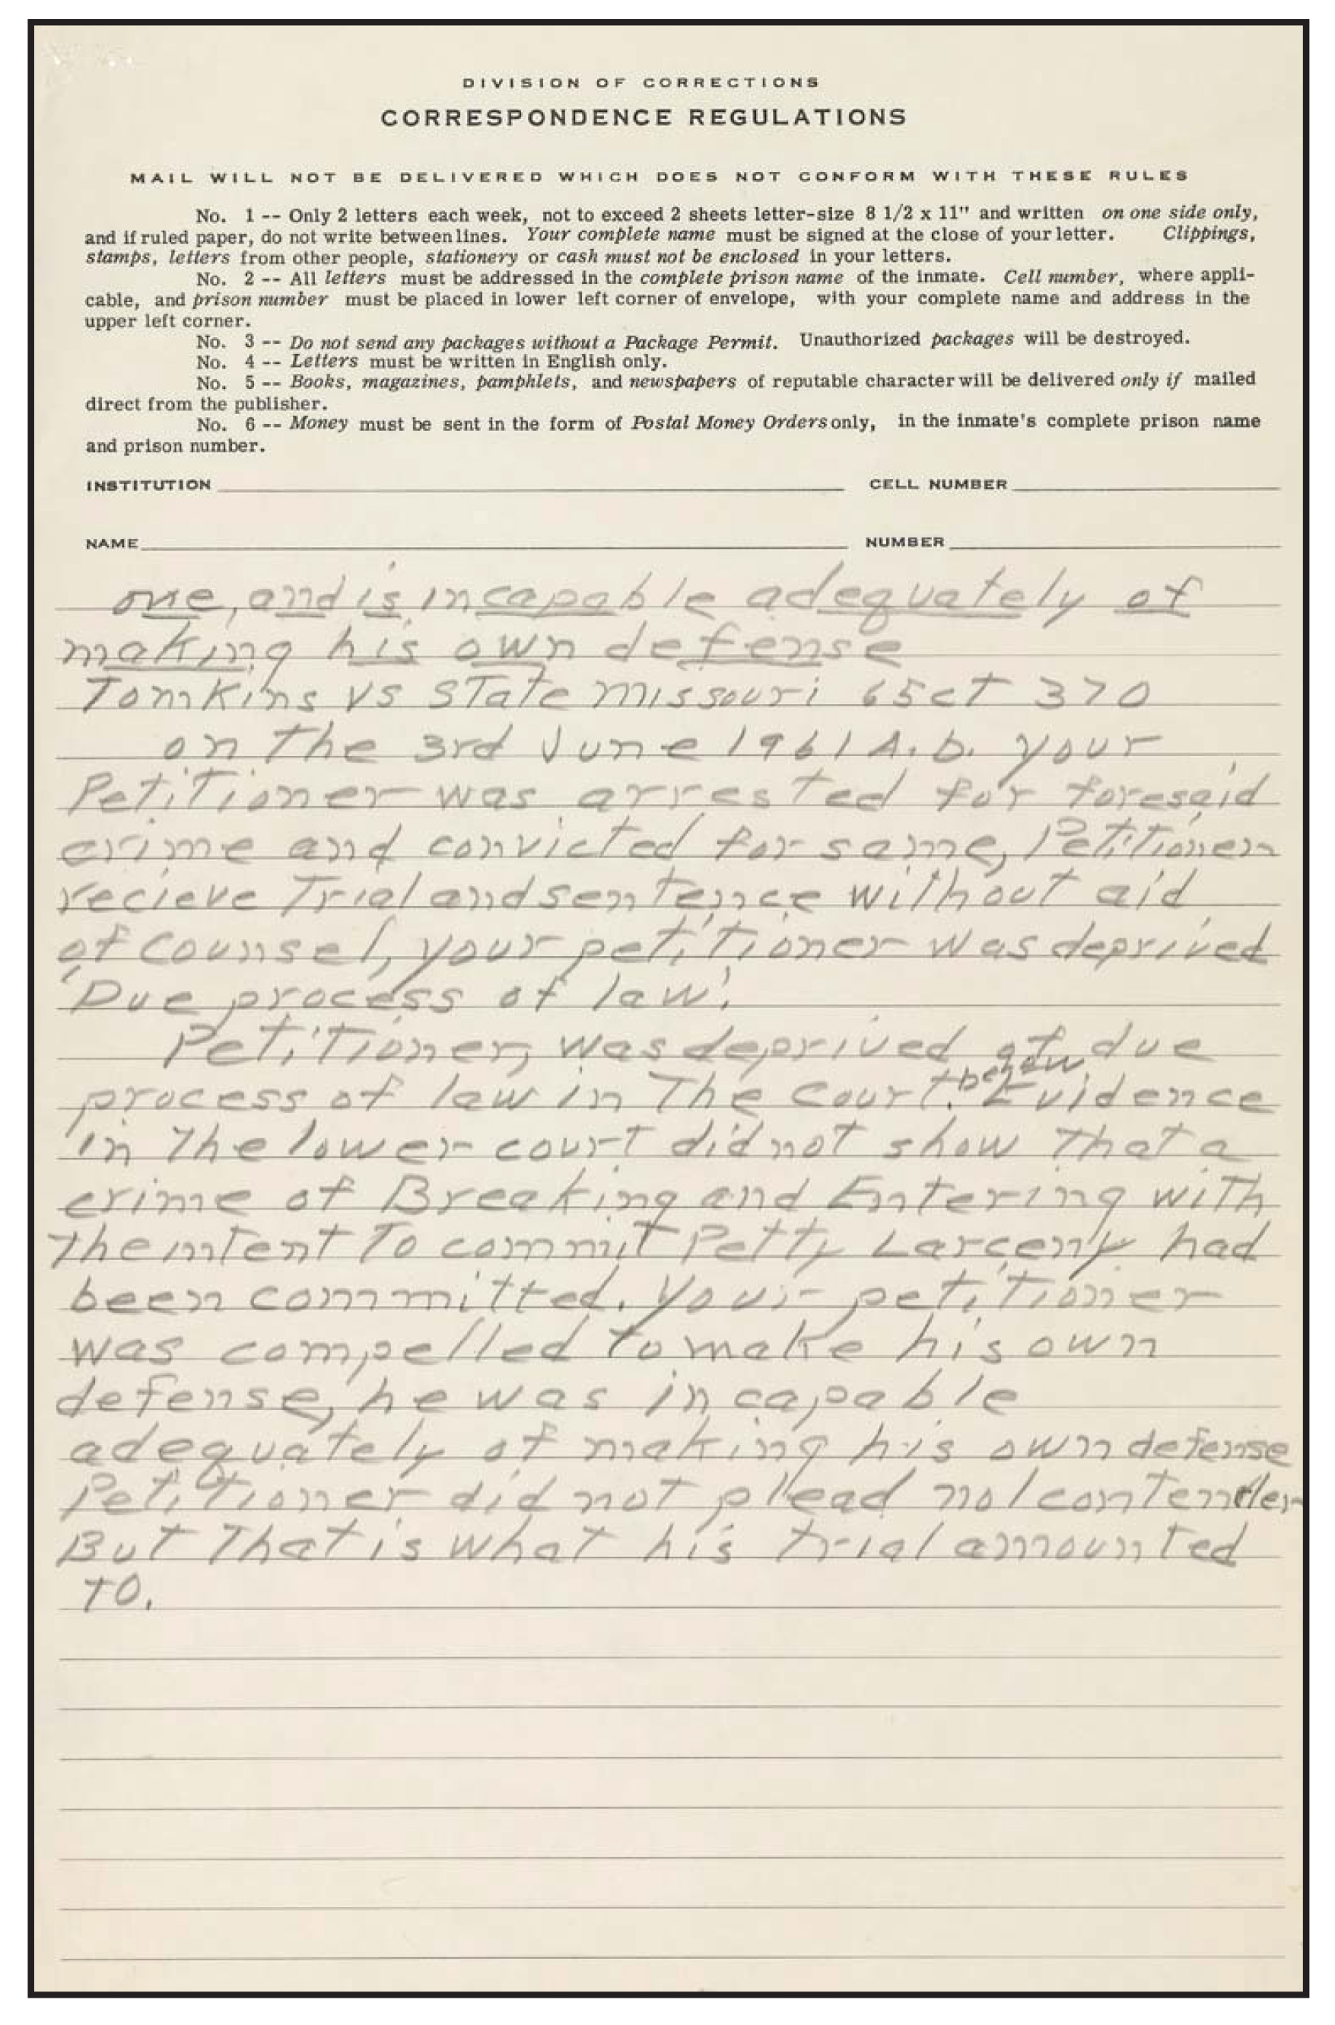
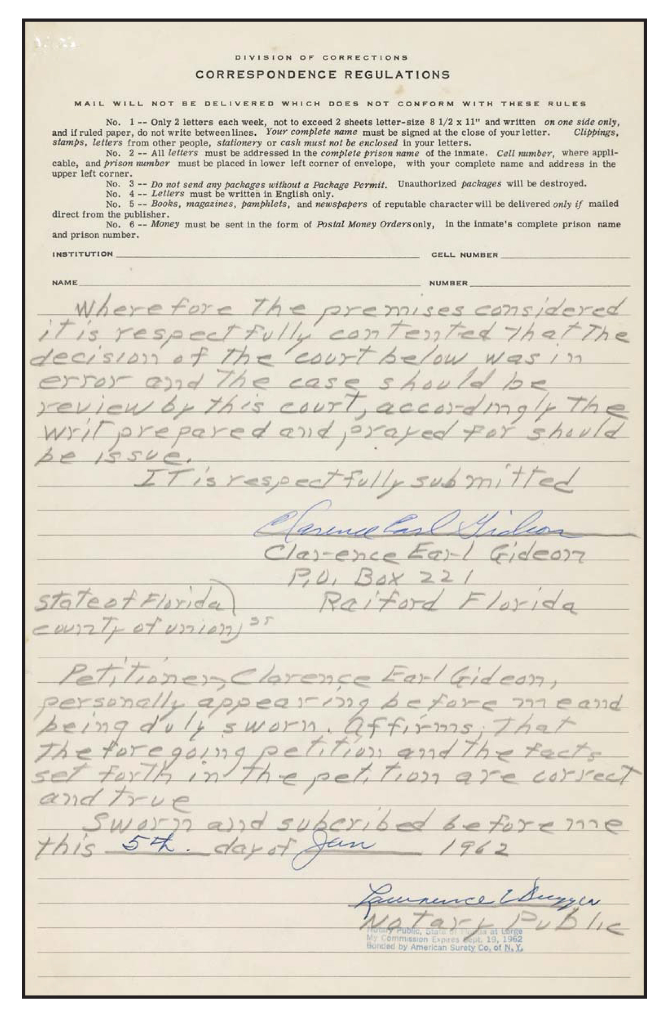

Adapted from the National Archives and Records Administration’s “Analyze a Written Document” resource.

