Gideon v. Wainwright / Cartoon Analysis
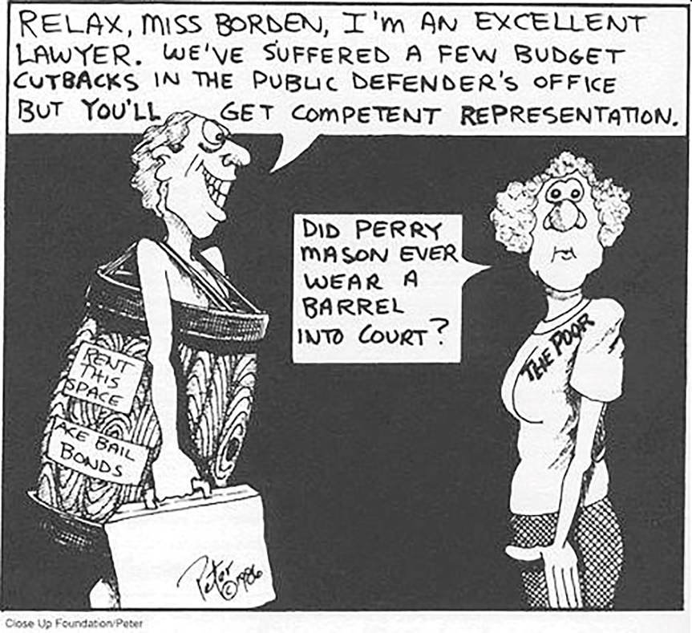
Source: Monk, Linda R. The Bill Of Rights: A User’s Guide. Close-Up Publishing: 1991. p. 152.
Analyze the cartoon below in terms of its meaning related to the Gideon v. Wainwright case. Answering the following questions will help you correctly interpret the cartoon’s meaning.
- What do you see in the cartoon? Make a list. Include objects, people, and any characteristics that seem to be exaggerated.
- Which of the things on the list from Question 1 are symbols? What does each stand for?
- What is happening in the cartoon?
- What is the cartoonist’s message? Do they think that the decision in Gideon v. Wainwright has resulted in fair representation for poor defendants?
- Do you agree or disagree with the message? Explain your answer.

