Engel v. Vitale / Photograph Analysis
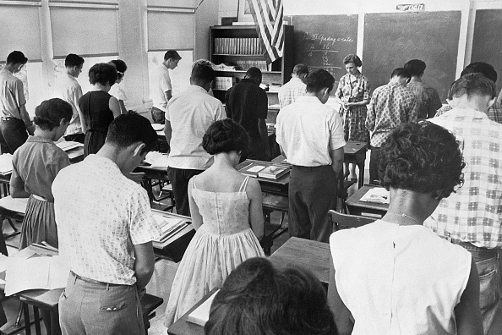
Texan School Class in Prayer, 6/27/1962, San Antonio, TX (Bettmann via Getty Images)
Observe
What do you notice first?
What people and objects are shown?
What is the setting?
Reflect
What is happening in this image?
What is significant about the date this photo was taken?
If someone took this photo today, what would be different? What would be the same?
Question
What do you still wonder about?
Caption
Write a caption for this image.

