Engel v. Vitale / Cartoon Analysis
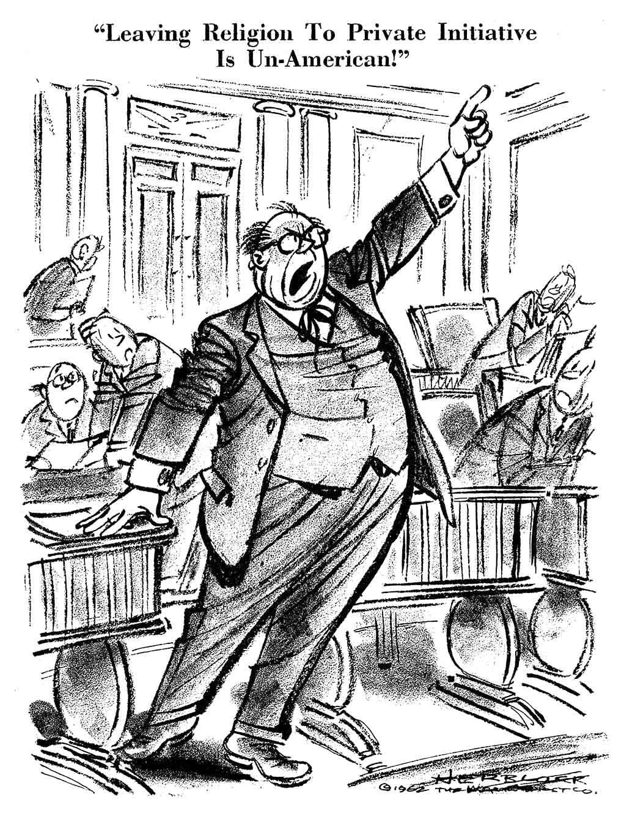
“Leaving religion to private initiative is un-American!” (published June 28, 1962)
Caption label from exhibit—“‘Herblock Looks at 1962’: When the Supreme Court ruled against state-mandated school prayer in public schools in 1962 in the case of Engel v. Vitale, several Congressmen protested the decision. In his support of the Supreme Court, President Kennedy encouraged Americans to pray privately, which further fueled the congressional backlash. Herblock created this caricature of Senator James Glenn Beall of Maryland who led the call for an amendment to require school prayer.”
A 1962 Herblock Cartoon, © The Herb Block Foundation
Observe
What people and objects are shown? Make a list of what you see in the cartoon including captions.
What is the setting?
Are there any objects or people that seem to be exaggerated? If so, why do you think the artist exaggerated?
Reflect
What is happening in this image?
What is significant about the date this cartoon was published (June 28, 1962)?
What does this image remind you of? Can you think of events or news stories that are similar? Do these images or issues relate to your community in any way?
Evaluate the Message
In your opinion, what is the cartoonist’s message? What elements of the cartoon give you that impression?
Do you agree with the point of view and message of the cartoonist? Why or why not?
What, if anything, should be done about the problem portrayed in the cartoon? Who should do it?
Question
What do you still wonder about?

