Dred Scott v. Sandford / Visit Dred Scott’s Memorial
View the three photos of a monument to Dred Scott and answer the questions to consider.
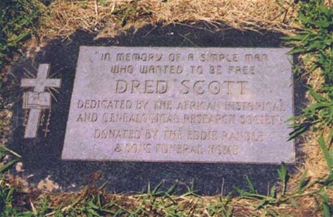
View 1
View 2
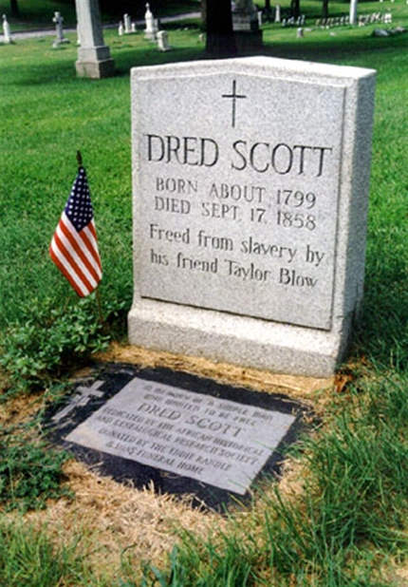

View 3
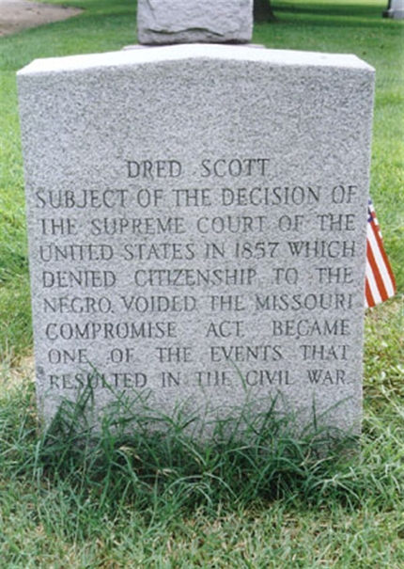

Questions to Consider
Why do you think the African Historical and Genealogical Research Society paid for a memorial to Dred Scott?
What three facts do the monuments include about the Supreme Court’s decision?
If you were to create a memorial to Dred Scott, what would it say? What would it look like? Draw the memorial below. Be sure to include an inscription.

Memorial dedicated by the African Historical and Genealogical Research Society. Images from Findagrave.com.

