Brown v. Board of Education of Topeka /
All Deliberate Speed
After the Brown v. Board of Education of Topeka decision, how quickly should schools have been desegregated? How quickly were schools desegregated?
Read Justice Frankfurter’s notes on the language used in the Brown II opinion and answer the questions that follow.
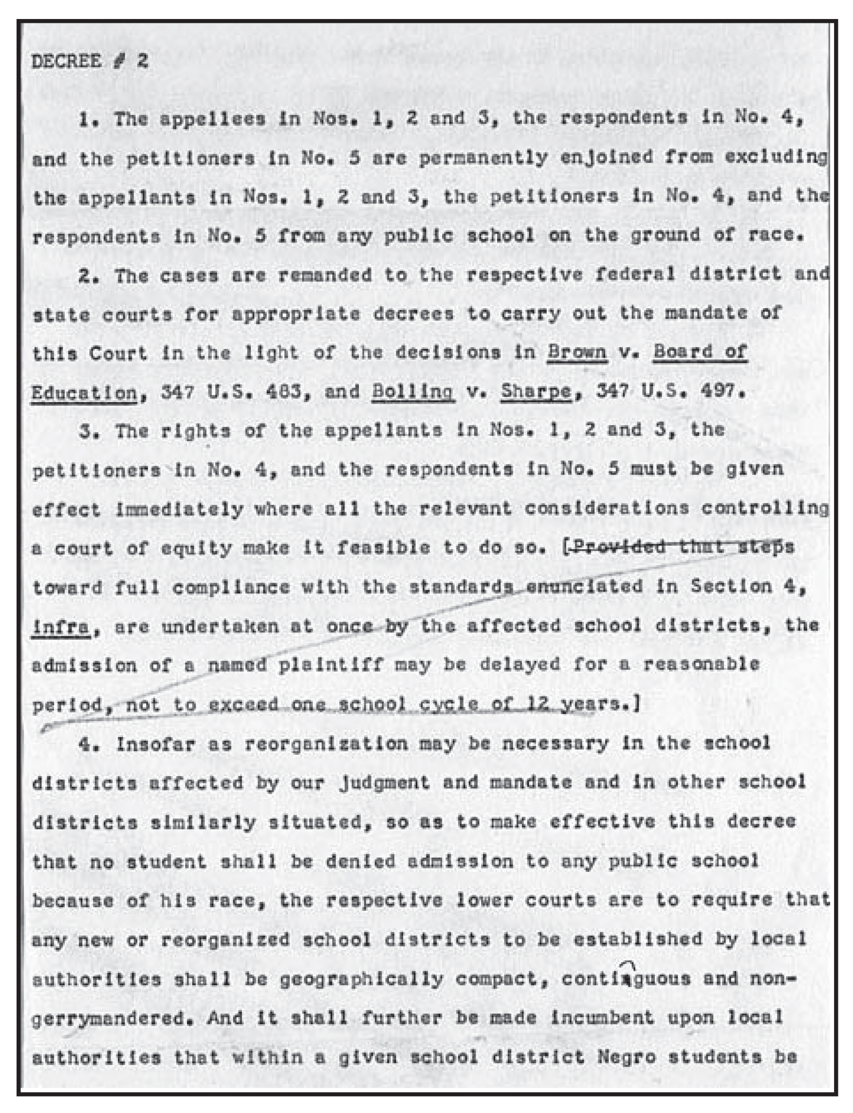

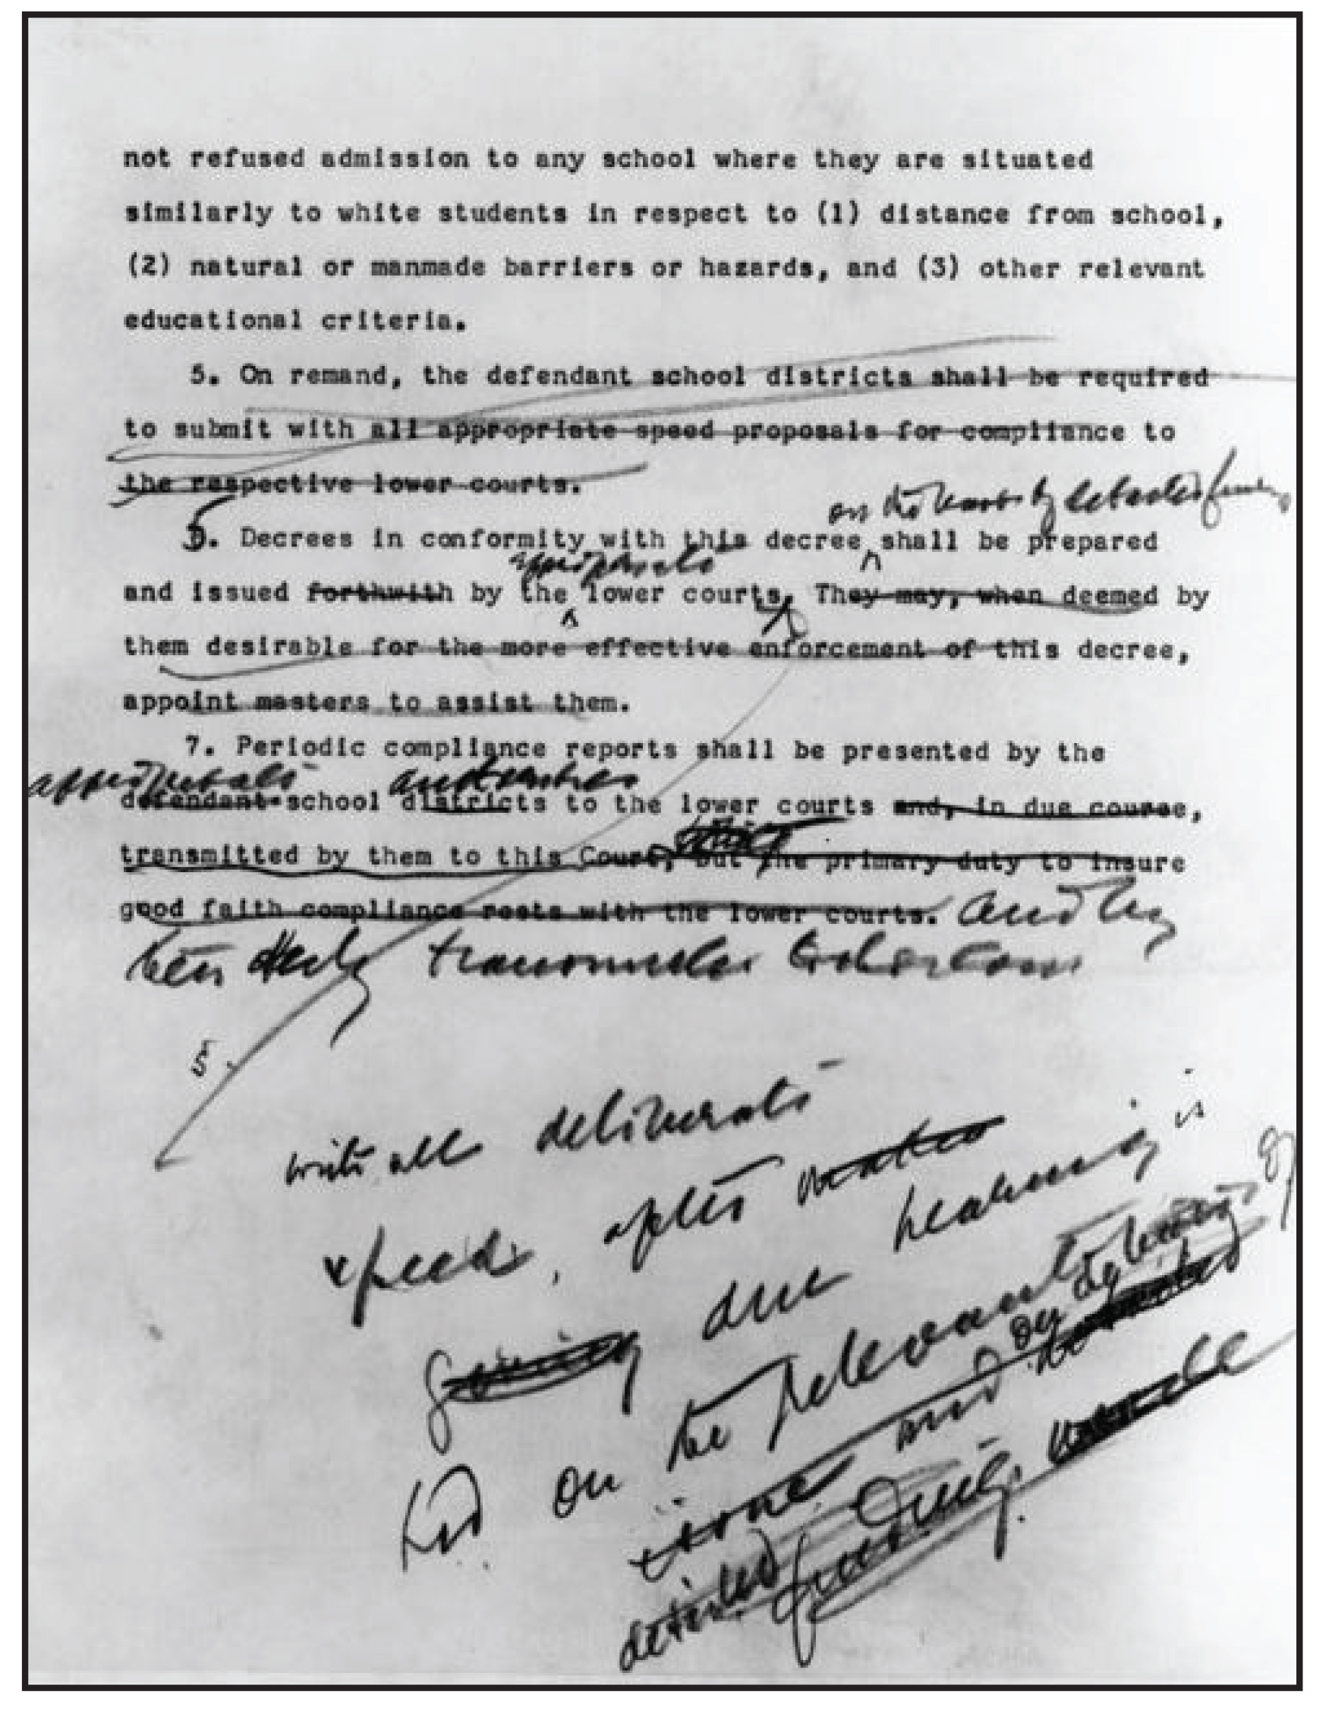
The decision in Brown v. Board of Education of Topeka came in two parts. First, the justices considered whether segregation was constitutional. The Brown I decision in 1954 determined that it was not, but there still remained the tricky question about how to end segregation. On this question, the Court heard arguments during the following term.
In 1955, the Supreme Court of the United States determined that segregation should be ended as soon as possible, but the Court also recognized that it would be difficult for communities to deal with the change and that there were many institutional, political, and social circumstances to be worked out. The Court struggled with how to phrase the order to desegregate schools and what kind of time frames should be attached to the order. The NAACP advocated for schools to be desegregated “forthwith,” which implies a quick timetable. However, Justice Warren adopted the advice of Justice Frankfurter and chose other language.
Questions to Consider
On page two of the typed notes, Justice Frankfurter writes his original recommendation for how quickly desegregation should occur. What does he say? (This is the typed version, not the handwritten version.)
Justice Frankfurter then crosses out point 5 and changes point 6 to point 5. He also changes his recommendation for how quickly desegregation should occur. How does he alter his recommendation? (This is the handwritten note.)
Why do you suppose Justice Frankfurter changed his mind? Think about what actions might be involved in desegregating schools at the local level.
What do Justice Frankfurter's notes tell you about how Supreme Court decisions are written?

The Court’s recommendation that schools should desegregate “with all deliberate speed” had enormous consequences for the speed of desegregation. Read this excerpt of a letter from Roy Wilkins to President Kennedy regarding desegregation in Prince Edward County, Virginia.
What does the letter tell you about how quickly desegregation occurred?
