Brown v. Board of Education of Topeka / Newspaper Analysis
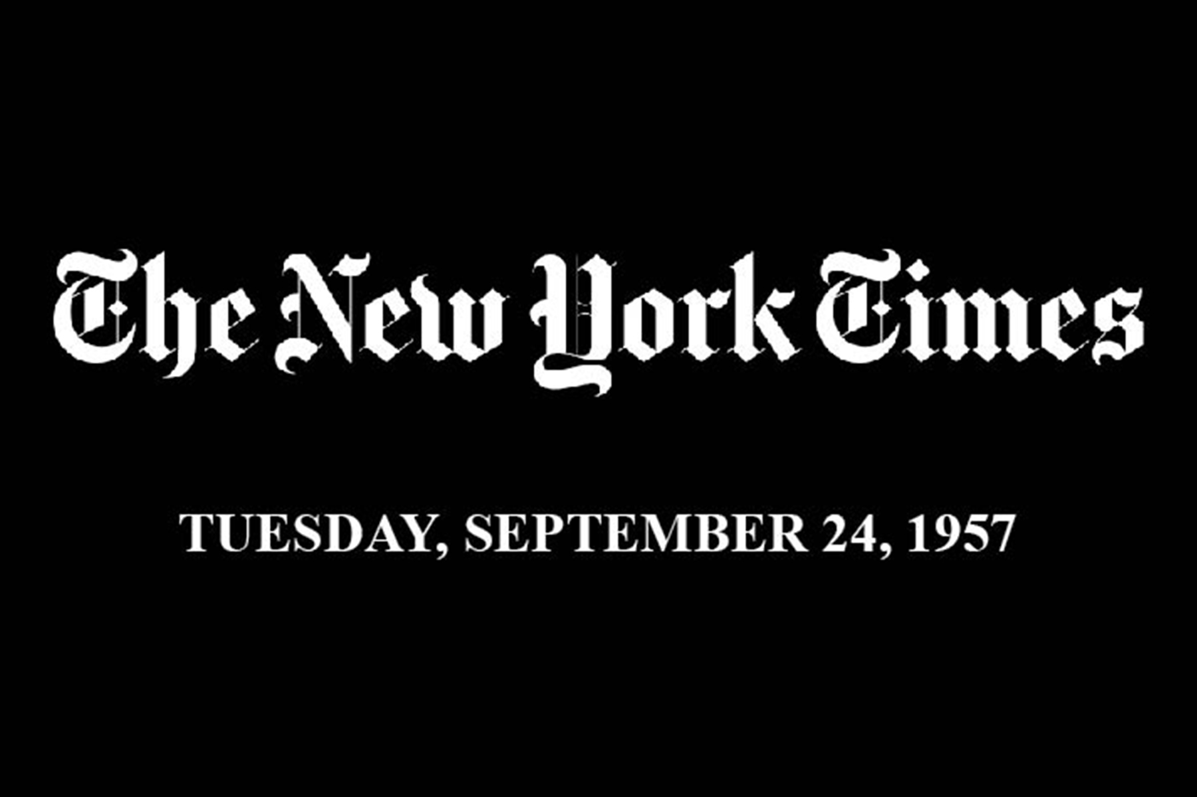
Access the primary source document from the New York Times at https://timesmachine.nytimes.com/timesmachine/1957/09/24/issue.html.

Before reading the articles, answer the following questions about the front page.
- Inspect front page of the newspaper, what information can you gather from it right off the bat?
- When was this newspaper published? Why is the date significant?
Read the article entitled “Students Unhurt: Return Today Unlikely—City Authorities Yield to Crowds” and answer the following questions, referencing the source as needed.
- Summarize the news story “Students Unhurt.”
- Why do you think this event is significant in the history of desegregation?
Read the article entitled “Eisenhower Irate: Says Federal Orders ‘Cannot be Flouted with Impunity’” and “President’s Statements,” and answer the following questions, referencing the sources as needed.
- What was President Eisenhower’s reaction to the events in Little Rock?
- What presidential powers can be used to enforce Supreme Court decisions?
- In Federalist #78, Alexander Hamilton wrote that the judicial branch is the “least dangerous branch” of government. Based on this article, would you agree? Why or why not?

