Brown v. Board of Education of Topeka / Cartoon Analysis
Directions: Analyze the cartoons in terms of their relation to the Brown v. Board of Education of Topeka case.

Cartoon 1
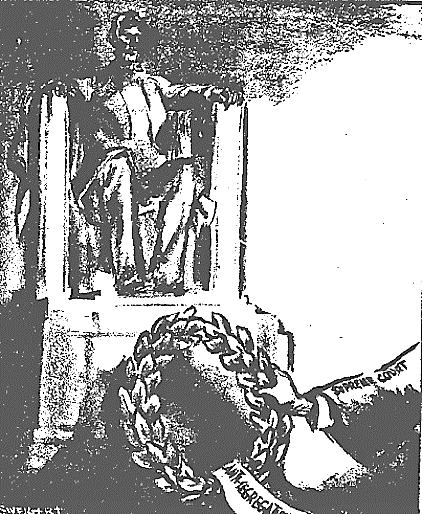
Source: Chronicle (San Francisco), May 18, 1954. Reproduced with permission.
- What do you see in the cartoon? Make a list of the people, objects, etc.
- Which of the items on the list from Question 1 are symbols? What does each stand for?
- What is the artist’s message in the cartoon? Is there political bias?
- Who would agree with the message? Who would disagree?

Cartoon 2
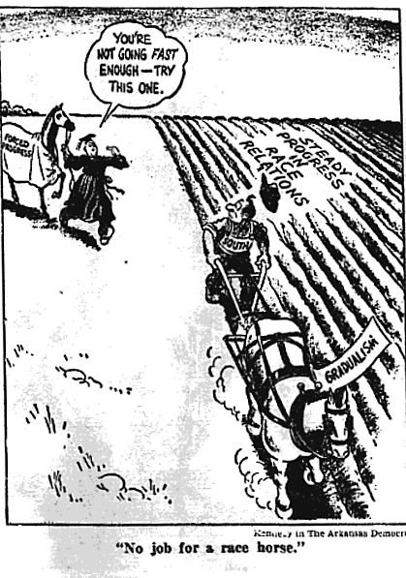
Source: Democrat (Arkansas), May 22, 1954. Reproduced with permission
- What do you see in the cartoon? Make a list of the people, objects, etc.
- Which of the items on the list from Question 1 are symbols? What does each stand for?
- What is the artist’s message in the cartoon? Is there political bias?
- Who would agree with the message? Who would disagree?
Cartoon 3
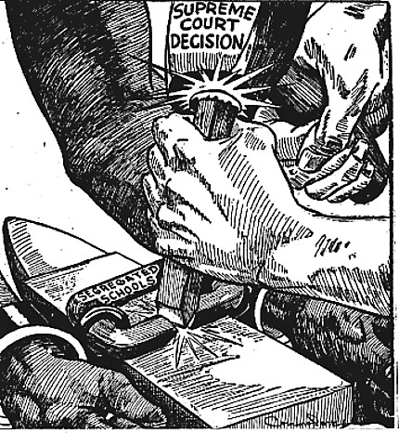
Source: Defender (Chicago), June 12, 1954. Reproduced with permission.
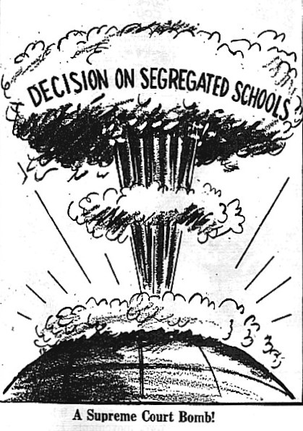
- What do you see in the cartoon? Make a list of the people, objects, etc.
- Which of the items on the list from Question 1 are symbols? What does each stand for?
- What is the artist’s message in the cartoon? Is there political bias?
- Who would agree with the message? Who would disagree?

Cartoon 4
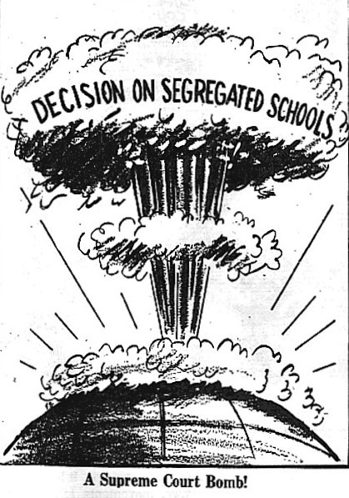
Source: Afro-American (Richmond), May 22, 1954. Reproduced with permission.
- What do you see in the cartoon? Make a list of the people, objects, etc.
- Which of the items on the list from Question 1 are symbols? What does each stand for?
- What is the artist’s message in the cartoon? Is there political bias?
- Who would agree with the message? Who would disagree?

