Regents of UC v. Bakke / Political Cartoon Analysis
Directions:
- Analyze each cartoon below in terms of its meaning related to the Michigan affirmative action cases: Gratz v. Bollinger and Grutter v. Bollinger. (Synopses of the cases and their decisions can be found starting on page 5).
- Answer the Questions to Consider for each cartoon.

Cartoon #1
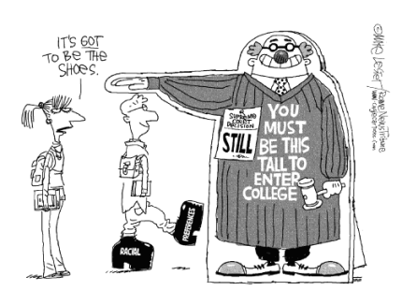
“You Must Be This Tall,” Mike Lester, The Rome News-Tribune, June 24, 2003. (Used with permission from www.caglecartoons.com.)
Questions to Consider
- What do you see in the cartoon? Make a list. Include objects, people, and any characteristics that seem to be exaggerated.
- Which of the items on the list from Question 1 are symbols? What does each symbol stand for?
- What is happening in the cartoon?
- What is the cartoonist’s message?
- Do you agree or disagree with the message? Explain your answer.
Cartoon #2
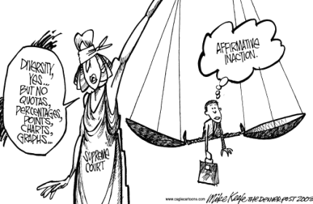
“Supremes on Affirmative Action,” Mike Keefe, The Denver Post, June 24, 2003. (Used with permission from www.caglecartoons.com.)
Questions to Consider
- What do you see in the cartoon? Make a list. Include objects, people, and any characteristics that seem to be exaggerated.
- Which of the items on the list from Question 1 are symbols? What does each symbol stand for?
- What is happening in the cartoon?
- What is the cartoonist’s message?
- Do you agree or disagree with the message? Explain your answer.

Synopses
Gratz v. Bollinger
Jennifer Gratz, a White student and a resident of Michigan, applied to the University of Michigan as a high school senior in 1995. Her standardized test score on the ACT (25) placed her in the top quarter of applicants, and she had a GPA of 3.8. In addition, Gratz participated in student council and various other extra-curricular activities. Nevertheless, the university denied Gratz admission. The University of Michigan’s admissions guidelines in effect in 1995 called for the acceptance of all underrepresented “minority” applicants with academic credentials similar to Gratz’s. Both parties agree that Gratz would have been admitted to the university had she been a member of an underrepresented group, like a racial or ethnic minority.
From 1995 through 1997, the university admissions officers used guideline tables or grids that reflected a combination of an applicant’s adjusted high school GPA and ACT or SAT score. To promote diversity, the university utilized different grids and admissions criteria for applicants who were members of preferred underrepresented groups as compared to other candidates. Michigan also set aside a prescribed number of seats in the entering class for students from those underrepresented groups in order to meet its numerical target.
In 1998, the university dropped its admissions grid system and replaced it with a 150-point “selection index.” Admissions officers assigned applicants points based on various factors, including test scores, “legacy” status, geographic origin, athletic ability, socioeconomic level, and race/ethnicity. The more points an applicant accumulated, the higher the chance of admission. Applicants from underrepresented racial and ethnic groups (African Americans, Latinos, and Native Americans) were assigned 20 points. Scholarship athletes and students who were economically disadvantaged also receive an automatic 20-point bonus. Geographic origin could earn six points, the child of an alumnus four points, and an “outstanding” admissions essay three points.
Gratz, and another unsuccessful White applicant, Patrick Hamacher, brought suit challenging the legality of the University of Michigan’s admissions policy. The federal District Court ruled that the school’s undergraduate admissions policy in place before 1998, which maintained a set-aside for racial and ethnic minorities, violated the 14th Amendment, but the court upheld the current points system, which did not use quotas and utilized race and ethnicity as a “plus.”
Grutter v. Bollinger
In 1997, Barbara Grutter, a resident of Michigan, applied for admission to the University of Michigan Law School. Grutter, who is White, had a 3.8 undergraduate GPA and scored 161 on the LSAT. She was denied admission and subsequently filed suit, claiming that her rights to equal protection under the 14th Amendment had been violated.
At the time, the law school had an admissions policy that used diversity as a factor in the admissions process. In selecting students, the law school considered the applicant’s academic ability (which included undergraduate GPA), LSAT scores, personal statement, and letters of recommendation. The school also considered factors such as the applicant’s experience, the quality of the undergraduate institution they attended, and the degree to which the applicant would contribute to law school life and the diversity of the community. The admissions policy did not define the types of diversity that would receive special consideration but did make reference to the inclusion of African American, Latino, and Native American students who might otherwise be underrepresented.
The school thought this policy complied with Bakke, on the grounds that it served a “compelling interest in achieving diversity among its student body.” The District Court ruled that the goal of achieving a diverse student body was not a compelling one. The Court of Appeals then reversed the District Court’s decision, saying that Justice Powell’s opinion in Regents of the University of California v. Bakke constituted a binding precedent establishing diversity as a compelling governmental interest sufficient under strict scrutiny review to justify the use of racial preferences in admissions. Furthermore, the attempt to enroll a “critical mass” of minorities was not comparable to a quota system.
The Two Cases Decided
Because the issues of diversity and affirmative action in higher education are so important and because federal courts of appeal had issued conflicting decisions, the U.S. Supreme Court granted certiorari and agreed to hear both Michigan cases in 2003. In analyzing both cases, a majority of the justices agreed that racial discrimination was involved and that the Court had to apply strict judicial scrutiny. This meant that the state had to show a compelling state interest in support of the use of race and that race could only be used to further that interest if it did not unduly burden disfavored groups. For example, a race-conscious admission program cannot use a quota system that sets aside a certain number of places in the entering class for members of selected racial or ethnic minority groups, although race or ethnicity could be considered a “plus” in a particular applicant’s file.
A majority of the justices agreed that student body diversity is a compelling state interest that can justify using race in university admissions. In a 5–4 opinion, the Court found that Michigan’s law school admissions policy did not violate Barbara Grutter’s rights. Having a critical mass (essential number) of students from underrepresented groups can enrich classroom discussion, produce cross-racial understanding, and break down racial stereotypes.
Rather than emphasizing diversity as justified by past or present discrimination, the Court’s opinion in the law school case looked to the future and related diversity to the challenges the nation faces: “Because universities, and in particular, law schools, represent the training ground for a large number of the Nation’s leaders, the path to leadership must be visibly open to talented and qualified individuals of every race and ethnicity.” The Court also noted that “the Law School engaged in highly individualized, holistic review of each applicant’s file, giving serious consideration to all the ways an applicant might contribute to a diverse educational environment.”
Four justices dissented in the law school case, believing that the “critical mass” notion was simply a disguise for an illegal quota. To the dissenters, the Constitution’s prohibition against racial discrimination protects both White and non-White people. They also believed there were nondiscriminatory ways to achieve diversity.
In contrast, Michigan’s undergraduate admissions policy was found unconstitutional by a vote of 6–3. The majority objected to the program’s failure to consider applicants on an individual basis as required by the Court’s decision in the Bakke case. While the undergraduate admissions program could use race-conscious affirmative action, it had to be in a form that was individualized and not mechanical.
The dissenters in the undergraduate case would have allowed the use of automatic points to achieve diversity because it was an honest, open approach to the role race plays in the admissions process.

