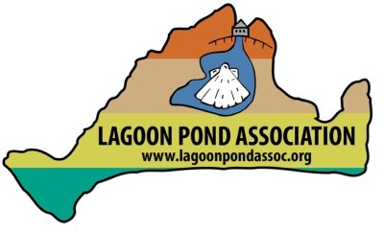
WHAT IS HAPPENING IN THE POND NOW AND CAN YOU DO ANYTHING ABOUT IT?

Water temperatures in the Lagoon this year are higher than ever. That, combined with septic system leaching, fertilizers and road runoff have caused an abundance of flora to multiply throughout our waters. Town officials have been testing the water to ensure our safety and we have been publicizing any warnings that we are aware of.

The Lagoon has seen a large bloom of a reddish, hairy algae we believe to be Dasysiphonia japonica (see Figure 1)1. This is an invasive seaweed that mucks up the waters and when it dies contributes to eutrophication, which in turn causes less dissolved oxygen and eventually a die off of fauna in the Lagoon.
Another invasive seaweed which is gaining prevalence in the Lagoon is Green Fleece seaweed (Codium fragile). You may have heard that a bounty was placed on this seaweed in Menemsha Pond.

What Can You Do?

You CAN take these seaweeds off your beaches. BUT you must be very, very careful not to remove any other flora and fauna with it. In particular, Codium fragile (see Figure 2) often attaches to shellfish. Do not remove the shellfish with the Codium. Look closely to see if baby shellfish of sand-grain size are harboring within the seaweed frond. Other creatures may also be in the seaweed and should be left alone. A “skim” raking of the seaweed from the beach is best to remove. DO NOT REMOVE OTHER SEAWEEDS.
And of course, you DO NOT WANT TO REMOVE ANY EELGRASS (see Figure 3) found in the Lagoon—there is very little as it is and we can’t afford to lose any as it is a healthy grass to have in our waters.

1 The identification of frilly seaweed is difficult. Although we believe this is the correct identification, it is possible a microscopic examination of the species in your hands would yield a different identification.

How to Dispose Of?

If you have room (and don’t mind the smell), letting seaweed dry out, bagging it and taking it to your Town disposal center is an option. Others wash the seaweed off (to remove some salt) and use it in their gardens and for compost. Please do your own research on Codium fragile, as some believe it has too much salt in it to use for compost. As an introduction to seaweed composting, here is one article describing composting of other seaweeds such as rockweeds (Fucus species):

https://zerowastehomestead.com/how-to-use-seaweed-in-the- garden/#:~:text=In%20fact%2C%20seaweed%20is%20so,pests%20away%20and% 20much%20more.
And from the Massachusetts Office of Coastal Zone Management: SEAWEED DISPOSAL OPTIONS USED BY MASSACHUSETTS COASTAL
COMMUNITIES
- No disposal—seaweed remains in place or is moved off to one side of the beach or to a non-recreational use area.
- Seaweed is allowed to dry in a designated storage area (good options include empty parking lots or fields).
Since seaweed is composed primarily of water, this reduces the amount of material to be disposed of. Once dried, seaweed may be:
- Returned to the beach wrack to help sand build up.
- Composted—either on site, at a transfer station.
- Brought to a landfill.
- For minor accumulations, other options include on-site burial or return to the sea when wind/tide conditions are favorable (seaweed may or may not be dried on site first).

Figure 1: Dasysiphonia japonica
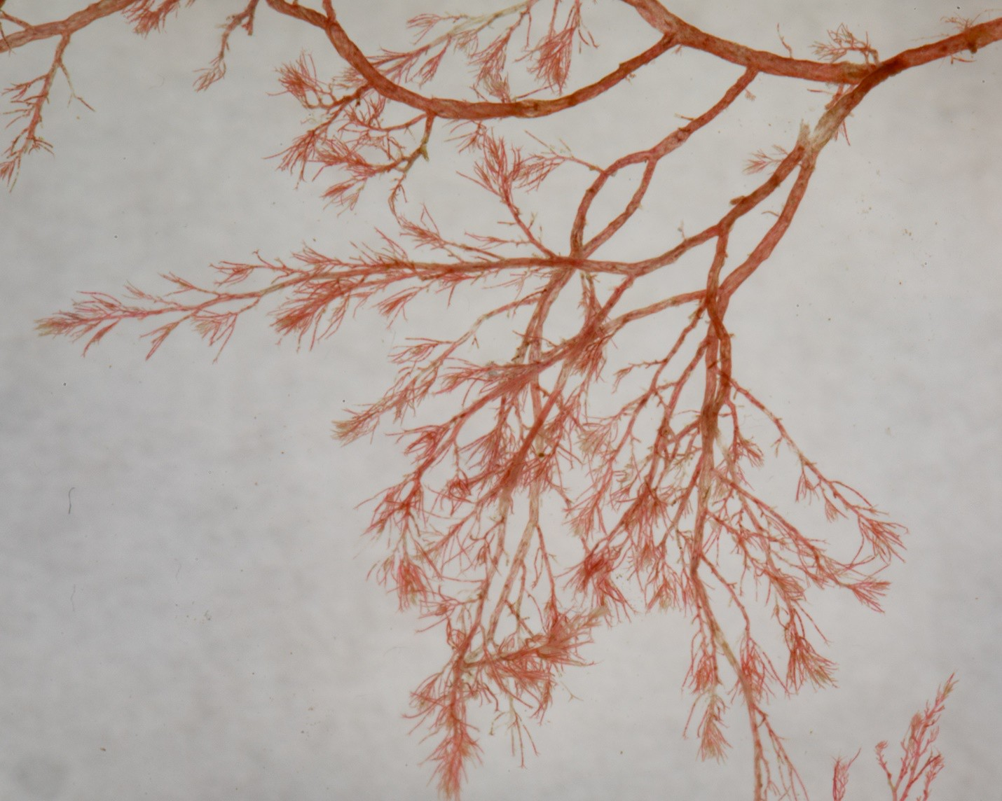
Dasysiphonia japonica (=Heterosiphonia japonica) is an invasive red seaweed native to the Northwest Pacific. It was first reported from Galicia, Spain in 1988 and spread in Europe north to Norway, and south to the Western Mediterranean. In 2008 it was collected off Rhode Island and is now found from Long Island to Nova Scotia. It grows as a deep rose-red, flattened, fan-shaped thallus, growing up to 200 mm high. In Great Bay, New Hampshire, it was found on eelgrass, shellfish farming gear, mud flats, oyster reefs, and inshore rock ledges. This seaweed is spreading aggressively in coastal waters. In Long Island bays, decaying blooms have been associated with fish die-offs and in experiments, toxins from the algae have been lethal to fishes and bivalve larvae.
(https://invasions.si.edu/nemesis/species_summary/13421#:~:text=Algae,south%20to%20the%20West ern%20Mediterranean.)

Image Credit: © alex_shure some rights reserved https://creativecommons.org/licenses/by-nc/4.0/

Figure 2: Codium fragile
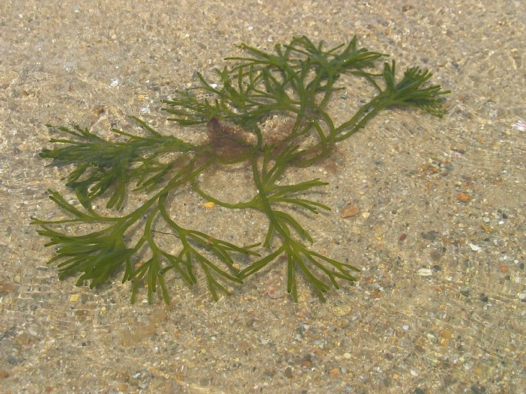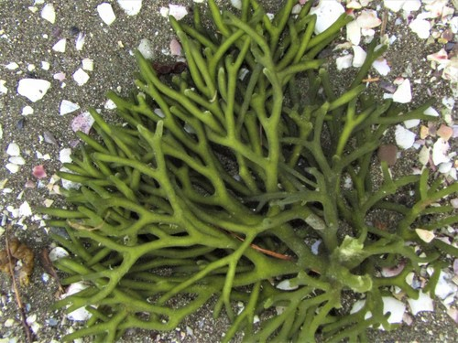
Codium fragile, known by several different common names (e.g., green fleece, dead man's fingers, green sea fingers, sponge seaweed, green sponge, green fleece) is a species of seaweed in the
family Codiaceae. It originates in the Pacific Ocean near Japan and has become an invasive species on the coasts of the Northern Atlantic Ocean. (https://en.wikipedia.org/wiki/Codium_fragile)

Figure 3: Eelgrass (Zostera marina): DO NOT REMOVE!
Eelgrass is a native vascular plant and NOT a seaweed
(Left: meadow plants, Randi Baird; Right: grass in beach wrack with seaweeds, the outershores.com)
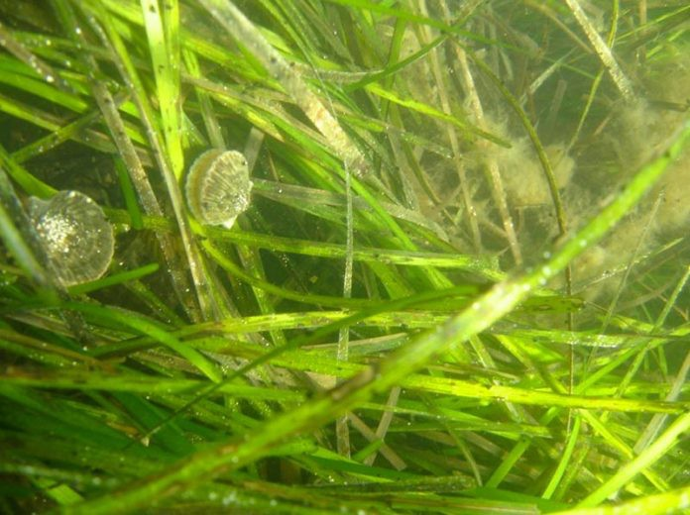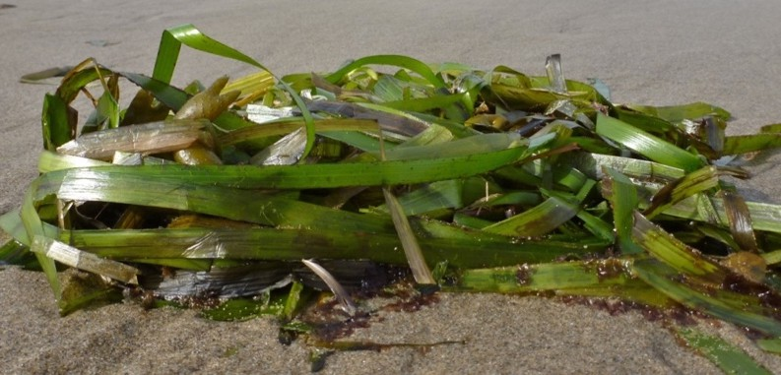
Eelgrass provides a number of important ecosystem functions, including foraging and spawning areas and shelter to young fish and invertebrates, food for migratory waterfowl and sea turtles. In fact, eelgrass forms the base of a highly productive marine food web. By trapping sediment, stabilizing the substrate, and reducing the force of wave energy, eelgrass beds reduce coastal erosion. The unique habitat also produces food and oxygen, improves water quality by filtering polluted runoff, absorbs excess nutrients, stores greenhouse gases like carbon dioxide, and protects the shoreline from erosion. Many people are unaware of the importance this plant plays in the marine environment. As a result, there has been significant degradation of eelgrass, primarily from human impacts such as urban development, dredging, pollution, and sediment runoff from upland areas.
(NOAA Fisheries: https://www.fisheries.noaa.gov/feature-story/importance-eelgrass)

