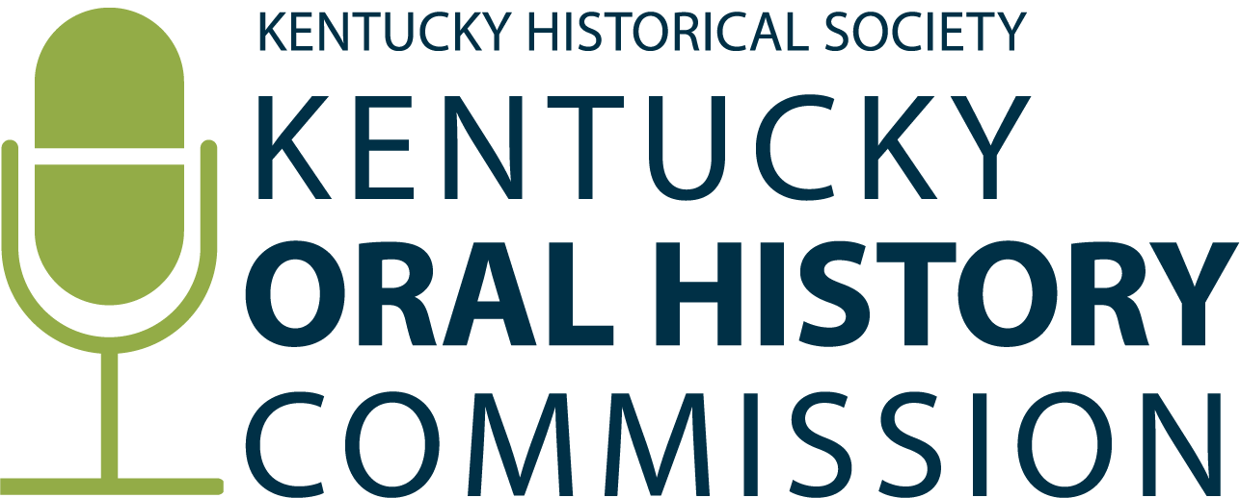

**KOHC Grant Guidelines Review Meeting**

**June 12, 2025, at 1:00 pm, via Teams**

**Minutes**

**Commissioners Present:**

Becky Bailey, Shana Goggins (vice-chair), Amanda Matthews (chair)

**Advisors Present:**

Ann Ferrell, Bailey Vandiver, DeBraun Thomas, Nathan Lynn

**KHS Staff Present:**

Johannah Ball (Oral History Processing Specialist), Michael Kilmore (Oral Historian), and Jonathan Noffke (Director of Historical Resources)

1. **Discussion about funding priorities:**

* Current funding priorities were developed by identifying gaps in KHS’ oral history collection.
* Emphasis on the need to provide more support to first-time grant applicants from community-based organizations who might have less experience with grant writing compared to academics.

1. **Supporting Grantees:**

* Clarify application requirements and create an eligibility checklist and provide more guidance for first-time applicants.
* Create a mentorship program for grantees, similar to the Community Scholars Program model.
* Create a glossary of terms to assist first-time applicants with understanding unfamiliar/technical terminology.