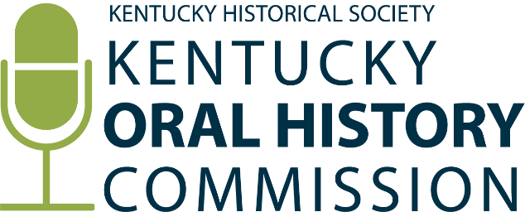
Kentucky Oral History Commission:
Grant Guidelines Review Subcommittee Meeting
Monday, July 21st at 10:00 am EDT
Via Zoom Teleconference
Zoom link: https://us06web.zoom.us/j/86468971856?pwd=bzd9NK6nT7bN8IlsCqSapuyYznmxaw.1
Password: 022580
Agenda
I. Old Business:
A. Funding Priorities
B. Grantee Support Strategies

II. New Business:
A. Feedback on Proposed FY2026 Revised Grant Guidelines
B. FY2026 New Guidelines Analysis Methods

