Steps To Install ERAssistant On Windows
- Click here and select the download the ER Assistant link on the website as shown below.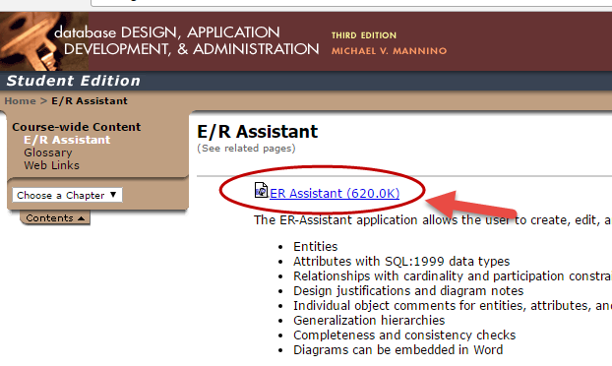
- Save the ERAsitant_2_10.zip file to a folder on your windows machine.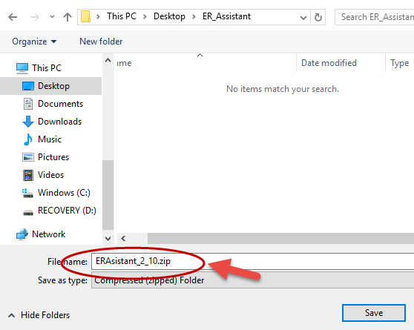

- Open the the folder you saved the ER_Assistant application you downloaded in Step 2.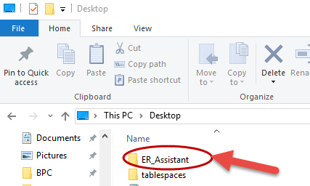
- The file is a compressed or zipped file as shown below.
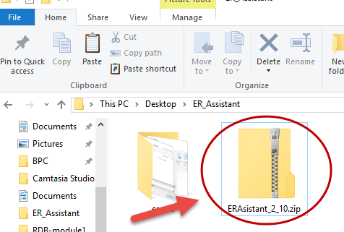

- Right-click the zipped file and select Extract to unzip the files to a folder on your computer as shown below.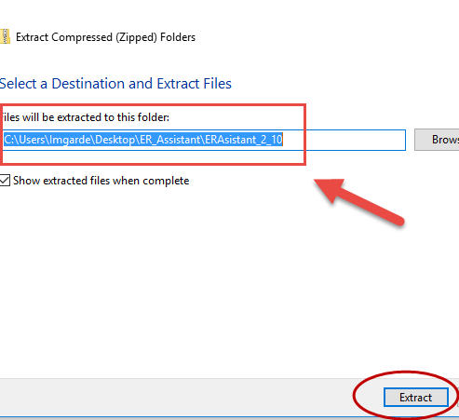

- Click the executable file to install the ER_Assistant application.
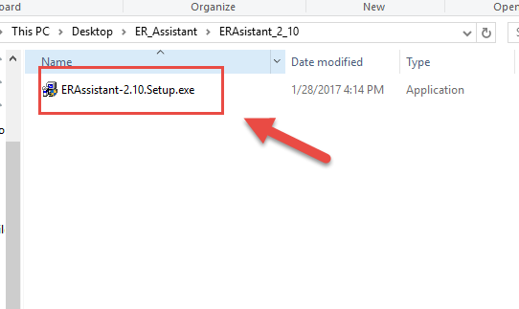

- Select the option Yes to allow the ER_Assistant application to continue with the installation.
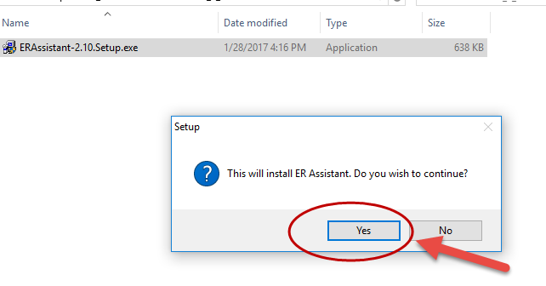
- Select NEXT to install the ER_Assistant application.
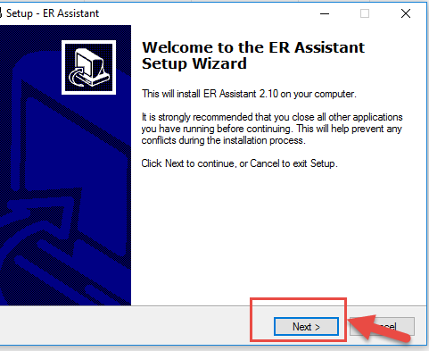

- Select the folder you will like the ER Assistant to be installed. You may choose the default location and select NEXT.
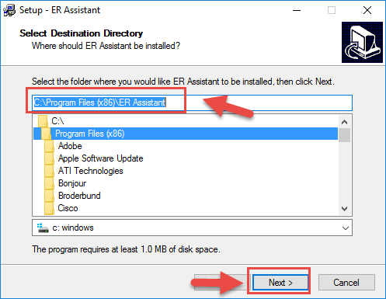

- Select the Start Menu folder in which you would like to Setup to create a shortcut to launch the ER Assistant and select NEXT.
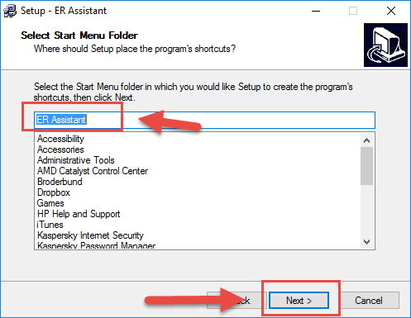

- Check the option to Create a desktop icon if you want and select NEXT to continue with the installation.
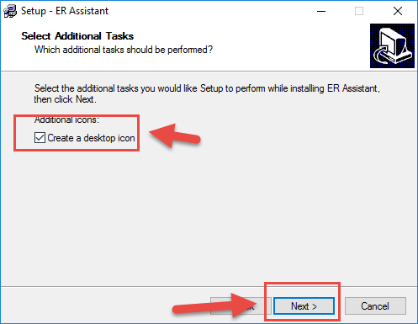

- Select Install to install the ER Assistant application.
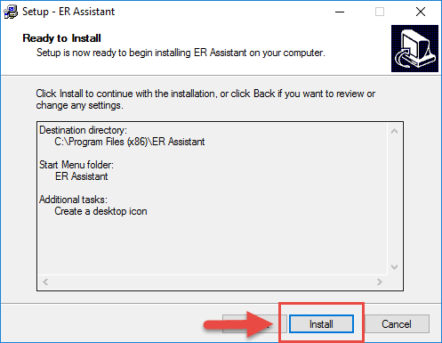
- Select Launch ER Assistant and click on Finish as shown below.
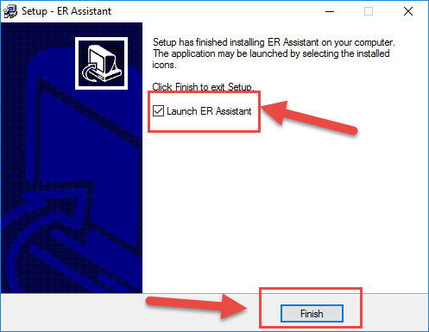
- The ER Assistant application will launch as shown below.
