Submission of Comments

Testing of the CBD Online Reporting Tool (ORT)

Using the template below, Parties are invited to submit comments (in Word) on the testing of the draft online reporting tool (ORT) by 15 September 2023 to secretariat@cbd.int.

TEMPLATE FOR COMMENTS

Contact information
Surname: |  | Outhwaite
Given Name: |  | Willow
Party: |  | United Kingdom of Great Britain and Northern Ireland
Organization  (if applicable): |  | Joint Nature Conservation Committee
Address: |  | Quay House, 2 East Station Road
City: |  | Peterborough
Country: |  | UK
E-mail: |  | Willow.outhwaite@jncc.gov.uk
General comments
The tool is user friendly and generally intuitive to use. The use of drop downs and pre-populated fields is very welcome from a data-entry point of view.
It would be helpful to have the option to download all (e.g. to .CSV) information that the UK has entered.
Additional rows can be added to this table by selecting “Insert” followed by “insert rows below”
Specific comments on the “My Country Targets” section of the draft online reporting tool
Overview | Comments/Feedback |  | Logged in User | URL
Overview | When I click to publish, the word ‘want’ is missing a t.  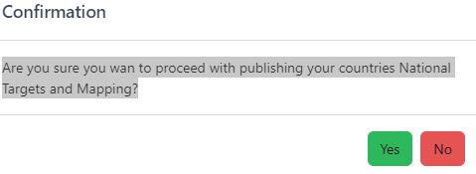 |  | Willow Outhwaite | https://ort.cbddev.xyz/national-targets/my-country
Overview | I have clicked to publish Parts I and II, but it is not clear what happens next. They still appear as draft in the Overview, but under my account my role is designated as the Publishing Authority. I have waited several hours and logged out and back in to try and refresh. It would be useful for a pop up to appear once the user has clicked publish to tell them what happens next. |  | Willow Outhwaite
Part I | Comments/Feedback |  | Logged in User | URL
Part I | The UK would like the option to fill out the ‘Full name/title of national target’ using the full text of the GBF target, followed by bullet points demonstrating which specific commitments within the UK will contribute to achieving this target. To enable this, the field type should change to being longer and allowing bullet points, as it already does for the “main policy measures” field. This is an important issue for the UK.  It is not sufficient to instead include the bullet points of commitments in the ‘main policy measures’ field, as we may wish to report progress on these commitments using national/component/complementary indicators. |  | Willow Outhwaite | https://ort.cbddev.xyz/national-targets/my-country/part-1/new
Part I | Currently the options given in the component/complementary indicators do not match what is in Table 2 of 15/5. For example, I have selected a National Target that aligns with GBF Goal A and Target 2. In the drop down component indicators, BERI appears – but this is not included in Table 2 for Goal A/Target 2 (it is a complementary indicator for Goal A and a component indicator for Target 8). |  | Willow Outhwaite
Part I | Currently the only component/complementary indicators that appear in the drop downs are those that link to the GBF Target/Goals as set out in Table 2 15/5. While this does make it more user friendly as the drop down contains a short list which is easy to navigate, there may be instances where Parties want to have more flexibility to use an indicator that ‘belongs’ to a different GBF target/goal. If this were the case, the question is what should the Party do – list the component/complementary indicator in the ‘other national indicators’ field, or an add additional goal/target to ‘Alignment with global goals and targets’? |  | Willow Outhwaite
Part I | Some indicators appear twice in the component / complementary indicator drop down field  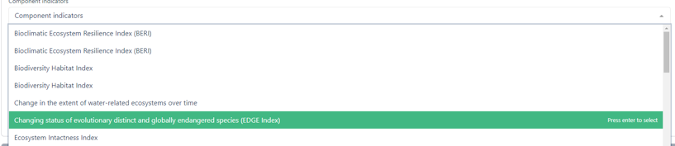 |  | Willow Outhwaite
Part I | It would reduce any potential confusion if the ‘Review’ and ‘preview’ buttons were named the same, as they appear to do the same thing?  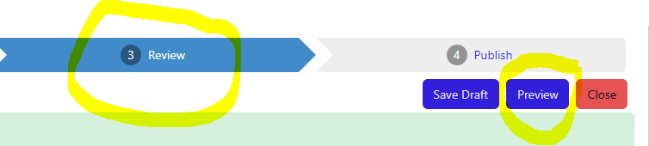 |  | Willow Outhwaite
Part I | When I preview the National Target, the Additional Means of implementation does something strange: |  | Willow Outhwaite
Part I | When I click ‘publish’, it directs me to instead use the Overview menu to publish. It feels quite clunky to expect to be publishing when a button is pushed, only to then find out there are still several more steps.  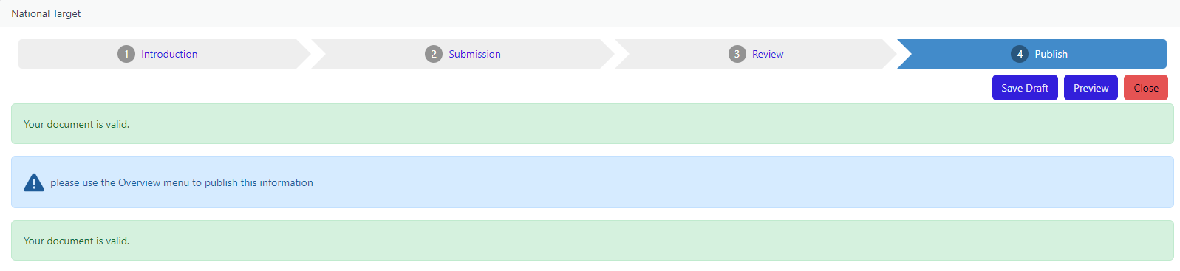 |  | Willow Outhwaite
 | When I publish, I get the following message. Perhaps it is more accurate to say “your country has not submitted any national targets for these global targets/goals”:  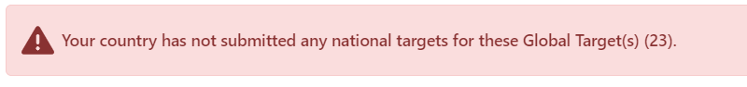 |  | Willow Outhwaite
 | Some considerations for implementation appear twice when I preview:  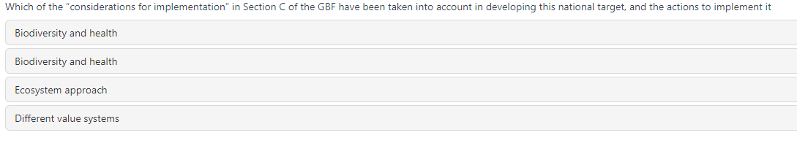 |  | Willow Outhwaite
Part II | Comments/Feedback |  | Logged in User | URL
Part II | When I click on the Part II section of the navigation pane, I can see the national targets I previously added. However, it is not obvious how I edit the ‘element of global targets information’ or ‘reference period’ fields – the ‘add mapping’ button suggests I have the option to add additional national targets that map to global targets/goal. I suggest changing ‘add mapping’ to ‘edit’ or ‘populate fields’. |  | Willow Outhwaite
Part II | For consistency, it would be helpful to add a red asterisk to each of the fields that are required (as is done with Part I) (noting this does appear when I click ‘add mapping’ and a new box opens) |  | Willow Outhwaite
Part II | When I click ‘add mapping’, the word rephrase is still there in this title: Is there a reference period for above national target(s) which relates to the headline indicator? (rephrase?) |  | Willow Outhwaite

