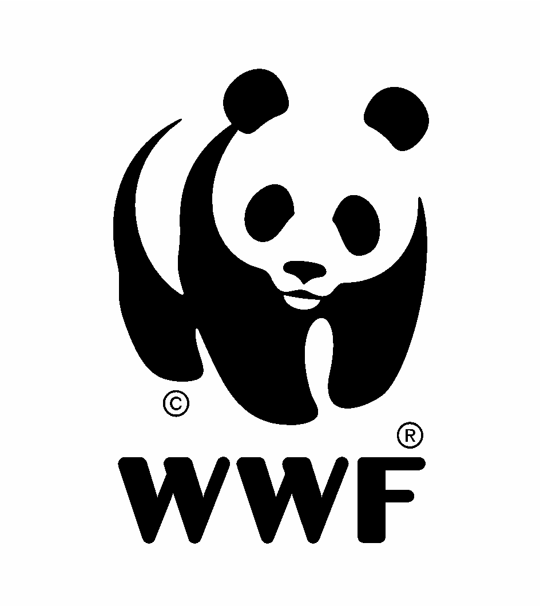
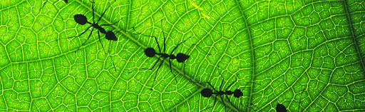

Views and Information
December 2025

Views and information on the strategic review and analysis of the Programme of Work on Protected Areas in the context of the Kunming-Montreal Global Biodiversity Framework

Background:
The Convention on Biological Diversity (CBD) has invited submission of views and information on the strategic review and analysis of the Programme of Work on Protected Areas in the context of the Kunming-Montreal Global Biodiversity Framework (KMGBF).

The programme of work includes 16 targets and 126 specific actions, organized under four key interlinked elements: (1) site establishment planning and management; (2) governance, participation, equity, and benefit-sharing; (3) enabling policy, institutional, and capacity frameworks; and (4) standards, assessment, and monitoring of protected area systems.

The Kunming-Montreal Global Biodiversity Framework (GBF) was adopted during the fifteenth meeting of the Conference of the Parties (COP 15). This historic Framework, which supports the achievement of the Sustainable Development Goals and builds on the Convention’s previous Strategic Plans, sets out an ambitious pathway to reach the global vision of a world living in harmony with nature by 2050. Among the Framework’s key elements are 4 goals for 2050 and 23 targets for 2030. See 2030 Targets (with Guidance Notes) .

TARGET 3 KM-GBF: Ensure and enable that by 2030 at least 30 per cent of terrestrial, inland water, and of coastal and marine areas, especially areas of particular importance for biodiversity and ecosystem functions and services, are effectively conserved and managed through ecologically representative, well-connected and equitably governed systems of protected areas and other effective area-based conservation measures, recognizing indigenous and traditional territories where applicable, and integrated into wider landscapes, seascapes and the ocean, while ensuring that any sustainable use, where appropriate in such areas, is fully consistent with conservation outcomes, recognizing and respecting the rights of indigenous peoples and local communities, including over their traditional territories.

WWF´s response process and timeline for submission to CBD

In response to this important opportunity, WWF has defined the following process:
- Establishment of a core Working Group to provide initial feedback on the guiding questions (shared here). The core Working Group is integrated by Jeff Worden, Cristina Eghenter, Wendy Elliot, Jorge Rickards, Harry Jonas, Stéphane Rivière, Rohit Singh, Jo Gacheru, Phillip Damian, Pauli Merriman.
- Share with the wider WWF community – including the PCA ACAI community – for feedback and input into the proposed responses (December 8)
- Reception of network responses (December 8 to 12)
- Consolidation and submission of final document to the CBD (December 15)

Section 1: Instructions for network feedback

- The submission of WWF´s response is guided by the following questions:

- What aspects should be incorporated or reinforced in the current review of the Programme of Work to improve alignment with the Kunming-Montreal Global Biodiversity Framework? Please consult the rapid gap analysis in document CBD/SBSTTA/25/INF/1 for reference.
- How could the approach to implementing the Programme of Work be revised to better contribute to achieving Target 3 of the Kunming–Montreal Global Biodiversity Framework? In your response, consider potential actors and timeframes.
- Which goals, targets, or activities of the Programme of Work should be prioritized to support national implementation of the Framework by 2030?

- Please review the initial response prepared by the Core Working Group (see below in Section 2).
- Add your input and comments in the section established for this purpose under each one of the three established guiding questions (Section 3 of this document).

Section 2: Core Working Group´s initial response

- What aspects should be incorporated or reinforced in the current review of the Programme of Work´(PoW) to improve alignment with the Kunming-Montreal Global Biodiversity Framework? Please consult the rapid gap analysis in document CBD/SBSTTA/25/INF/1 for reference.

The PoW needs to be updated and aligned with Target 3 of the KM-GBF and all its elements. Moreover, it needs to be reinforced with reference to the Programme of Work on Article 8j and other provisions of the CBD related to indigenous peoples and local communities to 2030 approved at COP16 , especially elements 1 (conservation and restoration) and 2 (sustainable use of biological diversity, and cross-cutting elements 6-8 (Human Rights-Based Approach HRBA, localization of funding, etc.).

The PoW also needs to be updated with reference to developments and other global fora like SDGs and Rio Conventions to build stronger synergies (climate change mitigation and adaptation, land tenure, etc) for an effective implementation of the PoW

A critical step would be to shift from a focus on Protected Areas alone to Protected and Conserved Areas as the possible expanded focus of the revised/updated PoW. This would allow identifying, recognizing and addressing OECMs and indigenous and traditional territories (ITTs) as per the ‘pathways’ in Target 3 of the KM-GBF. If this change is embraced, it might require a different organization of the PoW into three related components under a common umbrella, and each dedicated to one of three ‘pathways’ (PAs, OECMs, ITTs).

The revised PoW should:
- Strengthen focus on governance of protected and conserved areas in addition to management. A critical and new element of Target 3 of the KM-GBF is ‘equitable governance’ and the PoW should guide Parties and Stakeholders on how to address this dimension which is an important factor in ensuring sustainability and equity in Protected and Conserved areas systems, including mitigating conflicts. The IUCN Governance Type categories remain valid as a basis for identifying various and appropriate models of equitable governance like IPs-led, shared governance, co-management, etc.
- Embed a HRBA more effectively in the PoW. The current PoW talks more about beneficiaries than rights holders. A HRBA requires the full and effective participation and engagement of Indigenous Peoples and local communities and the full range of relevant rights holders potentially affected by PCAs and effective custodians of biodiversity areas and territories, most notably women, EHRDs (Environmental human rights defenders), persons with disabilities and youth in policy- and decision-making related to PCAs. The current PoW is still gender blind and has no provisions around the full protection of EHRDs.
- Update its language to reflect the principles in Section C of the KM-GBF such as gender, inter-generational equity and HRBA , and align with relevant global and regional treaties (e.g., Escazú Treaty for the LAC region on public access to information, public participation and justice, and full protection of EHRDs).
- Ensure that the rights holders, Indigenous Peoples, local communities, Afro-descendants, women and youth, and the enablers of this work, rangers, planetary health workers, natures guardians are recognized and fully supported - without them, the on-the-ground activities and goals will be difficult to meet. Reference to this should be integrated in goal 1.4. but also in all relevant targets and suggested activities under all Goals.

- Under suggested activity to Parties 1.1.4, we propose including a NEW activity : “Work with IPs and LCs and other rights holders and governments to appropriately recognize, respect and support ICCAs and ITTs, including ones that overlap with PAs, to strengthen systems of protected and conserved areas and their governance and management.”

- Goal 1.4.6: incorporate rangers, planetary health workers, natures guardians in the reference to staff that are well-trained and skilled, properly and appropriately equipped, and supported, to carry out their fundamental role in the management and conservation of protected areas.

- Embrace and drive action to ensure the critical ‘well connected’ element of Target 3 of the GBF and bring the PoW in line with latest connectivity conservation best practice and science. Suggested text additions in CAPS:
- Goal 1.1:
Revise Goal 1 to refer to ‘ecological networks’: “To establish and strengthen national and regional systems of protected AND CONSERVED areas integrated into ECOLOGICAL NETWORKS as a contribution to globally agreed goals”.

include NEW ACTIVITY “Prioritize establishment of new protected areas and the identification and reporting of OECMs and ITTs, through a participatory and inclusive approach in areas important for ecological connectivity”

- Goal 1.2:
“To integrate protected AND CONSERVED areas into broader land- and seascapes and sectors so as to maintain AND/OR RESTORE ECOLOGICAL CONNECTIVITY, ecological structure and function.”

Footnote 3: “the concept of connectivity may not be applicable to all Parties” should be deleted. The concept of connectivity has now been broadly adopted and recognized in multiple conventions (i.e. Convention on the Conservation of Migratory Species of Wild Animals/CMS, CBD) and in UN General Assembly resolution Nature Knows No Borders.
- Target under Goal 1.2: should be reworded as follows: “By 2030, all protected AND CONSERVED areas and protected AND CONSERVED area systems are integrated into the wider land- and seascape, and relevant sectors, by applying the ecosystem approach, MANAGING FOR ECOLOGICAL CONNECTIVITY, AND IDENTIFYING, RECOGNISING AND SECURING ECOLOGICAL CORRIDORS AND NETWORKS”.
- Two new proposed actions, taken from recently adopted IUCN World Conservation Congress resolution 127:
- “use the IUCN Connectivity Guidelines to identify and, as relevant, recognize/designate ecological corridors”
- “strengthen overall commitment, funding and capacity toward the design, governance, management, monitoring and implementation of ecological corridors and ecological networks”
- Goal 1.2 could be more explicit about the connectivity elements in landscapes and seascapes which are essential to achieve Target 3 of the KM-GBF:
- - OECMs establish ecological connectivity with protected areas (as well as other conserved areas). As stated by Broodie et al. (2025 https://doi.org/10.5281/zenodo.16051529): “Globally, designation of OECMs may be the only way that many countries can reach their 30 × 30 commitments of enhancing both the coverage of conservation areas and the connectivity among them; as such, the strategy holds great promise for slowing the extinction crisis in ways that may be more flexible and equitable than some common types of protected areas”.
- - all governance types and management categories.” (ibid.) could appear more explicitly in Goal 1.2.

- Goal 1.3, suggested text change to Target: “Establish and strengthen ... transboundary protected AND CONSERVED areas, other forms of collaboration between neighboring protected AND CONSERVED areas across national boundaries and regional networks, to enhance ECOLOGICAL CONNECTIVITY, the conservation and sustainable use of biological diversity, implementing the ecosystem approach, and improving international cooperation.”

- Since the original PoW was defined, the world’s largest conservation organizations have come together to define a consistently applicable standard to identify sites of biodiversity importance – Key Biodiversity Areas (KBAs). These sites represent areas of global significance for biodiversity, yet despite more than 16,000 KBAs being identified, less than half are protected. Thus, there is a significant opportunity to strengthen conservation impact by focusing on new protected and conserved areas in KBAs. Propose text addition in Activity 1.1.2.

- “As a matter of urgency ... take action to establish or expand protected AND CONSERVED areas, and work with rights holders on enhancing equitable governance of KBAs, FOCUSING ON UNPROTECTED KEY BIODIVERSITY AREAS, other taxa specific areas of importance (i.e. Important Marine Mammal Areas/ IMMAs, Important Marine Turtle Areas/ IMTAs), large, intact or relatively unfragmented or highly irreplaceable natural areas, or areas under high threat, as well as areas securing the most threatened species” -
- Proposed edit to activity 1.1.6: “identify sites of global importance for biodiversity, including updating national Key Biodiversity Area networks by fully applying the IUCN KBA Standard, and establish protected AND CONSERVED areas to conserve unprotected sites ensuring the establishment of comprehensive and ecologically representative national and regional systems of protected AND CONSERVED areas."

- How could the approach to implementing the Programme of Work be revised

- The effectiveness and relevance of the reviewed/updated PoW could be greatly enhanced by strengthening indicators to measure not only management effectiveness but also equitable governance and full and effective participation of rights holders in policy- and decision-making related to Protected and Conserved areas. This implies the use of both quantitative and qualitative indicators and adjusted to local and national socio-economic and historical circumstances.

- Incorporate planetary health workers, natures guardians, rangers are critical enablers to this wok, with appropriate resources to enable a skilled, professional workforce, that not only protects, manages and restores nature, but also builds community engagement and cohesion for conservation
- Goal 2.2- other relevant stakeholders to include rangers, planetary health workers, nature’s guardians as key stakeholders in this PoW.
- Include Partnerships with URSA- Universal Ranger Support Alliance, SERCA etc.

- Which goals, targets, or activities of the Programme of Work should be prioritized to support national implementation
- Goals 1.1. and 1.2. (and related targets and activities) need to explicitly integrate Conserved Areas and especially OECMs and indigenous and traditional territories (ITTs) as important categories for an effective and inclusive Protected and Conserved Areas system. This is especially important in consideration of the fact that many areas and territories traditionally governed by IPs/LCs are partially or totally overlapping with protected areas (see IUCN, Stevens et al. 2024 https://iucn.org/resources/publication/recognising-territories-and-areas-conserved-indigenous-peoples-and-local).

- Goal 2.1. and Goal 2.2. (and related targets and activities): A stronger implementation of a HRBA needs to be prioritized. Rights and benefits need to be equally emphasized in the case of those groups, communities, and constituencies more closely affected and dependent on the use of biodiversity. Indigenous Peoples, local communities, Afro descendants, women, EHRDs, youth should be recognized as rights holders and legitimately represented in policy- and decision-making processes regarding PCAs. Initiatives led by women and aiming to enhance the gender-responsiveness of the PoW on PCA should be given priorities as well as ensuring the full protection of EHRDs and women among them.

- Goal 2.2: Stronger language is required to incorporate the protection of environmental human rights defenders and stakeholders, particularly among local and indigenous communities. The current language is limited to participation and involvement.

- Goal 3.1. (and related targets and activities, see e.g., 3.1.4): Ensure that enabling policies are in place to support and resource equitable governance models that feature effective roles and responsibilities of rights holders in the establishment, planning management and governance and monitoring of PCA.

- Goal 3.5.2, should include rangers, planetary health workers, nature´s guardians as a target group for this goal.

Additional Recommendations and Suggestions:
- To ensure cross-biome relevance and align with GBF language, would suggest to position point 1F on important areas for biodiversity more broadly, to include KBAs but also other areas, e.g., …"take action to establish or expand PCAs, focusing on areas of particular importance for biodiversity such as KBAs, EBSAs, IMMAs, IMTAs, ISRAs, and other nationally or regionally identified priority areas etc."
- Update 1.1.3 to highlight the opportunities for MPAs in areas beyond national jurisdiction, under the BBNJ Agreement (Agreement under the United Nations Convention on the Law of the Sea on the conservation and sustainable use of marine biological diversity of areas beyond national jurisdiction); this is also relevant for Goal 1.3 on transboundary PCA networks.
- Suggest to add an activity around integration of PCAs into spatial planning processes, to ensure alignment with Target 1.
- Where we talk about rangers, we should also talk about MPA managers for consistency across biomes.
- Update 3.4 to incorporate work on innovative financing mechanisms for long term sustainable PCA financing.
- Suggest to include explicit focus on climate resilience of PCAs - including shifting ecological baselines, climate refugia.
- 1.4.5 on climate change adaptation and resilience has become much more critical over the past 20 years.
- Prioritise strengthening national enabling conditions, including long term sustainable financing and legal framework.

