Nature’s purest and most powerful health booster can help to unlock your natural energy, restore the gut microbiome, replenish minerals, and supercharge detox.

You probably already know that the food we eat today is not as healthy as it was generations ago. But it’s worse than you think.

Conventional farming methods including pesticides, herbicides, and chemical fertilizers have all depleted the soil our food grows in, resulting in crops that look the same but are empty of the nutrients we need to thrive.

Still, it might surprise you to learn that as a result of nutrient-depleted soil, a shocking 90% of people are deficient in one or more vital minerals. That’s 9 out of 10 people.

A deficiency in even one mineral can be devastating for your health. Magnesium, for example, is used in over 300 biochemical processes in the body, affecting the heart, muscles, kidneys, digestion and hormone production. A lack of magnesium can impact blood pressure, bone health, and even stress levels. And that’s just one mineral.

How can we get back what’s missing from our food?

The fact is that good nutrition starts with good soil. Scientists, nutritionists, and other health experts are now recognizing the one of the most important components of nutritious soil is fulvic acid. It’s a building block for health.

Fulvic acid is formed through the breakdown of nutrient-rich plant matter, and it contains organic substances that nourish food, which nourishes us. But today, soils are depleted of fulvic acid, which means that most of us just don’t get enough of the fulvic compounds, trace minerals, and antioxidants we need.

It’s a big reason why we can eat more food and still be starved of nutrition.

Fulvic Acid and Trace Minerals: Essential for Health

Fulvic acid is a nutrient booster that has fulvic compounds and trace minerals known to support every system in the body, including…

- Nourishing gut health by supporting the microbiome
- Strengthening natural defenses by supporting immune health
- Boosting nutrient absorption so you get more from the food you eat
- Optimizing cellular function by delivering nutrients and removing wastes
- Improving natural energy levels through electrolytes
- Supporting cognitive function for brain health
- Acting as an antioxidant to neutralize oxidative damage
- Supporting detoxification by binding to toxins

Formed over a long time as plant matter distills into complex organic substances, fulvic acid is a rich source of revitalizing compounds that cannot be replicated in a lab.

The health potential of fulvic acid is enormous. Fulvic acid compounds are believed to work at a foundational level to improve how our cells function, supporting gut health, immune function, energy processes and more.

Basically, the complex compounds in fulvic acid are what’s missing from our food today. And there is one fulvic acid supplement that stands above all the rest…
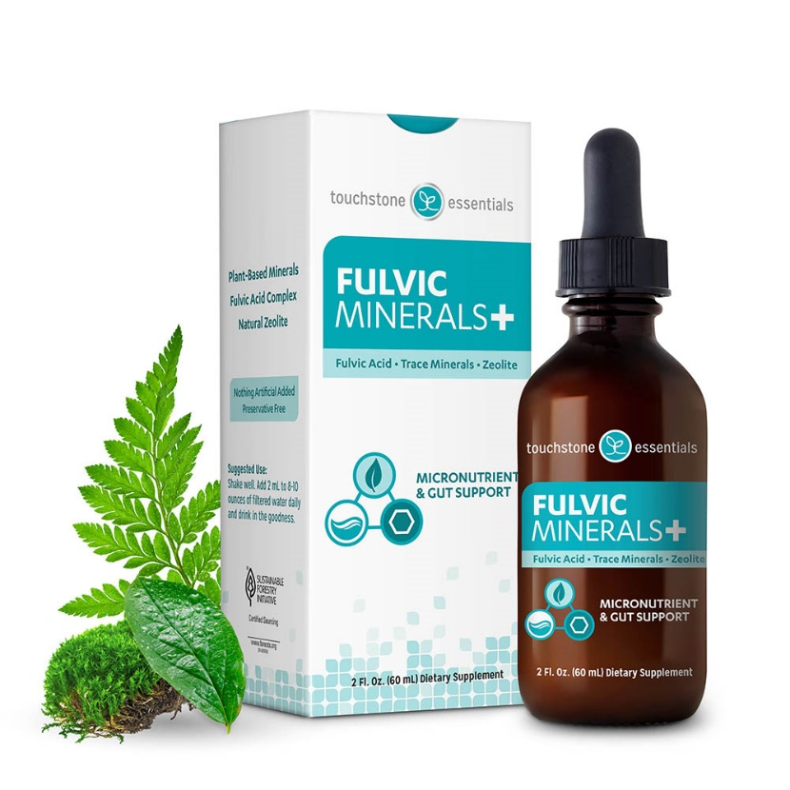

Not All Fulvic Acid Supplements Are The Same

You may have even heard about fulvic acid before, as more people than ever now realize how vital it is to replenish the body with fulvic compounds. But Fulvic Minerals+ is unlike any other type of fulvic acid supplement, thanks to three key reasons…

Fulvic Acid from a pure, peat source…
Fulvic Minerals+ sources fulvic acid complex from a remote peat bog in Canada that is free of environmental toxins and rich in organic fulvic compounds. This fulvic acid is extracted without solvents so it’s cleaner, and it is concentrated into liquid drops for a powerful boost that benefits the whole body.

Trace Minerals from nutrient-rich seaweed…
Abundant in minerals, seaweed has long been consumed in Japan and other cultures for its health benefits. The seaweed in Fulvic Minerals+ has been sustainably harvested from nutrient-rich waters in the North Atlantic and contains dozens of trace minerals vital for optimal health.

Natural Zeolite for a gut detox…
Revered as a master detoxifier, the natural zeolite Clinoptilolite binds and traps heavy metals and other environmental toxins. The zeolite in Fulvic Minerals+ also undergoes a proprietary cleansing and sizing process so it’s activated for maximum detox benefit in the gut. This is the same zeolite used in the best-selling Pure Body detox.

Fulvic Minerals+ is the ONLY fulvic supplement to combine the power of fulvic acid, plant-based trace minerals, and natural zeolite for micronutrient and gut health.

And Fulvic Minerals+ is easy to use every day. Just add drops (2 mL) to 8-10 ounces of filtered water for a taste-free way to feel your best.

Warning: Most Fulvic Acid Has High Heavy Metals

The problem is, most fulvic acid supplements contain a mix of fulvic and humic acid, which is often extracted from brown coal deposits (lignite). This source is usually high in heavy metals which can accumulate in the body and are extremely toxic.

It’s absolutely critical to know the sourcing of the fulvic acid, and to confirm if the product has been tested for heavy metals content. That’s why I haven’t recommended a fulvic acid product before… until now.

Fulvic Minerals+ includes fulvic acid sourced from pristine peat bogs in Canada. The fulvic acid is carefully harvested (without using toxic solvents) and it is tested for purity. Fulvic Minerals+ also does NOT contain any humic acid as there is no humic acid source that meets Touchstone Essentials’ high standards.

In addition to testing on each ingredient, the finished product is tested by an independent laboratory to affirm it is extremely LOW in heavy metals, so you can enjoy all the benefits of fulvic acid and trace minerals, without any concern of toxins.

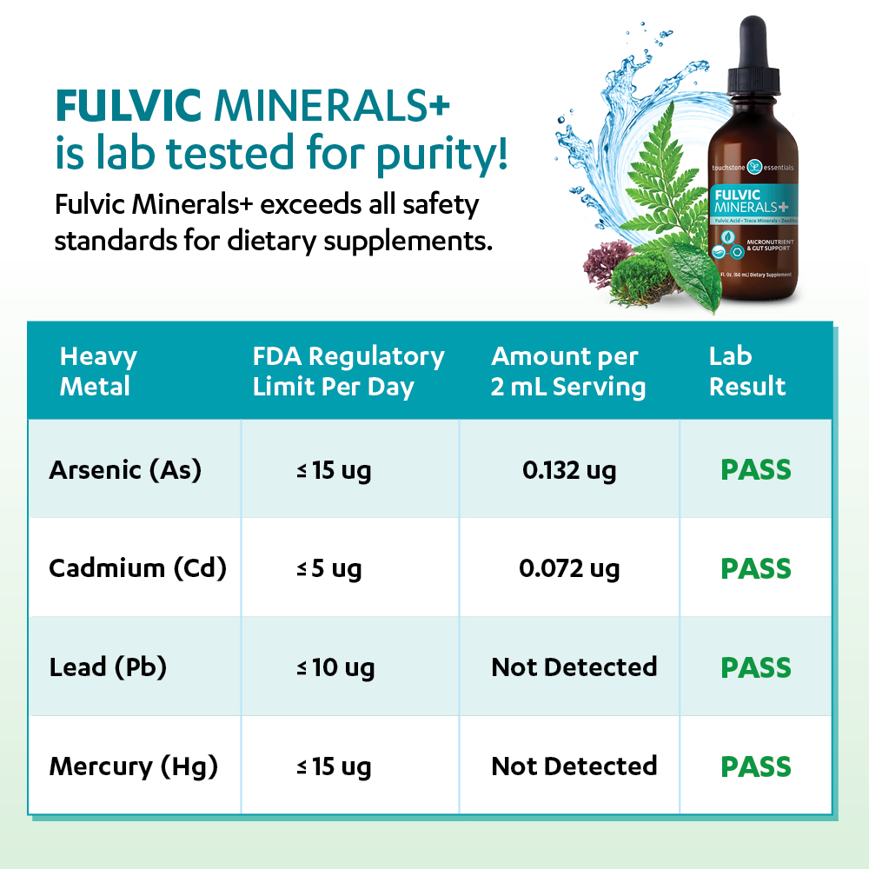

I’m so excited there is finally a clean way to get all the benefits of fulvic acid and trace minerals. In all my research, this fulvic acid product has the most powerful combination of natural nutrients and zeolite.

Fulvic Minerals+ is free of preservatives, is gluten-free, and is vegan friendly. It’s an easy way to nourish your gut, support natural immunity, and get more nutrients every day.

What Health Experts Say About Fulvic Minerals+

Fulvic Minerals+ is also endorsed by other natural health experts who had this to say…

“The combination of fulvic acid, plant-based minerals and zeolite in my opinion is truly genius. This formula is a super powerful 3 in 1 that is going to help people of all ages super charge their health.”
- Anna Victoria Rodgers, Author of Toxic World Toxic People

“Because modern farming practices have destroyed our soils, our food supply is lower in naturally occurring fulvic acid. Yet research has shown that fulvic acid can ensure we grow strong and healthy by benefiting digestion, the absorption of nutrients, gut and immune health, cognitive functioning, skin health, slowing down the aging process and improving energy levels.”
- Cindy Klement, MS, CNS, MCHES

“Touchstone Essentials is the perfect nutritional company to bring fulvic acid to market as they are committed to purity, consistency and independent laboratory verification for all of their products.”
- Robert C. Greenberg DC, Ph.D.

“I am super excited about Fulvic Minerals+. The fact that we have another key supplement that gets to the root causes of our health problems is awesome! Such a unique formula for the gut, while improving so many other areas in our body at the same time!”
- Inge Wetzel ND, CNHP, ANMA Board Certified

Why I’m Recommending it Today

I have been waiting for the right fulvic acid product to come along. When I saw Fulvic Minerals+ I was so impressed that I reached out to the company’s Founder and CEO, Eddie Stone about making this unique formulation available to my readers.

It turns out, Eddie is as passionate about prevention and natural approaches to health as I am, and is committed to making a difference in people’s lives. He agreed to reserve 500 bottles of Fulvic Minerals+ at an incredibly low price, exclusively for my readers. It’s truly an amazing product, and an amazing deal, which is why I’m recommending it now.

A Special Offer for My Readers Only

Normally, this remarkable nutrient booster sells on their website for $65, which is why I was stunned when Eddie said he’d offer it to my readers for just $5. They’ll even include free shipping.

But it gets better.

When you subscribe to a monthly shipment today, not only is your first bottle $5, but you’ll lock in a 25% off member discount and free shipping every month after that.

In a time of rising prices everywhere, I asked Eddie how he could possibly offer it at such a low price. He shared with me that he’s on a mission to touch the lives of five million families with goodness. He knows that when people just try it, so many will experience such great results that they’ll keep reordering it.

I only wish that more companies had this dedication to helping others. Touchstone Essentials is practically giving away these bottles, so there is a limited supply.

100% Risk-Free Guarantee

Best of all, there’s zero risk. You can cancel your subscription at any time (even before the next shipment), or return your shipment within 30 days for a full refund. They’ll even refund your $5 if you’re not happy with the product, less return shipping of course.

Imagine experiencing more energy, getting the full measure of nutrition, and supporting your immune health with Fulvic Minerals+. And it’s easy to use! Simply add the drops to your water each day and you are done!

Hurry, It’s Only Available to the First 500 People

There is absolutely nothing to lose and so much to gain. But you have to hurry, there are only 500 reserved and at only $5, they’re selling quickly. We will run out soon.

Claim Your $5 Bottle of Fulvic Minerals+ Now

In today’s world, the food we eat is simply lacking in the minerals we need to thrive, and our body’s detoxification system simply can’t keep up with the toxic overload. We all need extra nutrient support to feel our best and support immune health.

Fulvic Minerals+ will give you an easy way to nourish gut health, replenish vital trace minerals, enhance detoxification and much more.



