

3 Ways to De-Bloat

Feeling bloated is the opposite of fun! Whether you're actively trying to balance your weight or are trying to balance your relationship with food, bloating can completely throw you off! Here are 3 simple home remedies to de-bloat.

- Water


Dehydration is one of the leading causes of bloating, and the cure is natural hydration. Drink lots of water. It’s commonly noticed that drinking a lot of alcohol or soda consistently results in bloating. Water helps wash the waste out of your system. Drink eight glasses of water daily to not only de-bloat, but also other amazing benefits of water.
- Pay attention to your fiber intake

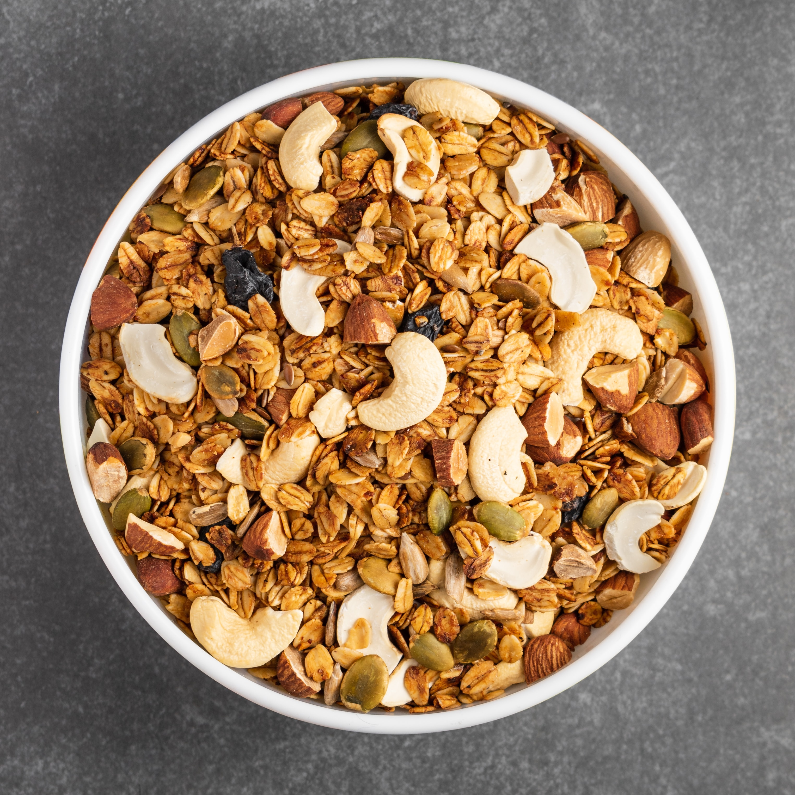
Fiber is key for staying healthy and becoming a balanced eater. It keeps your digestive system chugging along smoothly and helps you feel satiated for longer, which is a plus if weight balancing is what you're after. The issue is when you go from eating very little fiber to taking in way too much, like when you've decided to overhaul your eating habits in an effort to get healthy. Overdoing the fiber when you're not used to it can make you really bloated. Too much fiber can be tough to digest and create gas, both of which might puff you up. Aiming for between 20 and 25 grams of fiber per day and drinking a lot of water along with any fibrous food to help your body digest it easier.

- Warm water, lemon and a pinch of turmeric

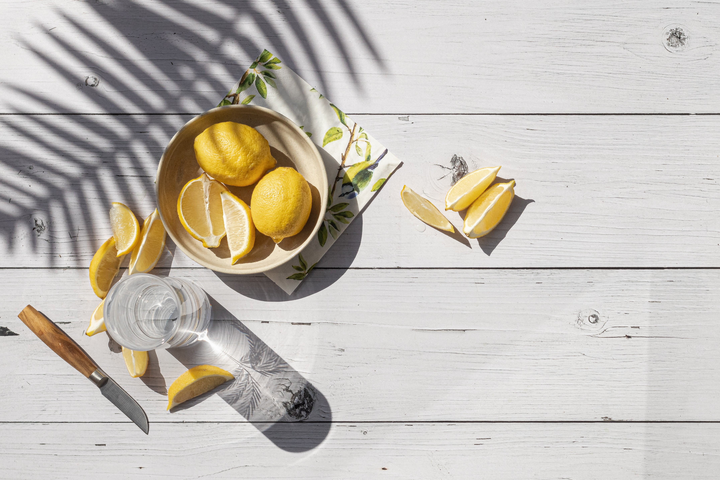
This is a wonder trick. Simple and inexpensive—yet effective! If you are suffering from bloating, this will help. If your morning routine currently involves throwing back a coffee, why not try starting with warm turmeric lemon water first?! The health benefits are vast, including de-bloating, anti-inflammatory, and weight balancing!

- Digestive Enzymes

And when needed, these digestive enzymes by Mary Ruth Organics always do the trick!

