Rare Miracle Mineral Removes Deadly Toxins
and Heavy Metals in Just 30 Seconds a Day

By some estimates, we are exposed to over 80,000 chemicals in our daily lives, just from the food we eat, water we drink, and air we breathe. These toxins build up in our bodies affecting our sleep, memory, concentration, weight, and even inflammation (1, 2, 3, 4).

Much of the disease, cancers and health problems we experience are rooted in toxicity. Mercury, arsenic, lead, cadmium, pesticides, and volatile organic compounds just scratch the surface of what our bodies have to fight against daily.

Modern medicine doesn’t have the answer to this modern problem. But… nature does.

There is a rare natural mineral, created through a reaction of volcanic ash and seawater, that can eliminate dangerous toxins from the body, down to the cellular level.

Its negative-charge and honeycomb shape acts as a natural chelator, binding to positively-charged toxins and ushering them out of the body, quickly and effectively.

Zeolite Clinoptilolite: The Miracle Mineral for Detox

If you’ve heard of the zeolite Clinoptilolite, it’s because this type of zeolite has been widely studied for its ability to:

- Flush heavy metals from the body, including toxic lead (5)
- Provide alkalizing minerals to support a healthy pH
- Protect kidney function by detoxing heavy metals (6)
- Strengthen the immune system through removing toxins (7)
- Protect against leaky gut by strengthening the intestinal wall (8)
- And much more, as extensive clinical research shows (9)

The detoxification and health benefits of the zeolite Clinoptilolite are astounding. It’s hundreds of times more effective than activated charcoal, a commonly known and used detoxifier that can detox the gut but comes with harsh side effects.

The zeolite Clinoptilolite can bind to toxins throughout the whole body and has an affinity for toxins only, so it never removes beneficial minerals, and there are no negative side effects.

Warning: Most Zeolite Products Do Not Work

The problem is, most zeolite products are not capable of cleansing at the cellular level. To go beyond the gut and reach into cells for a deep detox, the zeolite must be nanosized.

When the zeolite is nanosized and suspended in water molecule clusters, this natural detoxifier can travel throughout the body, even past the blood-brain barrier.

Imagine clearer thinking, ease in recalling tasks, improved mood and much more because your brain is now free of neurotoxic heavy metals!

But to take out heavy metals and other toxins, the zeolite must also be cleansed and pre-filled with alkalizing minerals. Why? The fact is, when mined, zeolite comes filled with environmental pollutants because that’s what zeolites are good at in nature – absorbing toxins.

However, if a zeolite is already filled with toxins, it can’t take any more from your body. That’s why most zeolites sold today don’t work, and why we haven’t recommended one before.

Until now…

The Most Effective Zeolite on the Market Backed by Science

After doing extensive research, we discovered Pure Body Extra by a company called Touchstone Essentials. Their cleansing process and nanosizing technology is hands-down the most advanced we’ve seen, yielding the only zeolite on the market that can effectively detoxify the entire body on a cellular level.
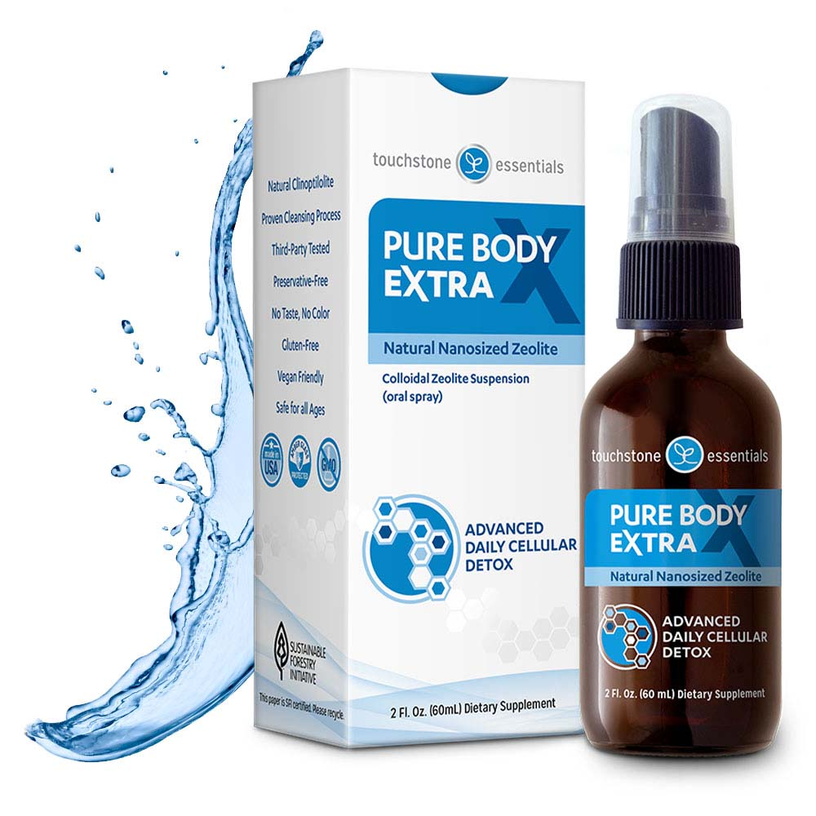

This zeolite uses nanosized Clinoptilolite to access toxins everywhere in the body. These particles are so small they are invisible to the naked eye and need to be magnified thousand-fold. And it’s backed up by the gold standard in instrumentation – Malvern particle size testing.

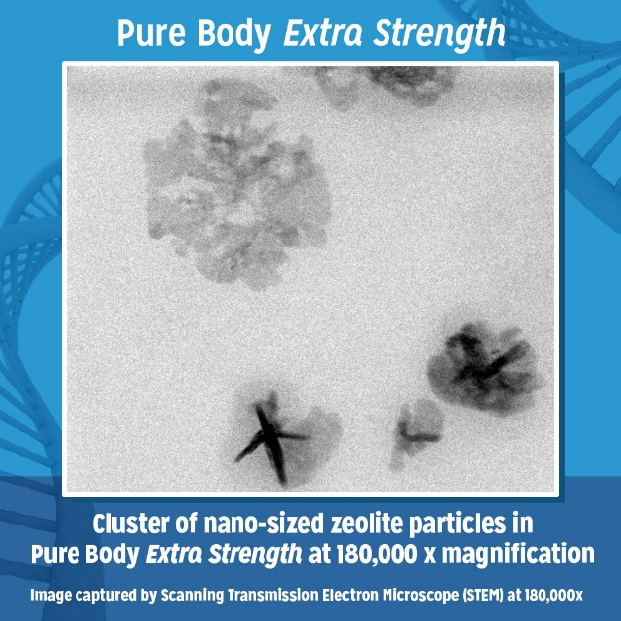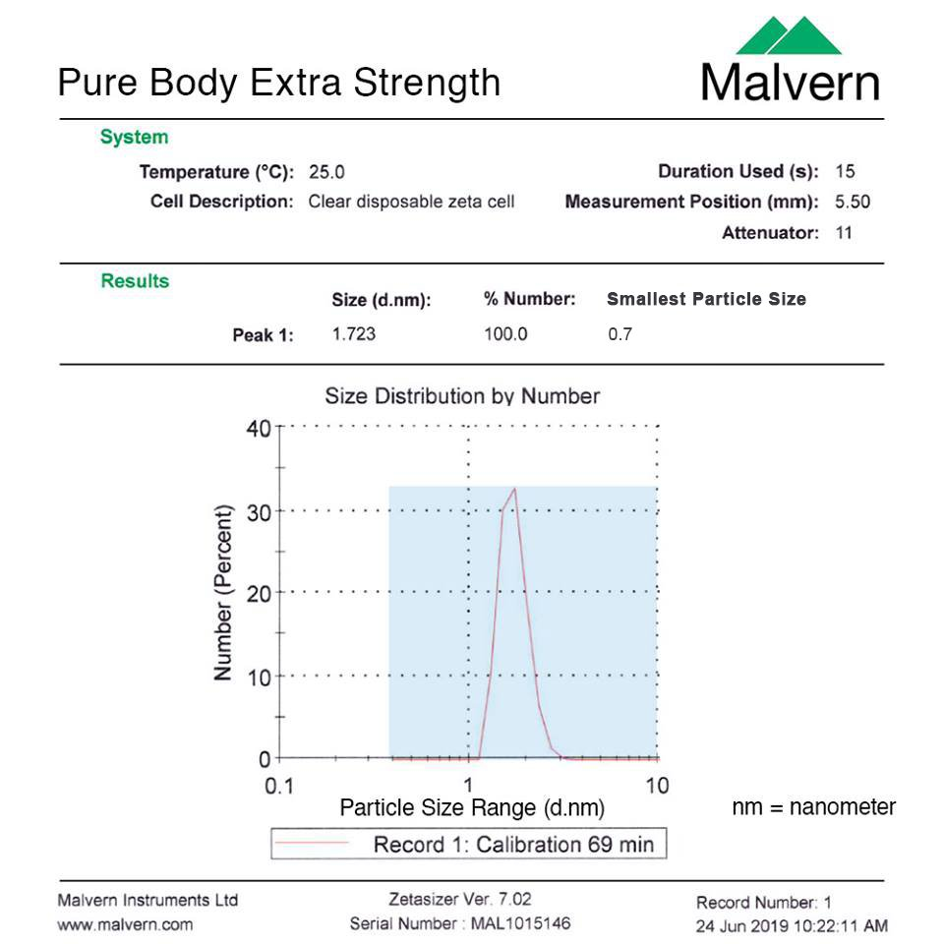

This nanometer size means they can get to a cellular level, and it also means the collective surface area of the zeolite particles creates a vast filter that mops up toxins within hours.

And because these zeolite particles are encapsulated within water molecule clusters, it is delivered in a liquid spray that is easy to use (just a few sprays, morning, noon, and night) with no odor, no taste, and no hassle.

Pure Body Extra has also been cleansed of existing pollutants so that it more effectively removes heavy metals throughout your body. This is all proven with third-party independent clinical testing. Not only that, the zeolite particles are pre-filled with alkalizing minerals. That way, the zeolite “swaps” a beneficial mineral for a toxin every time.

In all our research, this zeolite product has the most rigorous research and testing.

What People Are Saying Pure Body Extra

We scoured the internet and came across hundreds of testimonials for Pure Body Extra. Here are a few that stood out to us:

"Now when I wake up I actually spring out of bed and I have never felt better! The mental clarity I have has helped me become more organized and focused and I feel young again as if I am starting a new life."
Sandra N.

"I feel a thousand times better than I did before. I'm no longer feeling low, constantly tired, and irritable. I sleep much better, my mood is more stable and I'm happier throughout the day."
Aaron S.

“I am getting better sleep and feeling more energy and less brain fog!!”
Melanie L.

“I'm delighted to have come across this product. I'm starting to see changes in my Sons Behaviour. He's been using it for 10 days now and it seems to be healing his Leaky Gut too. I'm well over the Moon. Such an Incredible Product.”
Dandan C.

There are countless reviews and testimonials that show Pure Body Extra is making a real difference in people’s lives.

Why We’re Recommending it Today

We take Pure Body Extra every single day and have been blown away by the results. We were so impressed that we reached out to the company about making this zeolite available to our readers.

It turns out, Touchstone is as passionate about prevention and natural treatments as we are, so they agreed to reserve 500 bottles of Pure Body Extra at an incredibly low price, exclusively for our readers. Which is why we’re recommending it to you now. It’s truly a miraculous product.

A Special Offer for Our Readers Only

Normally, this remarkable detoxifier sells on their website for $79.95, which is why we were shocked when Touchstone said they’d offer it to our readers for just $5. They’ll even include free shipping. We asked them how they could possibly offer it at such a low price, and this is what the company said.

“We’re on a mission to touch one million families with goodness. We know if we just get the product in people’s hands, the results are so good, people reorder it again and again. We’re happy to make a difference in people’s lives.”

But it gets better.

When you subscribe to a monthly shipment today, not only is your first bottle $5, but you’ll lock in a 20% off member discount and free shipping every month after that.

100% Risk-Free Guarantee

Best of all, there’s zero risk. You can cancel your subscription any time (before the next shipment), or return your shipment within 30 days for a full refund. They’ll even refund your $5 if you’re not happy with the product, less return shipping of course.

Imagine being free of disease-causing heavy metals, nitrosamines, volatile organic compounds, and pesticides in just 30 seconds a day, with no harsh side effects.

Hurry, It’s Only Available to the First 500 People

There is absolutely nothing to lose and so much to gain. But you have to hurry, there are only 500 reserved and at only $5, they’re selling quickly. We will run out soon.

Claim Your $5 Bottle of Pure Body Extra Now

In today’s toxin-filled world, our body’s detoxification system simply can’t keep up with the daily onslaught. We all need to reduce our toxin load if we want to live happy, healthy lives.

Pure Body Extra will give you a way to free yourself of toxins, alkalize the body, strengthen your immunity and much more.



