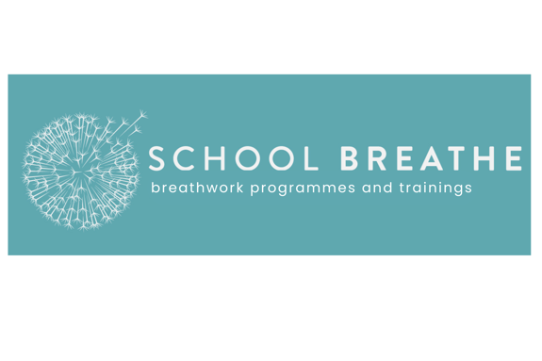
School Breathe Breathing Poems: Inspiration to leave with your Origami Creation

We invite you to add a mindful touch to your origami creation by pairing it with a breathing poem! Simply print out one of the poems below or write your own, and leave it alongside your origami for someone to discover. A few calming words, combined with the beauty of your folded design, can bring a moment of peace and reflection to someone’s day.

Butterflies (written by Tim Harrison)

My dearest, I am glad you are here.

Let’s just take a breath.
Let us share this moment, this space, this bit of air.
I probably don’t even know you but I definitely care.

Breathe in slow.
In slowly through your nose.
Follow the feeling as it drifts down the whole of you.
The soul of you.
Every cell of you.
And out, even slower still…two…three….four.

Breathe in deep through your nose, breath in slow.

Down to where the butterflies grow, I know, I know.
I hear you.
We’ve all been here, we all know anxiety and fear.

I’m glad you are here.

Breath in slow, in through your nose, follow it as it flows deep down to where the butterflies grow.
And breathe out slow.

Notice how you feel… it takes a just a moment
to set those butterflies free.

Boats (Written by School Breathe)
Place me in your palm, release all your worries,
I’ll sail away with them, turning them to stories.
Breathe in through your nose, feel the wind within,
Breathe out softly through pursed lips, and let’s begin.
On this breath journey, where we learn to slow,
And most importantly, breathe through the nose.
Breathe in through your nose, 1.2.3,
Breathe out gently, pursing your lips with ease.
Let’s ride this wave of breath a few more rounds,
Feel your shoulders soften, your toes on the ground.
Breathe in for 1.2.3,
Breathe out slowly, pursed lips gently.
Now, imagine a boat, sailing away with your cares,
As your out breath sends rainbow bubbles into the air.
Breathe in for 1.2.3,
Breathe out softly, pursed lips gently.

Box Breathe (written by Tim Harrison)

I have gift, an empty box just for you.
Breathe in 2…3…4…
And pause 2…3…4…
Breathe out softly 2...3...4…
And pause 2…3…4…
Repeat that once more.
I’m glad you’re here, my dear you.

Nose, Belly, Slow (School Breathe)

Hello there gorgeous being, let’s take a few slow breaths.
Giving yourself permission to have a well-deserved rest
Breathing in gently through your perfect nose.
Breathing out softly, imagine your breath travel to your toes.

When you breathe in, imagine your belly rising,
Full of light and energy, warm and surprising.
As you exhale, let go of your worries and fears,
Drifting away like the wind, calm and clear.

Now breathe in very slowly, giving yourself time,
Imagine the breath as your body’s own rhyme.
Breathe out slower still, letting go of your worries,
Like petals that dance in the warm summer breeze.

Triangle Breathe (written by School Breathe)

Try this triangle breathing exercise
Breathing through your nose
Breathing in, feel your belly rise
Breathe out, all the way to your toes

Breathe in 1..2..3..
Pause the breath for 1..2..3..
Breathe out 1..2..3
Breathe in 1..2..3..
Pause the breathe for 1..2..3..
Breathe out 1..2..3..
Repeat until you feel calm

