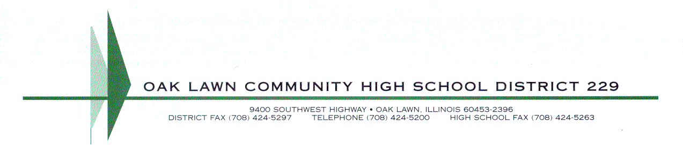
Press Release | Date: May 27, 2021  Contact: Marcus Wargin, Assistant Principal 708/741-5613 | mwargin@olchs.org Brian Frangella, District Feature Writer  708/424-5200 x5745 | bfrangella@olchs.org  Website: www.olchs.org

IHSA, SOUTH SUBURAN CONFERENCE HONOR SPRING STUDENT-ATHLETES
Written by Brian Frangella, OLCHS Staff Writer

Having to play their individual sports with masks on during competition and learning in a remote setting for most of the year was a difficult task for student-athletes. However, Oak Lawn Community High School still had many students standout on the playing field and in the classroom.

The Illinois High School Association and the South Suburban Conference recently recognized these student-athletes for outstanding achievement. The IHSA gives Scholastic Achievement Awards to juniors and seniors that competed in at least one full season and maintained a cumulative grade point average of 3.5 or higher. The SSC recognized senior varsity athletes with a GPA of 3.5 or higher.

Here are the IHSA honorees for OLCHS:

In Football, Adam Alcantar, Ken Alwyn Cabral, and Evan Zambrano earned the award. In Girls Volleyball it was Arianna Andersen, Allyssa Canales, Emma Garrett, Jessica Kasprzak, Mia Kennelly, Samantha Labuda, Victoria Niton, Madison Ryan, and Shannon Showan earning the award. In Boys Soccer the award recipients were Michael Conroy, Daniel Gaidelis, Steven Hebel, Damian Komperda, and Fredy Lopez Jr.

The SSC All-Academic Athletic Team members from Oak Lawn are Andersen, Canales, Garrett, Showan for volleyball, and Conroy, Gaidelis, and Lopez Jr. for boys soccer.

Photograph: Spring Sports Awards2.jpg

