Krowdfunder the Game – press release

24th October 2014

River Horse is about to launch a new card game called “Krowdfunder”.

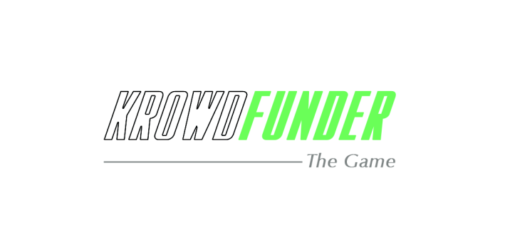
Krowdfunder is an affordable game that consists of a single colorful deck of cards. This simple and fun game re-creates the exciting ups and downs of a crowdfunding campaign (like Kickstarter, or IndieGogo…).
In a surreal twist, the game is going to be launched on Kickstarter first, with the campaign scheduled to launch in early November 2014.

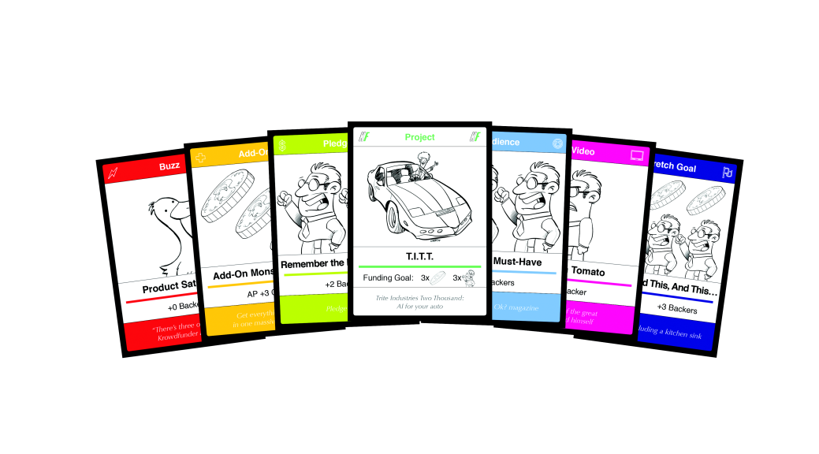

About crowdfunding and Kickstarter
Crowdfunding is a new phenomenon that has taken the world by storm in the last few years. But how does it work?
To put it simply, on one of the many crowdfunding websites, creatives pitch their ideas for products to the public, illustrating them with a more or less advanced prototype and spreading the news through social media.
If the internet crowd likes what they are seeing, they can become backers, pledging a small amount of money to the creators using their credit cards, effectively buying in advance the product before it is physically made.
If the project reaches its funding goal, then it goes live, the backers’ credit cards are charged and the product is made and delivered to the backers.
If the funding goal is not reached, the project is aborted and the backers’ credit cards are not charged.
It’s a win-win solution that allows the creatives to fund their projects directly from the end customers, and allows the customers to have a creative input and get some coll stuff cheaper and earlier than anyone else!
With over one billion dollars pleaged on it to date, Kickstarter is the most successful of these crowdfunding websites, and gaming projects are the ones that have raised the highest amount of money, as seen here:
https://www.kickstarter.com/help/stats
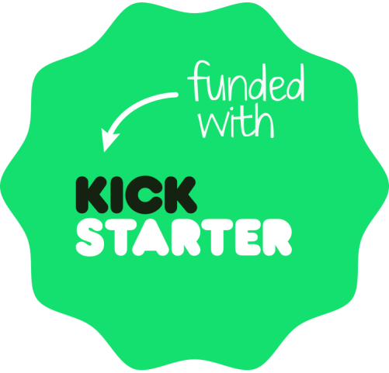

About Krowdfunder the game
As explained in its intro video, the game has been conceived and written by veteran games designer Alessio Cavatore (Warhammer, Bolt Action, The Lord of the Rings Strategy Battle Game, the Tarot of Loka…) of River Horse Games.
As he says, Alessio has been involved in many crowdfunding campaigns for several games, and he thought that these campaigns all have internal rules, as well as an overall strategy and tactics to react to challenges one encounters. Alessio has distilled these rules and the good and bad moves one can make while on a “crowdfunding quest”.
The game rules are extremely simple and fun, so that they are accessible by all ages, but also include some more challenging advanced options for the more sophisticated gamers.
Illustrated by talented artist Scott Johnson of Extra Life, the cards are colorful and cartoony, with a friendly, tongue-in-cheek tone they share with the game mechanics – they borrow deeply from ironically presented icons of the ‘gaming geek’ culture, never taking anything, or themselves, too seriously.

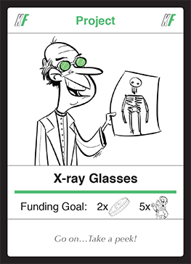
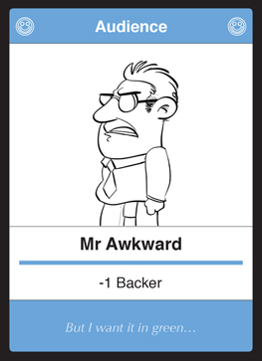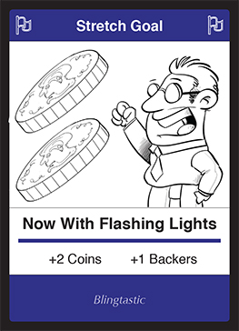

In conclusion
Surely a game about crowdfunding that is being crowdfunded on the major games crowdfunding platform is going to be an intriguing project to follow.
And not only for gamers, but also for fans of crowdfunding that are not gamers (yet), and for the public at large, which can be introduced to the concept of crowdfunding in a light-hearted fashon!
Before the launch, you can register your interest here and join us on facebook.

